_____________________________________________________________________________
Luke 1:57-66
Now the time came for Elizabeth to give birth, and she bore a son. Her neighbors and relatives heard that the Lord had shown his great mercy to her, and they rejoiced with her.
On the eighth day they came to circumcise the child, and they were going to name him Zechariah after his father. But his mother said, ‘No; he is to be called John.’ They said to hr, ‘None of your relatives has this name.’ Then they began motioning to his father to find out what name he wanted to give him. He asked for a writing-tablet and wrote, ‘His name is John.’ And all of them were amazed. Immediately his mouth was opened and his tongue freed, and he began to speak, praising God. Fear came over all their neighbors, and all these things were talked about throughout the entire hill country of Judea. All who heard them pondered them and said, ‘What then will this child become?’ For, indeed, the hand of the Lord was with him.
_____________________________________________________________________________ I will never forget the first time I saw the skyline of New York City with my own eyes. I was in 8th or 9th grade and visited the City on a school trip. I remember approaching the city on a big charter bus and seeing the expanse of skyscrapers and trying to wrap my head around the sheer magnitude of humanity all crammed into a space of about 23 square miles. For a teenager who grew up in a relatively small town called Dalton, Georgia, it was one of the most poignant memories I have experiencing the emotion of amazement.
In her most recent book, Atlas of the Heart, Brené Brown categorizes 87 different emotions. Each chapter is entitled “Places we go when we…”. And when she talks about the emotions of amazement, awe, and wonder, and curiosity, she calls that chapter “Places we go when it’s beyond us.” I absolutely love the way she describes it. Places we go when it’s beyond us. Those of us who are messy practitioners of faith know this place well. In fact, you’re in that place right now! What is worship, after all, than gathering as God’s people to approach the unfathomable mystery and wonder of the Divine?
Today’s theme in our Advent journey is “We allow ourselves to be amazed.” Amazement, my friends, is another way to describe a phrase you hear me say so often from this pulpit: “holy curiosity.” The moment we cease to allow ourselves to be amazed by the world around us is, I think, the moment we lose an important part of what it means to be human. That’s why we need the poets, the prophets, the preachers, and the playwrights to draw our attention to the wonder of the world around us. Mary Oliver, my favorite poet, once said the following: “Rules for living a life: Pay attention. Be astonished. Tell about it.”
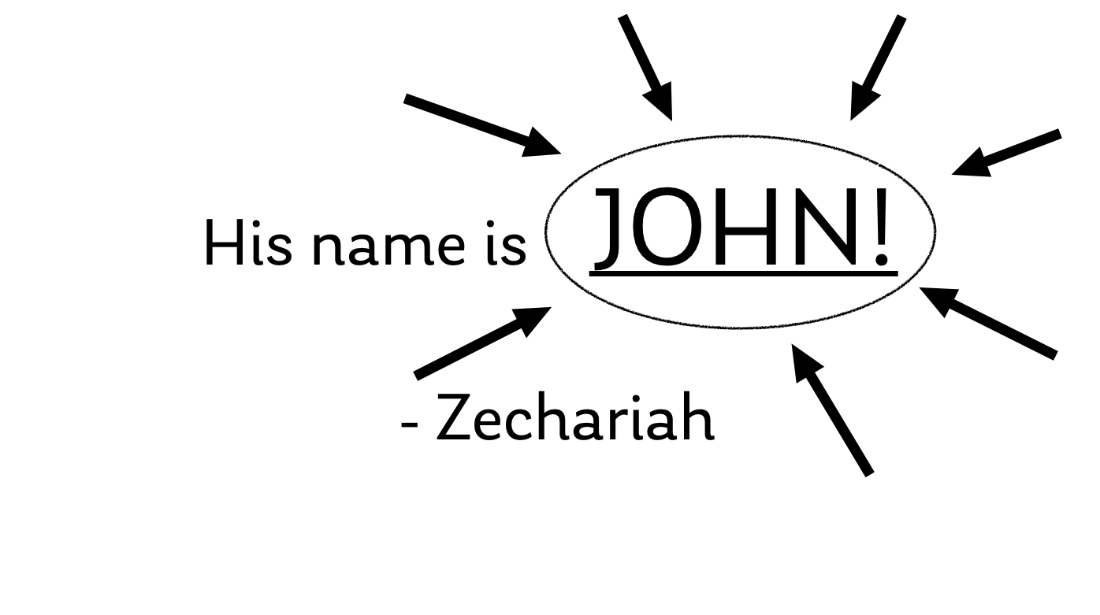
Y’all, that’s a spiritual discipline that serves as a powerful antidote to our weariness, despair, and cynicism. You see, in today’s passage, the people stand in amazement when Zechariah agrees with his wife’s assertion, or, rather, the angel Gabriel’s assertion, that the child be named John. The custom of the day would usually have the child named after his father. But my this time, I suspect Zechariah has learned his lesson during his forced silent retreat. He finally comes to understand that he is not in the driver’s seat in this divine story. He follows his wife’s lead, and the Spirit’s lead, and gives into the holy mystery of all that is happening around him.
“His name…is John.” He writes on the writing tablet. I imagine he probably circled the name “John” approximately three times and underlined it with little arrows pointing at it from all directions to make sure everyone gets the memo! And in that moment, his mouth is opened. At long last, his ability to speak - and sing - is restored. In that moment, he could have chosen any number of responses with his newly freed lips. He could have shaken his fists and the heavens and condemned God for his sentence. He could have finally listed off ten reasons for why he didn’t deserve his muted punishment. He could have listed off every complaint he had or told off the spectators who doubted his wife’s wishes.
But he does none of that. Instead, the text tells us, his mouth opens in praise. And that, my friends, is the heart of this passage. Because praise is nothing more, or less, than our faithful response “when it’s beyond us.” Praise is our song when we have an abiding sense that we are part of something beyond our comprehension, beyond our deserving, beyond our ability to fully express. But we do our best. We sing songs and pray prayers and preach sermons. We create beautiful new liturgical art such as the one you see hung up before you today. We put on timeless Christmas pageants and decorate with poinsettias in memory or in honor of those who have loved us into being. We give of our tithes and our pledges to support the ministries of God’s Church. We give our pennies to feed the hungry. We visit and feed those who are sick, alone, or grieving.
All of these things, my friends, are acts of praise that are responses to our amazement at God moving in this weary world.
And so, my neighbors, your homework assignment is as follows: be amazed. Every day, between now and Christmas Day, I invite you to look around your world and find something that you’ve perhaps previously overlooked that is simply amazing. Something beautiful. Something mysterious. Something that captures your imagination and makes you go “wow.” And then I want you to share that thing with someone close to you, a neighbor, a friend, your spouse, children, or parents.
And so, I’m going to share with you mine. Yesterday, I went to the science center with my family and we found my favorite animals in the whole place, upside-down jellyfish. They live their lives upside-down like this because they have a symbiotic relationship with a kind of algae that lives on their tentacles, and the algae requires sunlight to grow. So they adapted, over the millennia, to do things differently to survive and thrive. I don’t know why, but that just amazes me!
So friends, let us follow the Spirit’s lead. Let us follow Elizabeth’s lead. Let us follow Mary Oliver’s lead. Let us pay attention. Let us be amazed. And let us tell about it!
In the name of God the Creator, Redeemer, and Sustainer, may all of us, God’s children, say: Amen.

