2nd Sunday after Pentecost (Year A)

__________________________________________________________________________________________

Genesis 4:1-16

Now the man knew his wife Eve, and she conceived and bore Cain, saying, ‘I have produced a man with the help of the Lord.’ Next she bore his brother Abel. Now Abel was a keeper of sheep, and Cain a tiller of the ground. In the course of time Cain brought to the Lord an offering of the fruit of the ground, and Abel for his part brought of the firstlings of his flock, their fat portions. And the Lord had regard for Abel and his offering, but for Cain and his offering he had no regard. So Cain was very angry, and his countenance fell. The Lord said to Cain, ‘Why are you angry, and why has your countenance fallen? If you do well, will you not be accepted? And if you do not do well, sin is lurking at the door; its desire is for you, but you must master it.’
Cain said to his brother Abel, ‘Let us go out to the field.’ And when they were in the field, Cain rose up against his brother Abel and killed him. Then the Lord said to Cain, ‘Where is your brother Abel?’ He said, ‘I do not know; am I my brother’s keeper?’ And the Lord said, ‘What have you done? Listen; your brother’s blood is crying out to me from the ground! And now you are cursed from the ground, which has opened its mouth to receive your brother’s blood from your hand. When you till the ground, it will no longer yield to you its strength; you will be a fugitive and a wanderer on the earth.’ Cain said to the Lord, ‘My punishment is greater than I can bear! Today you have driven me away from the soil, and I shall be hidden from your face; I shall be a fugitive and a wanderer on the earth, and anyone who meets me may kill me.’ Then the Lord said to him, ‘Not so! Whoever kills Cain will suffer a sevenfold vengeance.’ And the Lord put a mark on Cain, so that no one who came upon him would kill him. Then Cain went away from the presence of the Lord, and settled in the land of Nod, east of Eden.
Ephesians 4:25-32
So then, putting away falsehood, let all of us speak the truth to our neighbors, for we are members of one another. Be angry but do not sin; do not let the sun go down on your anger, and do not make room for the devil. Thieves must give up stealing; rather let them labour and work honestly with their own hands, so as to have something to share with the needy. Let no evil talk come out of your mouths, but only what is useful for building up, as there is need, so that your words may give grace to those who hear. And do not grieve the Holy Spirit of God, with which you were marked with a seal for the day of redemption. Put away from you all bitterness and wrath and anger and wrangling and slander, together with all malice, and be kind to one another, tender-hearted, forgiving one another, as God in Christ has forgiven you.
__________________________________________________________________________________________
“Pastor Stephen, what do I do when I feel true, deep-seeded hatred for another person and am unable to feel even the smallest amount of love towards them?” That was one of the suggestions for this sermon series offered to me anonymously by one of our youth. And I love this question, not only for its honesty, but because of just how relevant it is for our current context. For who among us doesn’t know that struggle?
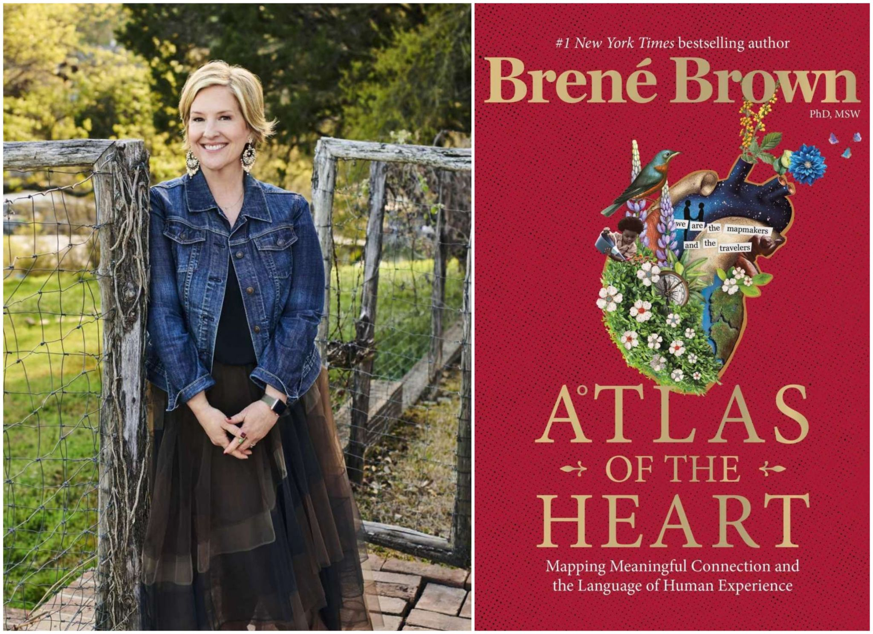
Well, let’s start from the beginning. Hate: what is it and why do we do it?
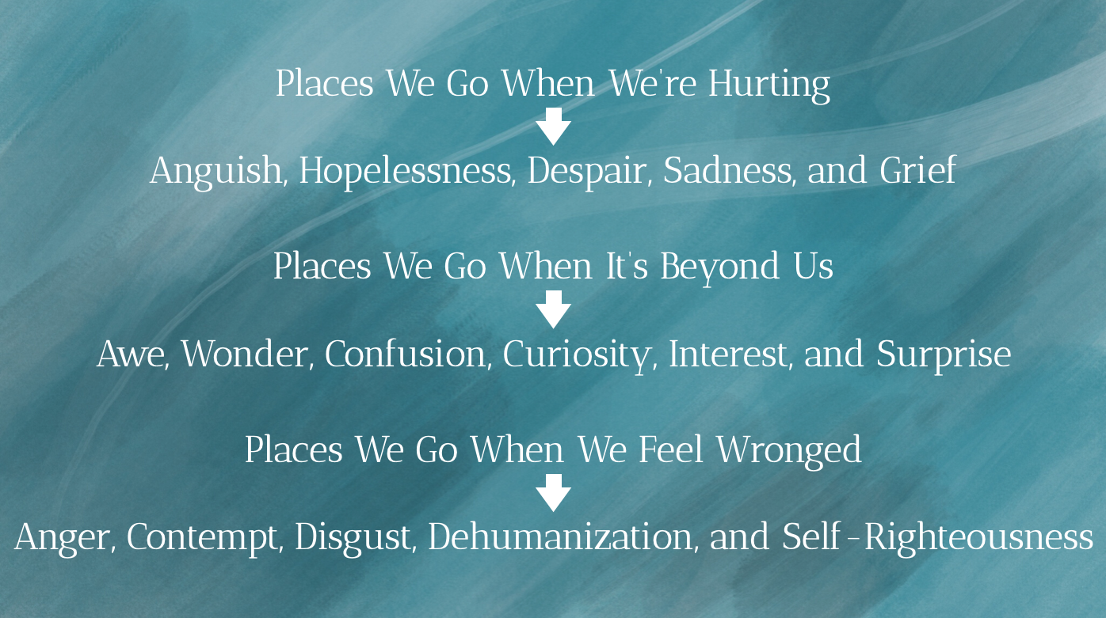
In her book Atlas of the Heart (which I mentioned in last week’s sermon), Brené Brown explores 87 different emotions and categorizes them into “destinations” in our heart.
For example, she categorizes the emotions of anguish, hopelessness, despair, sadness, and grief as “places we go when we’re hurting.” She categorizes the emotions of awe, wonder, confusion, curiosity, interest, and surprise as “places we go when it’s beyond us.” Hatred, along with the other emotions of anger, contempt, disgust, dehumanization, and self-righteousness, are “places we go when we feel wronged.”
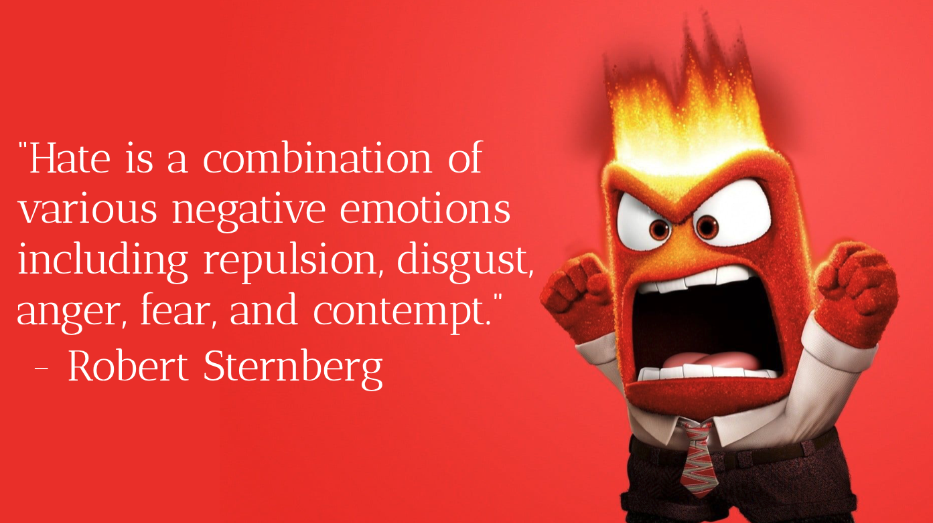
In her chapter on the subject, Brené Brown adopts researcher Robert Sternberg’s definition of hatred as follows:
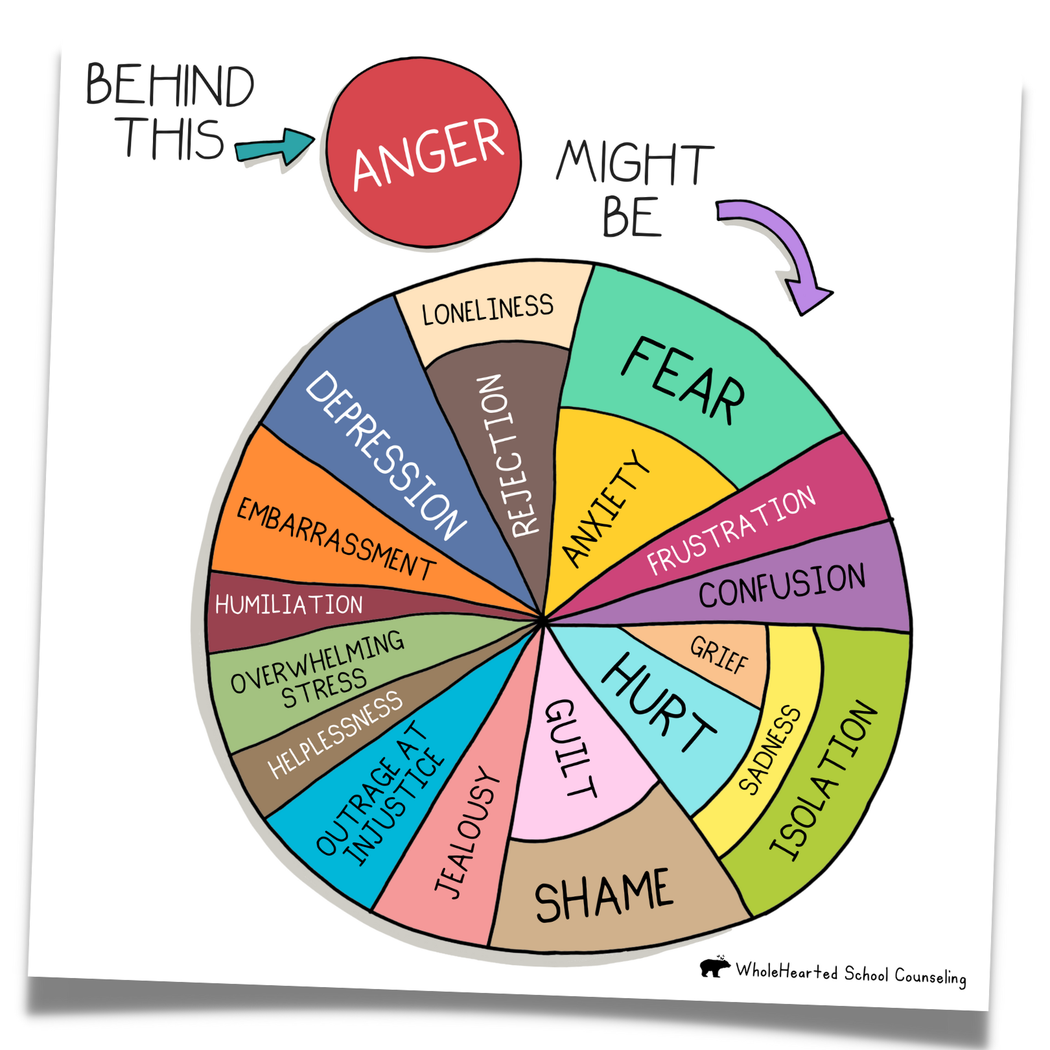
“Hate is a combination of various negative emotions including repulsion, disgust, anger, fear, and contempt.”
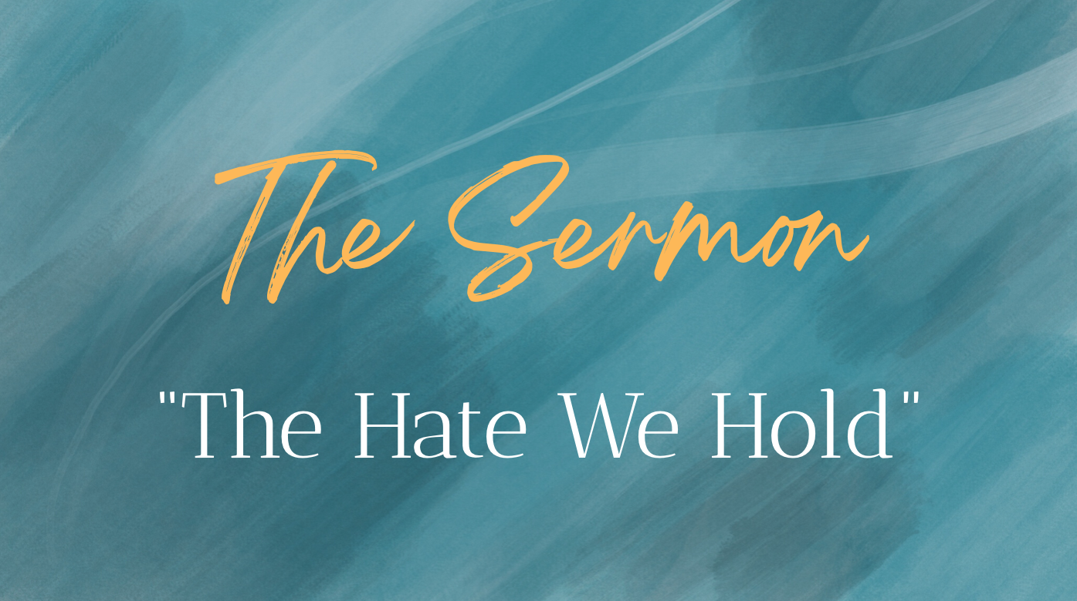
I tend to agree with Brené Brown’s assertion that hate tends to be a secondary emotion, that is to say that, more often than not, what lies “beneath” hate is a whole lot of other emotions such as anxiety, depression, stress, guilt, shame, outrage at injustice, just to name a few. But many of these emotions are closely connected with fear. We hate someone because we fear that who they are or what they believe or what they do threatens us. Hate, it turns out, is a powerful motivator. Hate can be a catalyst for change, either good or ill. But Brené Brown reminds us that while hate, and it’s near-cousin, anger, can spark change, they are not the change! In other words, anger and hate can be the part of positive social change but any movement that only utilizes those tools in it’s tool belt is bound to fail.
So, again, I don’t want us to approach today’s topic from a stance of “hate is bad.” Rather, I want us to adopt the posture that hate is an emotion, along with the 86 other emotions Brené Brown describes in her book, that are all of them - each and every one of them - a normal part of the human experience. But what makes us better human beings, more kind human beings, more loving human beings, is when we train ourselves to respond to hate in ways that interrupt cycles of violence that have become all too familiar in our world.
Now I want us to approach hate from two perspectives: the hate one individual feels towards another and the hate one group of people feel towards another. The story of Genesis 4 will guide us through the topic of individual hate and text of Ephesians 4 will guide us through the topic of communal hate.
While the word itself does not appear in the Genesis text, I feel it’s rather safe to assume that Cain hated Abel. To use Brené Brown’s metaphor of hate, Cain was definitely in a place where he felt wronged. He was a lover of things that grow and therefore tended the fields while his brother, Abel kept the sheep. Two brothers, two offerings, and one God who, on that day at least, preferred one over the other. Now, I trust most of us know the story well: A) the brothers give their offerings and God prefers one over the other, and the B) Cain kills Abel. But there’s a very important part of the story have happens between those two plot points that makes all the difference in our interpretation.
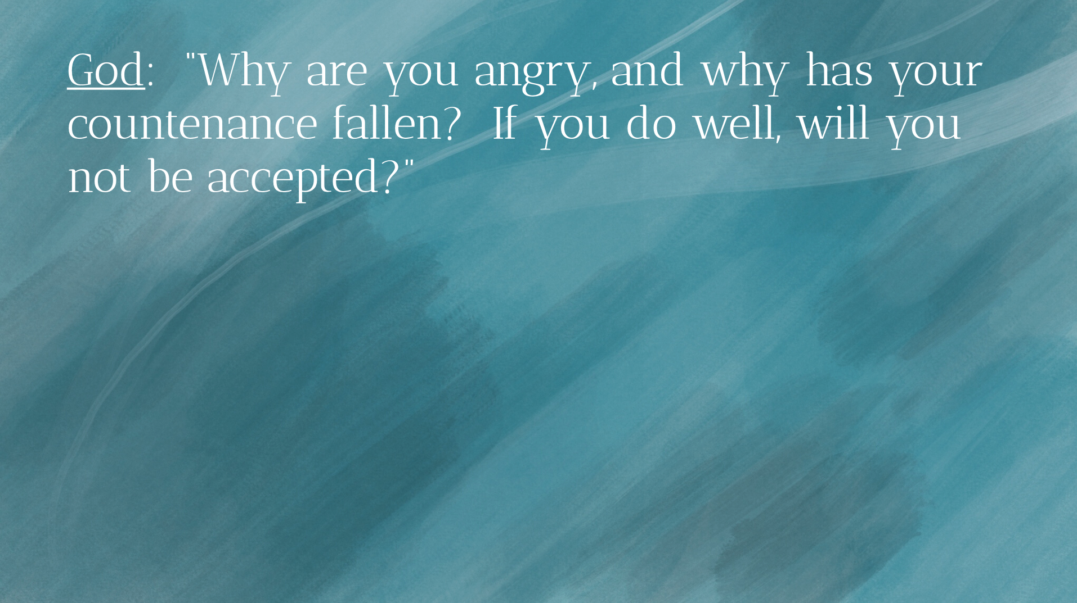
Before Cain has an opportunity to respond to his hatred, God intervenes. God notices Cain’s fury and attempts to have a conversation with him:
“Why are you angry, and why has your countenance fallen? If you do well, will you not be accepted?”
This verse tells us a very important part of the story: God tries to talk with Cain about his feelings. We might be tempted to think that God is a cruel God who doesn’t care for Cain but this verse actually challenges that notion. Because what we see here is a God who is concerned enough about Cain’s wellbeing - and that of his brother, too, most likely - to open a dialogue with him.
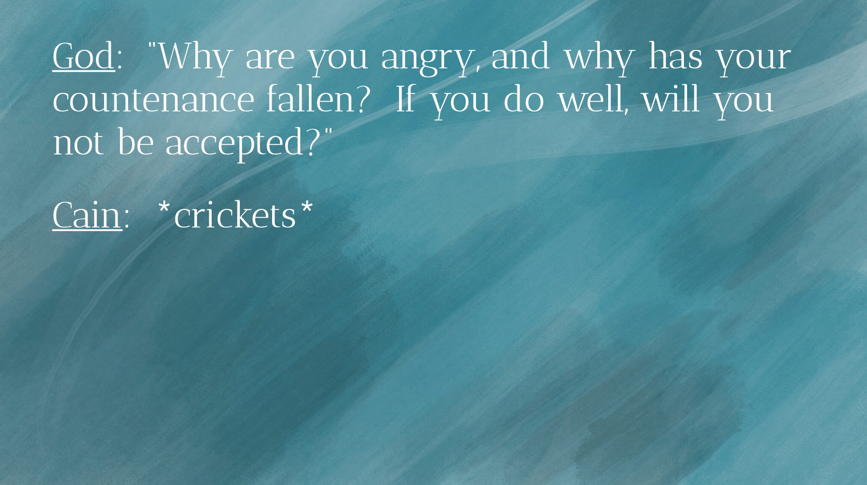
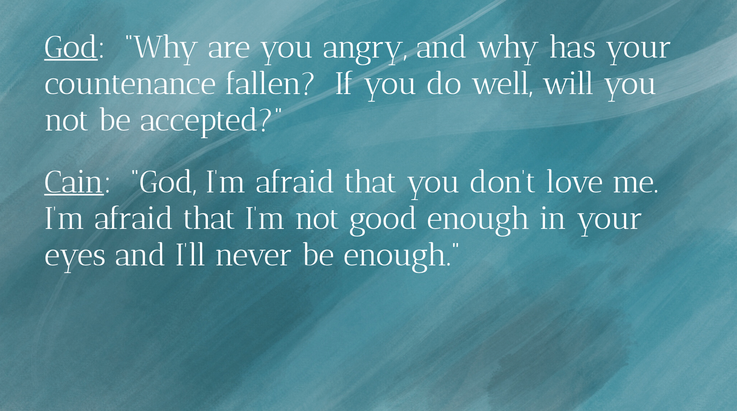
But the text gives us no response from Cain. And this is why Cain’s next move was murder. You see, you and I might imagine what would have happened differently if Cain had accepted God’s invitation to dialogue. He could have said,
“God, I’m afraid that you don’t love me. I’m afraid that I’m not good enough in your eyes and I’ll never be enough.” Notice I’m using the language of “fear” because that’s usually what fuels hatred and anger. And we might imagine God’s response: “You know, kid, I just wasn’t in the mood for asparagus today. Your brothers’ roasted lamb was just too good to pass up. But, you know what? Those tomatoes you’re growing are looking perfect so why don’t you try again tomorrow and, who knows, I just may be in the mood for something different?”
I say all this to suggest that the first step in choosing healthy ways to respond to hate is to explore it. Don’t pretend that it’s not there. Be curious about it. Explore it. Talk about it. If Cain had had the courage to talk to God about his fury, he might have discovered that there was a way to resolve the conflict without murdering someone who, truth be told, did nothing wrong. It is our responsibility, my friends, to process our hate in ways that don’t turn our neighbors into collateral damage.
How do we do that?
Well, a few things that are working for me these days. Again, this list is neither exhaustive or universal, but it’s working for me and I invite you to find what works for you.
The first is the same thing I recommended first last week: THERAPY! I’m convinced that so many of our nation’s problems would be solved if everyone saw a therapist. Yes, I know I’m biased, both because I have a therapist and I’m married to one! But emotional awareness, intelligence, and curiosity are essential to growing together as more compassionate, courageous, and loving human beings. And therapy is a powerful tool and is, frankly, one of the best gifts you can give not only to yourself but to those you love.
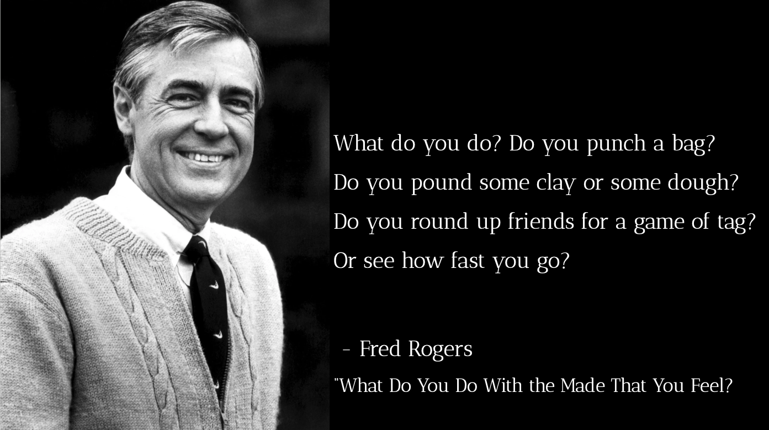
The second thing I’ll suggest is physical exercise, to the extent that you’re able to do so. I recognize that we are all differently abled and that running a marathon or swimming a mile isn't on the menu for all of us. But to the extent to which you’re able, keep your body in motion and treat “the soft animal of your body” (as Mary Oliver would say) with gentleness and kindness. Anger, fear, hate, anxiety, all of these things have a very physical impact on our bodies. The hate we hold is a heavy burden and we have scientific research that suggests that it can negatively affect our health by raising our blood pressure, compromising our immune system, and in general decreasing our quality of life. Physical exercise can be a healthy way to mitigate anger, stress, and hatred. There’s a reason Mister Rogers sang the following in “What Do You Do With the Mad You Feel?”
What do you do? Do you punch a bag?
Do you pound some clay or some dough?
Do you round up friends for a game of tag?
Or see how fast you go?
Mister Rogers knew that physical activity helps regulate emotions for children. And, guess what? That fact doesn’t change when we become adults!
The third thing I’ll suggest to help process our hate in ways that build up the community instead of harm it is the following: explore ways to redirect that energy to something that healthy for you and the neighborhood. Take that hate and the energy that it causes to bubble up inside of you and put that into a project. Volunteer here at the church or get involved in another local non-profit. Start a project. Write a book. Learn a new hobby. Find productive ways to channel your hate to improve yourself and build up the neighborhood.
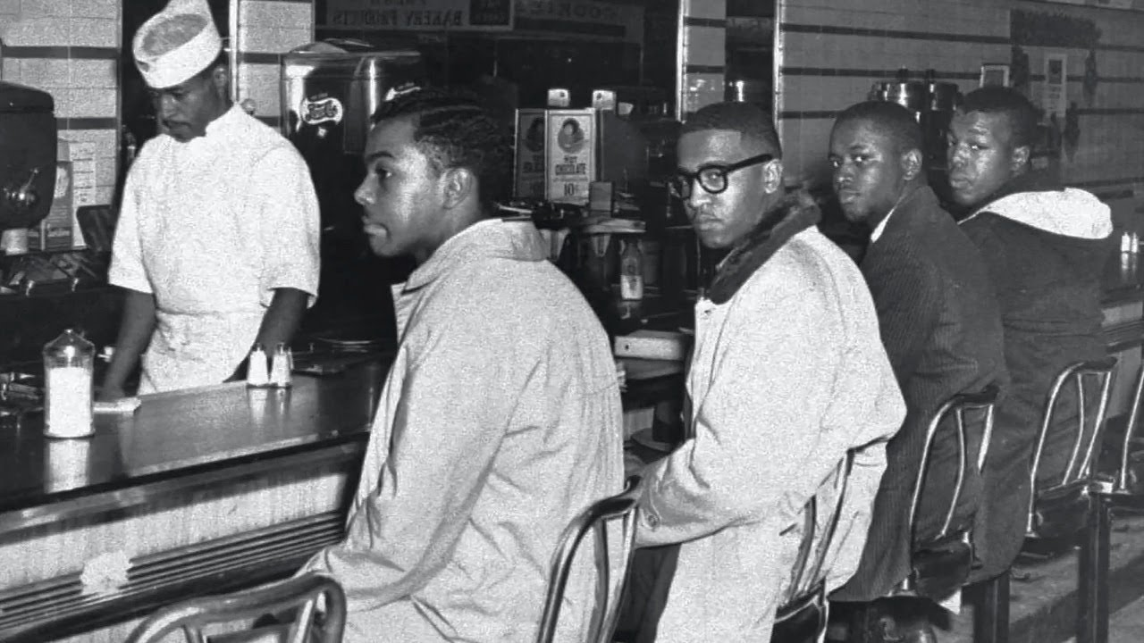
So if Genesis passage gives us insight to how to deal with hate on an individual level, the Ephesians passage talks about hate and anger on a communal level. Paul is writing to an early Christian community and the predominant theme for the letter in its entirety is Christian unity. Because Paul knows that the biggest threats to unity are the things he mentions: bitterness, wrath, anger, wrangling, slander, and malice (all things that are byproducts of hatred given the chance to fester). But earlier in the passage Paul says a peculiar thing: be angry. Isn’t that an interesting thing? In this passage Paul says two seemingly antithetical statements. First he says “be angry” and then he says to “put aside anger.” I think that’s because Paul knew that in order to set anger and hate aside, we first have to acknowledge it and process it in healthy ways. Be angry, Paul says, but then he follows that statement with four very important words: but do not sin.

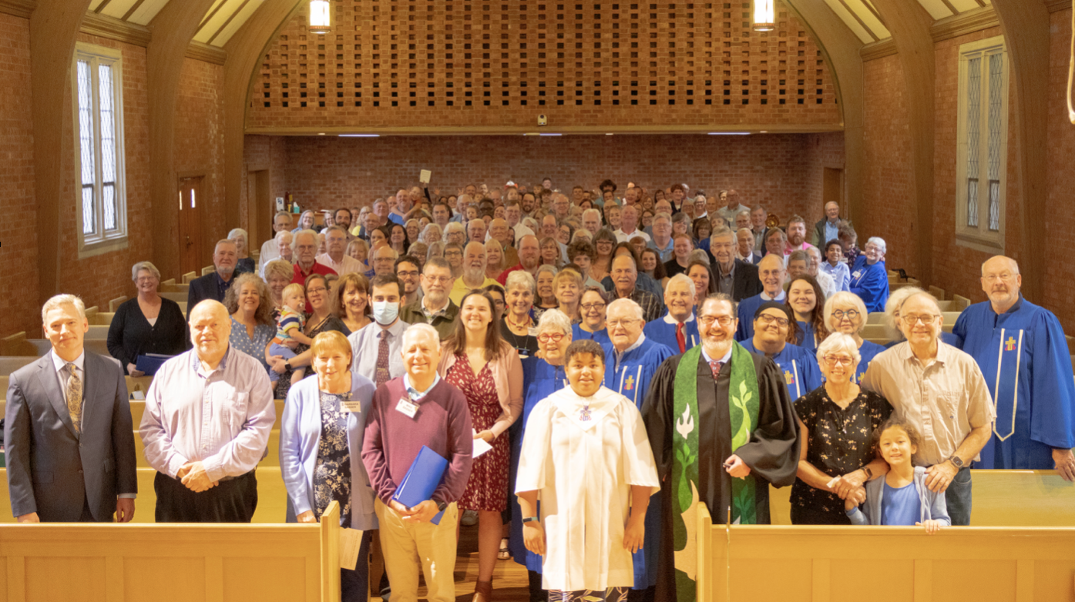
Friends, there is a time and a place for righteous anger. Non-violent protests, such as those at the Woolworth Store a few miles from here, are concrete actions rooted in anger; specially, anger over an injustice. But the practice of non-violent protest is a concrete way of channeling that anger ways that solves the issue without drawing blood or furthering cycles of violence.
Another act of non-violent protest is what we’re doing right now. We gather together as a community not unlike those who were the original recipients of Paul’s letter to the Ephesians. We gather, as Paul says, to put aside falsehood and to speak the truth to one another; the truth that we are each others keepers, that we are members of one another. You see, Cain didn’t realize this. Rather, he believed the lie that states the exact opposite. Remember, God asks Cain where his brother was and he arrogantly replies, “I don’t know; am I my brother’s keeper?!”
Friends, we are each other’s keepers. And that means that we are responsible for dealing with the hate we hold in healthy ways. This is not an optional part of being a Christian; it is, rather, the very heart of what it means to be a follower of Christ. Jesus got angry, y’all; angry enough to throw over tables.
But we must never forget the story of the Garden of Gethsemane, when Peter allowed his hatred to unsheathe his sword and strike one of the guards arresting Jesus. Jesus said to Peter, “Put it away. That’s not how we do things around here. The rest of the world may hate with reckless abandon but I expect more of those who choose to follow me.”
You know, I’ll never forget the first time I swam a mile at the Lexington Athletic Club in Lexington, KY. I had been swimming for a few months and at the beginning the thought of swimming a mile seemed ludicrous to me, an unfathomable distance swum by professional athletes and in people in much better shape than me. But I did it. I still have much room to improve; I don’t swim a very fast mile. But I can do it. And you know how I did it? Stroke by stroke. Lap by lap. Day by day.
It’s the same way with dealing with the hate we hold. It takes time. It takes practice. But, above all, it takes intentionality. And it takes a neighborhood committed to the practice. Let’s be that here at Guilford Park Presbyterian Church and in our fine city.
In the name of God the Creator, Redeemer, and Sustainer, may all of us, God’s children, say: Amen.

Brown, p. 226.
https://www.psychologytoday.com/us/blog/the-mind-body-connection/202007/what-causes-anger-and-how-it-affects-the-body
http://www.neighborhoodarchive.com/music/songs/what_do_you_do.html

