13th Sunday after Pentecost (Year B)

__________________________________________________________________________________________

John 4:5-42

So he came to a Samaritan city called Sychar, near the plot of ground that Jacob had given to his son Joseph. Jacob’s well was there, and Jesus, tired out by his journey, was sitting by the well. It was about noon.

A Samaritan woman came to draw water, and Jesus said to her, ‘Give me a drink’. (His disciples had gone to the city to buy food.) The Samaritan woman said to him, ‘How is it that you, a Jew, ask a drink of me, a woman of Samaria?’ (Jews do not share things in common with Samaritans.) Jesus answered her, ‘If you knew the gift of God, and who it is that is saying to you, “Give me a drink”, you would have asked him, and he would have given you living water.’ The woman said to him, ‘Sir, you have no bucket, and the well is deep. Where do you get that living water? Are you greater than our ancestor Jacob, who gave us the well, and with his sons and his flocks drank from it?’ Jesus said to her, ‘Everyone who drinks of this water will be thirsty again, but those who drink of the water that I will give them will never be thirsty. The water that I will give will become in them a spring of water gushing up to eternal life.’ The woman said to him, ‘Sir, give me this water, so that I may never be thirsty or have to keep coming here to draw water.’

Jesus said to her, ‘Go, call your husband, and come back.’ The woman answered him, ‘I have no husband.’ Jesus said to her, ‘You are right in saying, “I have no husband”; for you have had five husbands, and the one you have now is not your husband. What you have said is true!’ The woman said to him, ‘Sir, I see that you are a prophet. Our ancestors worshipped on this mountain, but you say that the place where people must worship is in Jerusalem.’ Jesus said to her, ‘Woman, believe me, the hour is coming when you will worship the Father neither on this mountain nor in Jerusalem. You worship what you do not know; we worship what we know, for salvation is from the Jews. But the hour is coming, and is now here, when the true worshippers will worship the Father in spirit and truth, for the Father seeks such as these to worship him. God is spirit, and those who worship him must worship in spirit and truth.’ The woman said to him, ‘I know that Messiah is coming’ (who is called Christ). ‘When he comes, he will proclaim all things to us.’ Jesus said to her, ‘I am he, the one who is speaking to you.’

Just then his disciples came. They were astonished that he was speaking with a woman, but no one said, ‘What do you want?’ or, ‘Why are you speaking with her?’ Then the woman left her water-jar and went back to the city. She said to the people, ‘Come and see a man who told me everything I have ever done! He cannot be the Messiah, can he?’ They left the city and were on their way to him.

Meanwhile the disciples were urging him, ‘Rabbi, eat something.’ But he said to them, ‘I have food to eat that you do not know about.’ So the disciples said to one another, ‘Surely no one has brought him something to eat?’ Jesus said to them, ‘My food is to do the will of him who sent me and to complete his work. Do you not say, “Four months more, then comes the harvest”? But I tell you, look around you, and see how the fields are ripe for harvesting. The reaper is already receiving wages and is gathering fruit for eternal life, so that sower and reaper may rejoice together. For here the saying holds true, “One sows and another reaps.” I sent you to reap that for which you did not labour. Others have laboured, and you have entered into their labour.’
Many Samaritans from that city believed in him because of the woman’s testimony, ‘He told me everything I have ever done.’ So when the Samaritans came to him, they asked him to stay with them; and he stayed there for two days. And many more believed because of his word. They said to the woman, ‘It is no longer because of what you said that we believe, for we have heard for ourselves, and we know that this is truly the Saviour of the world.’
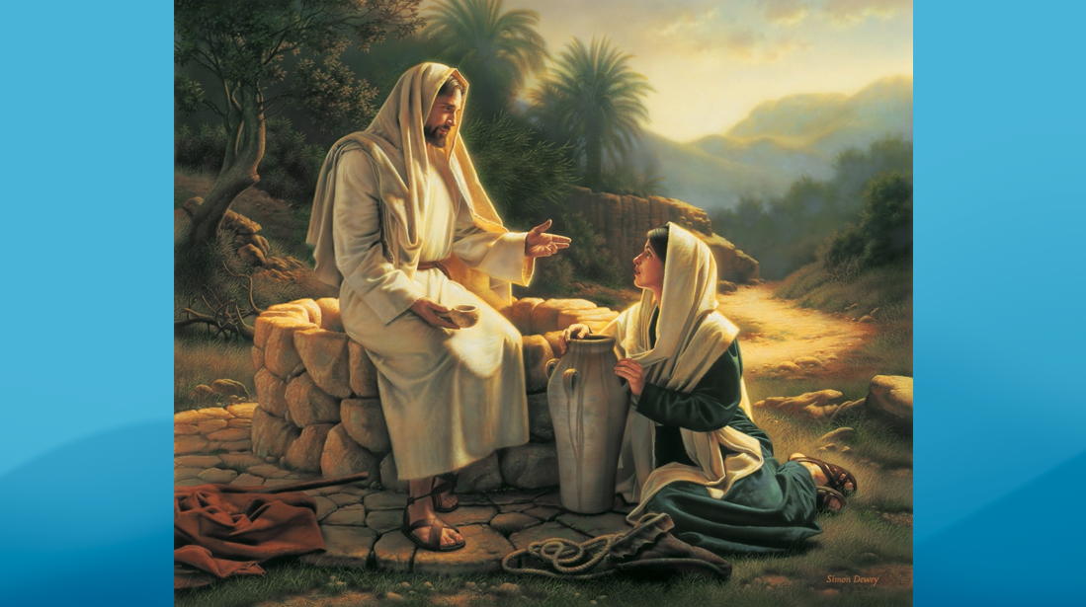
__________________________________________________________________________________________

“Will you give me a drink?” That is the question asked of the woman in this artistic depiction of today’s story. I found this picture of the story of Jesus and the Samaritan woman at the well by googling it and this happened to be the first image that popped up. What I find most obvious about this painting is the body language of the two characters depicted in it. The unnamed woman, who has one of the most detailed conversations with Jesus in any of the four Gospels, is depicted on the ground. As such, Jesus has to literally “talk down” to her. Notice, nowhere in the text does it suggest that the woman was on the ground and Jesus was above her and yet there are many artistic depictions that block the scene that very way.
I want us to explore for a moment why it is that the artist depicted Jesus talking down to the woman. I don’t mean to vilify the artist who created this image or in any way to suggest that there was malicious intent to this piece of art. But I want to focus on it as a means to draw our attention to the ways that the people in this woman’s neighborhood talked down to her and the ways that interpreters of this text over the centuries have similarly placed her in a position of shame and lowliness.
Samaritans were constantly “talked down to.” They were considered dirty, sinful, and a nuisance. For this reason, although Samaria occupied a space between Judea and Galilee, Jews would often deliberately take the longer route around to avoid their Samaritans neighbors.
Secondly, she was a woman. Alone. For any man to engage with a woman in public on a one-on-one basis was taboo at best and downright scandalous at worst.
And thirdly, she had been married five times. And that little fact has caused the Samaritan woman to shoulder the burden of two thousand years of patriarchal assumptions. Who knows? Maybe that’s the reason she’s on the ground in the first place. That’s a heavy load to carry, my friends. And, as a man, I’ll be honest that I don’t know what that load feels like. But I know it when I see it. And I see it in the Samaritan woman.
And we can lighten the load for her - and for the women and girls among us - by reminding ourselves that there could have been several reasons she had five husbands, a none of them could have had anything to do with sexual promiscuity.
She could have been in abusive relationships.
She could have been barren, and without the ability to produce children, she was seen as worthless and passed from husband to husband with no other way to support herself.
Or, one or more of her husbands could have died, with the law of that day obligating the man’s brothers to claim her as their spouse.
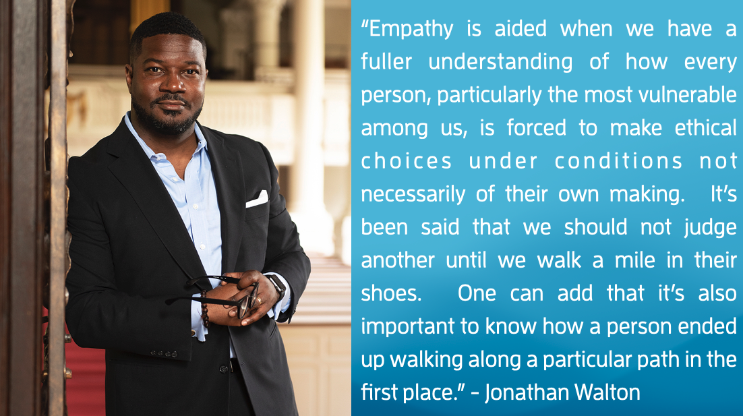
Any of these reasons, or a combination of them, could have led to her situation. But as is so often true of ourselves, we assume the worst of our neighbors, leaving little room for holy curiosity.

Jonathon Walton says the following of empathy: “Empathy is aided when we have a fuller understanding of how every person, particularly the most vulnerable among us, is forced to make ethical choices under conditions not necessarily of their own making. It’s been said that we should not judge another until we walk a mile in their shoes. One can add that it’s also important to know how a person ended up walking along a particular path in the first place.”
Neighbors, might we be curious together as to why this woman was walking this particular path in the first place? A particular path to a well all by herself in the middle of the day, a time when all other folks avoided the well, having collected their water in the cool early hours of the day. Perhaps it was that holy curiosity that led Jesus not to a place of judgment, but to a place of authentic connection and community.
You see, Jesus assumes a far different posture with her than the Samaritan woman was used to. Which is probably why she’s so caught off guard by his question: “Will you give me a drink?” She’s expecting another harassment, another snide comment, another upturned nose or side-eyed glance. But she gets none of that from Jesus. He doesn’t accuse her of wrongdoing. He doesn’t shame her or cajole her. He doesn’t even ask why it is that she is clearly trying to avoid human interaction. He doesn’t even care to ask why it is that she’s had five husbands or why she evades his question at first. He doesn’t care. She’s alone and marginalized. And, frankly, that’s all Jesus needs to know that this is a ministry opportunity.
But there’s actually a very human thing that happens here that’s somewhat unlike John. You’d expect it from Matthew or Luke maybe, and definitely Mark, but not John. You see, Jesus is exhausted and thirsty, two very human conditions. And so he asks a simple, human question: “will you give me a drink?”
And that one question sets the tone for a very different kind of conversation. He doesn’t ask, “why are you here?” Instead he says, “I have a need and you can help me.” And that’s a gutsy question. You see, those of us in dominant spaces sometimes don’t like to ask our marginalized neighbors if there’s something they can help us with. Because we like to be saviors. We like to be in control. We so often tell ourselves that we are the ones that bring the value to the conversation.
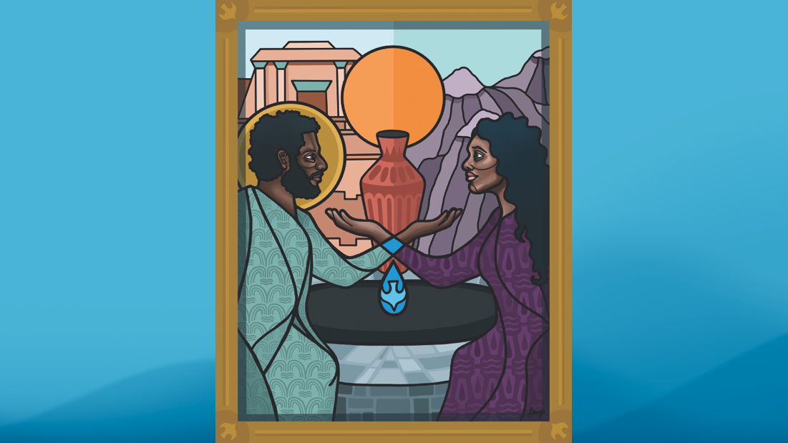
Here, Jesus flips the script. In asking “will you give me a drink,” he’s acknowledging that there’s something this woman, who has been cast aside her whole life, can do to help him and bless him. And so, from the get-go, the Samaritan Woman knows that this conversation is going to go very differently than those she’s had with her neighbors.

And now I want to share with you another painting that demonstrates just how differently this conversation is going to end up for her and Jesus, the image you’ll find on the front of today’s bulletin.
This depiction of this same story is by a colleague of mine, the Rev. Lauren Wright Pittman. In stark contrast to the first piece of artwork, the Samaritan woman is not cast on the ground, sitting at Jesus’ feet. Instead, my sister colleague envisions them eye-to-eye, sitting as equals, in a stance of mutuality. And that mutuality is remarkable given the culture divide that existed between these two characters. In the upper left, you see the Temple, where the Jews worshipped. And in the upper right is Mt. Gerizim, where the Samaritans worshiped. You’ll also notice a subtle difference in color hue down the middle. But in the foreground this Jew and this Samaritan cross those boundaries over the waters of their baptism. Isn’t that a beautiful image, my neighbors?
But, I gotta admit y’all, if I am to try to put myself in the shoes of the Samaritan woman, that mutuality makes me a little uncomfortable. You know why? Because I love to sit at the feet of Jesus; but I don’t always enjoy looking him eye-to-eye! Because when I just sit at the feet of Jesus, all I gotta do is listen. But when he calls me eye-to-eye, well that’s when the rubber meets the road; that’s where risk enters the equation; that’s where growth enters the equation; that’s the messy and wonderful dance floor where vulnerability and courage decide to tango. And that requires me to give up some of my comfort. That requires me to admit that I don’t have all the answers. That requires me to go out on a limb for the Gospel. That requires me to change.
But Jesus trusted this woman to rise to the task. And I’m convinced that she did so because the fertile fields of mutuality had been fertilized. Jesus needed something from her; the man was thirsty. And she needed something from him; she needed less shame and more truth. She needed less condemnation and more Spirit. She needed that living water that fed the parched places of her heart. She needed a new identity other than the one thrust upon her: a worthless, washed-up divorced woman. Instead Jesus gave her a new identity; beloved.
And with that identity, Jesus asked one thing more of her: that she go out and seek the very people she had avoided that day and to tell them who he was. Because Jesus trusted this woman to be the first person to hear these three sacred words from his mouth: I Am He.
I struggle, y’all. I want to stay at the feet of Jesus. I want to listen. I want to learn. But when he calls me eye-to-eye and tells me who he really is, and by extension, who he’s really calling me to be, that’s where I’m taken out of my safety zone. That’s where I go from preaching to practice, from avoiding connection to seeking it out, even and especially with people who are different than me!
But friends, I’m finding courage today. I’m finding courage in this woman. I’m finding courage in her testimony. I’m finding courage in the fact that she left that water-jar because that freed up her hands to do the real work of ministry. She no longer needs those water vessels because now she’s the vessel; carrying the good news of a man who knows the messy parts of our lives but asks us for a drink anyways! Because she understood that a burden had been lifted from those shoulders that were certainly sore from bearing those water-jars in the heat of the day for countless weeks, months, and years. And she knew she would never be the same.
And neither can we, dear neighbors, ever be the same. Not once Jesus has called us from his feet and looked us eye-to-eye and called us beloved. It’s time for us to look our neighbor eye-to-eye, and give them that same life-giving, culture-changing, boundary-breaking blessing.
In the name of God the Creator, Redeemer, and Sustainer, may all of us, God’s beloved children say: Amen.

https://www.pulpitfiction.com/notes/lent3a
Walton, 135.

