3rd Sunday after the Epiphany (Year A)

__________________________________________________________________________________________

Matthew 4:12-23

Now when Jesus heard that John had been arrested, he withdrew to Galilee. He left Nazareth and made his home in Capernaum by the lake, in the territory of Zebulun and Naphtali, so that what had been spoken through the prophet Isaiah might be fulfilled:
‘Land of Zebulun, land of Naphtali, on the road by the sea, across the Jordan, Galilee of the Gentiles—
the people who sat in darkness have seen a great light, and for those who sat in the region and shadow of death light has dawned.’ From that time Jesus began to proclaim, ‘Repent, for the kingdom of heaven has come near.’
As he walked by the Sea of Galilee, he saw two brothers, Simon, who is called Peter, and Andrew his brother, casting a net into the lake—for they were fishermen. And he said to them, ‘Follow me, and I will make you fish for people.’ Immediately they left their nets and followed him. As he went from there, he saw two other brothers, James son of Zebedee and his brother John, in the boat with their father Zebedee, mending their nets, and he called them. Immediately they left the boat and their father, and followed him.
Jesus went throughout Galilee, teaching in their synagogues and proclaiming the good news of the kingdom and curing every disease and every sickness among the people.
__________________________________________________________________________________________
I’d like to open my sermon this Sunday with a very brief clip from a video series I’ve used in Elder training with the newest class of elders. In it, you’ll see a colleague of mine, the Rev. Landon Whitsitt, talk a bit about how we view this thing called ministry in the Presbyterian Church. And, in particular, the importance of debunking a common myth about the way we order the Church in this denomination.
(Show clip from 1:37-3:13)

We believe everyone has been called to ministry.
Say it with me: We believe everyone has been called to ministry.
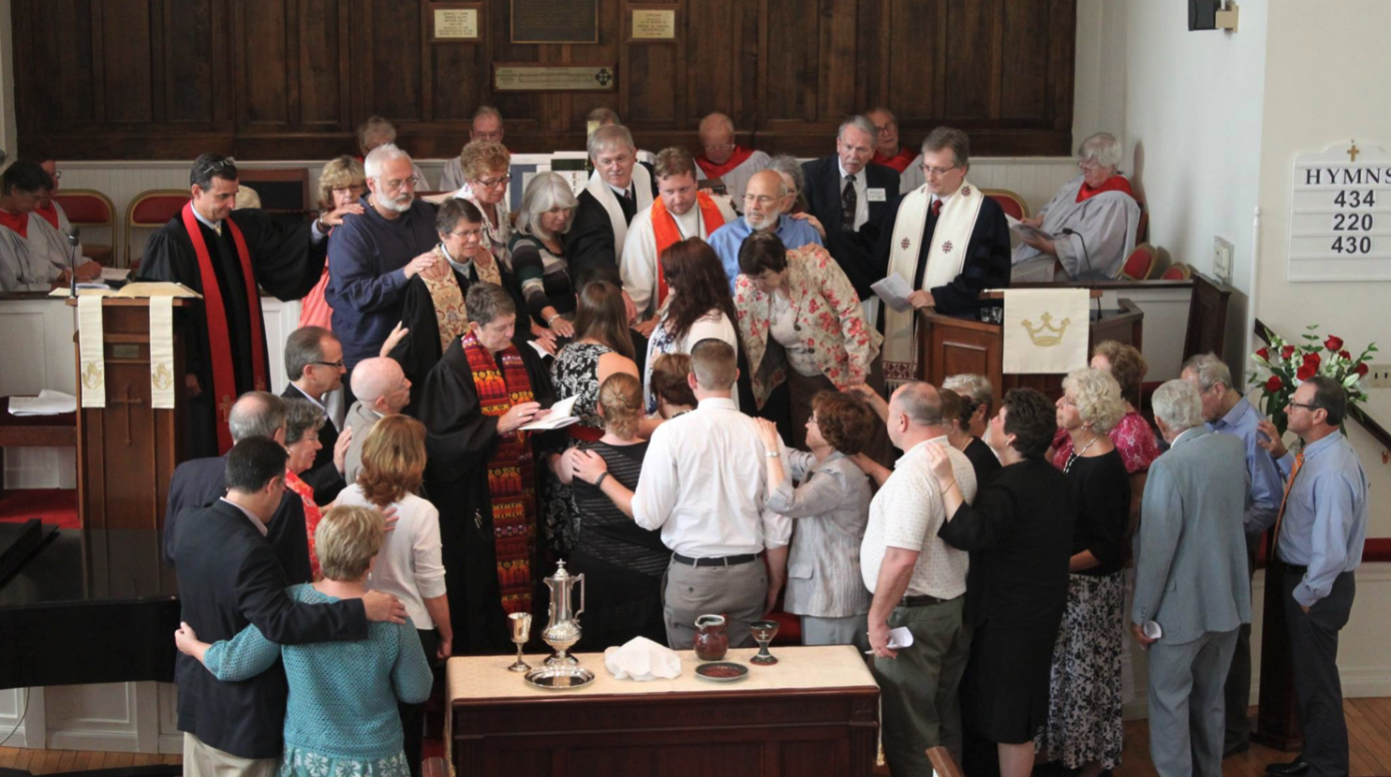
If you remember nothing else from this sermon or today’s service, remember those eight words, “We believe everyone has been called to ministry.”
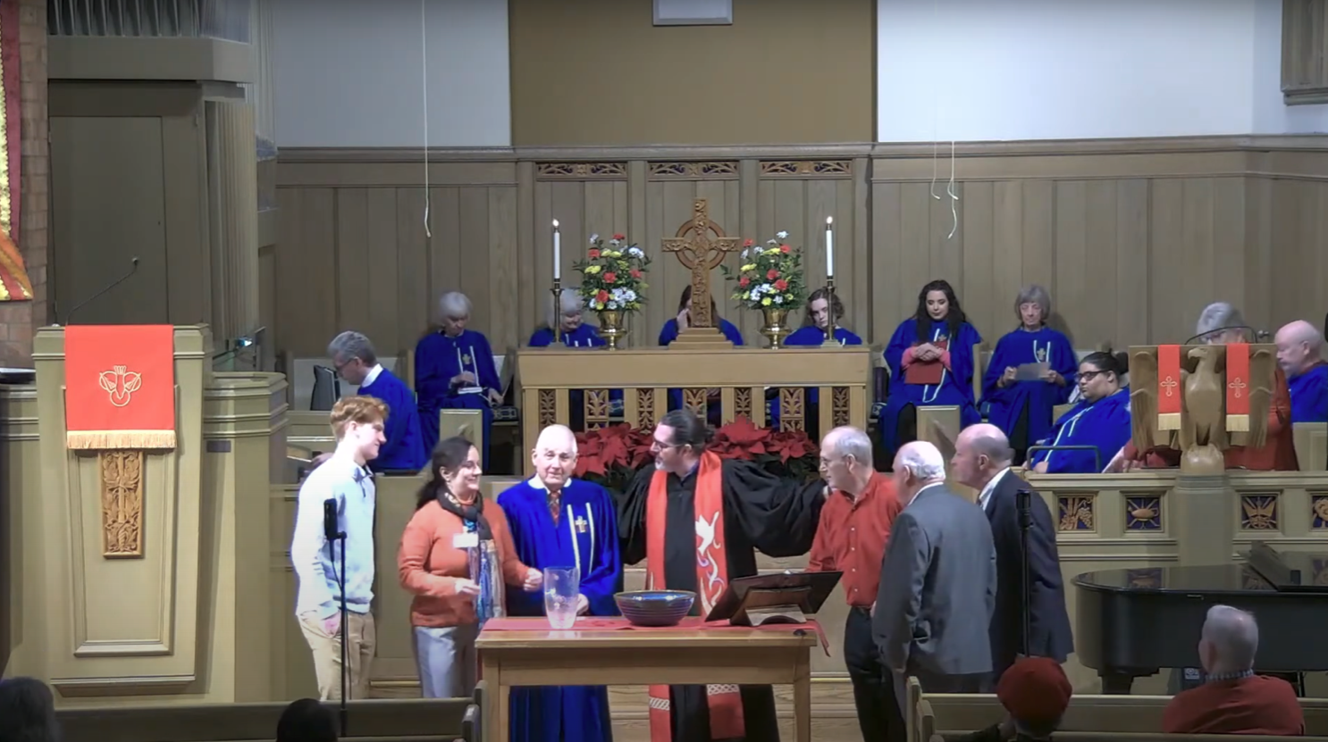
On the screen you’ll see a picture of my ordination at Shelter Island Presbyterian Church on July 27th, 2014 in Shelter Island, New York. You can’t see me because I was surrounded by a great cloud of witnesses, other fellow elders in the Church, laying their hands on my and imparting God’s blessing for my ministry as a pastor.
On the screen now you’ll see a screenshot of the ordination and installation of our most recent class of elders here at Guilford Park Presbyterian Church. We ordained as elder Leslie Loyd, Cooper Kirkpatrick, Katherine Glasgow, and Jim Lumsden and we installed those who had been previously ordained: Tim Peck, Bill Hickling, and Brad Kemmerer.
But those elders that you see on your screen are not the only ministers in this congregation. Over our time together, you’ll probably get sick of hearing me remind y’all from this pulpit and outside of it, that we are all called to ministry. In fact, the back of your bulletin reflects this theological belief of our denomination. You’ll notice that at the top of the list of staff members it states the following: Ministers: all the members of the church. In fact, we could just as easily call our upcoming New Members Class “New Ministers Class.” Though that might be a little intimidating. But it need not be. And this is why.
A few weeks ago when we celebrated the gift and promise of baptism, I invited y’all to dip your fingers in the water and trace the sign of the cross on your forehead or the forehead of your neighbor saying the following words: “Your baptism is sufficient for your calling.” But on this Sunday, you and I might just as similarly say: “Your baptism is sufficient for your ministry.” For we are all called to ministry. And to explore this truth, let’s briefly visit the passage before us.

There are three simple observations I’d like to make.
The first is this: Jesus came to Peter, Andrew, James, and John and not the other way around. It was the practice of religious leaders in early Judaism to set up shop somewhere, in a home or school, for their pupils to come to them. Here, in today’s passage, Jesus does the exact opposite. Jesus goes out and recruits disciples instead of waiting for them to come to him. That’s an important conversation for the Church these days but I’ll save that for another sermon. Suffice it to say that Jesus’ ministry reminds us that our ministry must never be confined to one building or place.
It reminds me of the words of the wonderful hymn, “Here In This Place:”
Not in the dark of buildings confining,
not in some heaven, light years away:
here in this place the new light is shining;
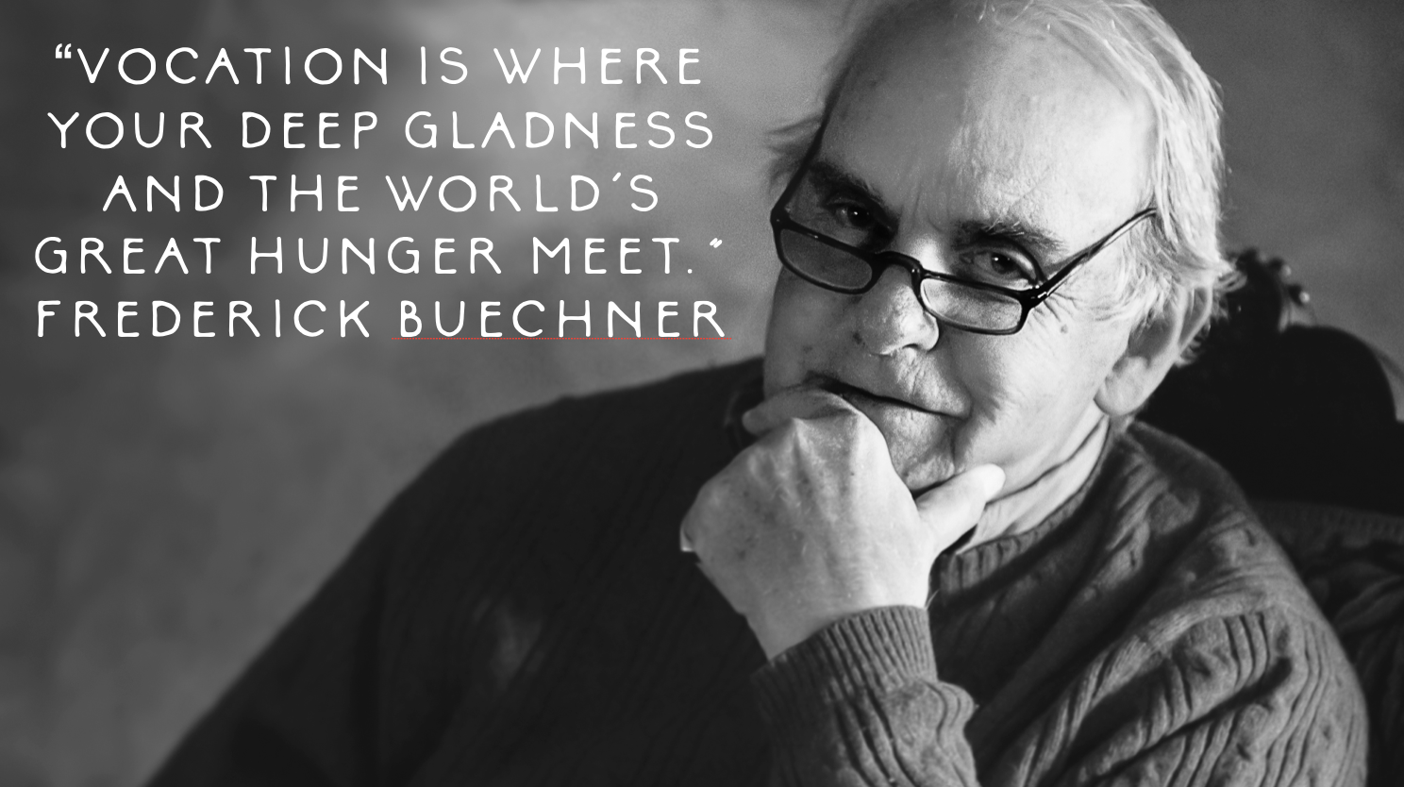
now is the kingdom, and now is the day.
Friends, the “place” of which we sing in that hymn is not just this beautiful sanctuary, it is equally and especially wherever you are where Frederick Buechner so famously said, “Your deep gladness and the world’s great hunger meet.”
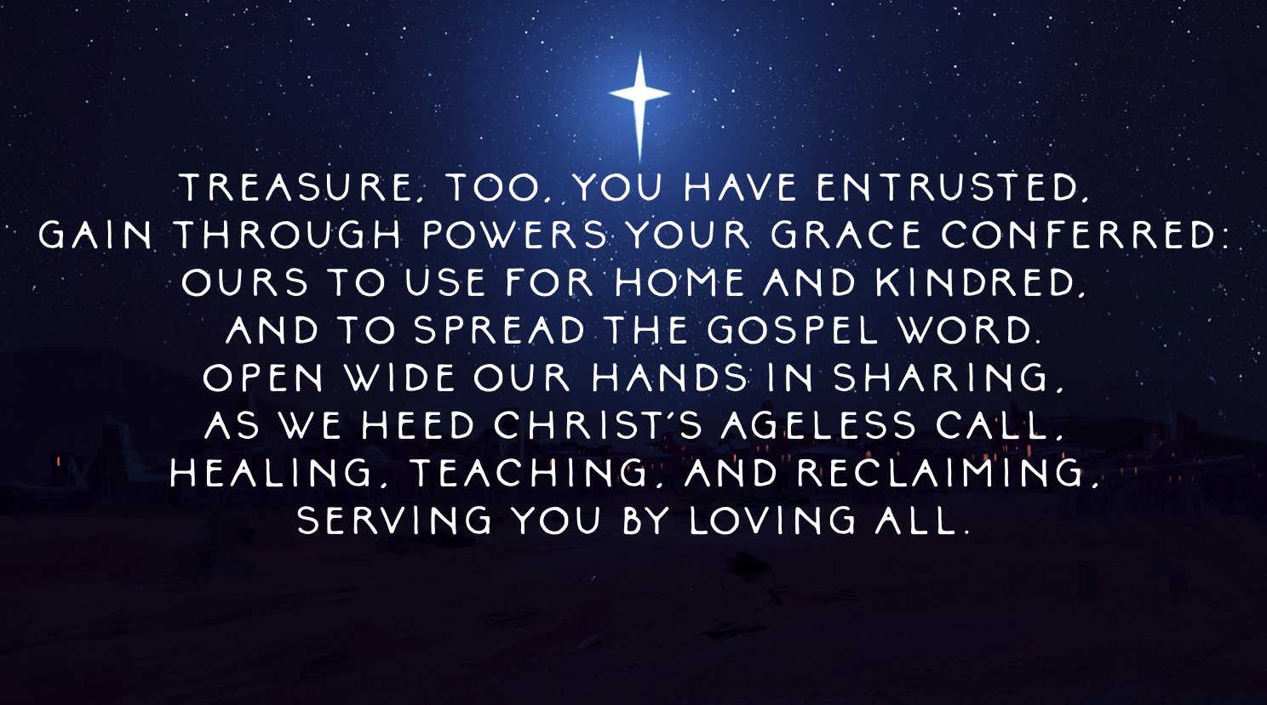
My second observation is this: Jesus called his first disciples in pairs. Jesus calls Pete and Andy together and then he calls the Zebedee boys, James and John, together. We do ministry together. Each of us is called to ministry but none of us is called to ministry alone. I need you, you need me, and we all need one another. Specific gifts of the spirit that make ministry possible may be bestowed upon individuals, but the practice of ministry is a communal one. This is an important reminder when churches are tempted to compare themselves to one another. We look at the mega church next door or the church down the street that has flashier toys or the fancier building or the bigger membership and we’re tempted to think we’re “losing” and they’re “winning.” The kind of ministry that Jesus models in today’s passage couldn’t be further from the truth. He doesn’t call four disciples and then send them out as individuals to see who can amass the largest following. Jesus chooses not to play that game. Instead, he offers not a game but a Gospel; one that is about strengthening the neighbor through collaboration instead of competition.

It reminds me of the final verse of one of my favorite hymns, “God, Whose Giving Knows No Ending:”
Treasure, too, you have entrusted,
gain through powers your grace conferred:
ours to use for home and kindred,
and to spread the gospel word.
Open wide our hands in sharing,
as we heed Christ's ageless call,
healing, teaching, and reclaiming,
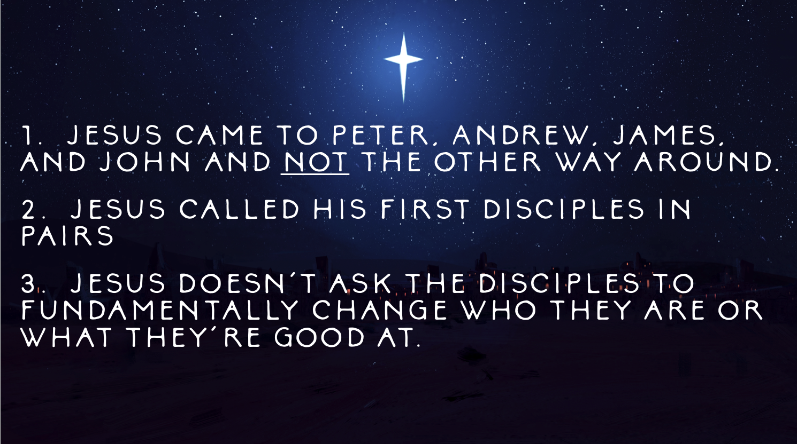
serving you by loving all.
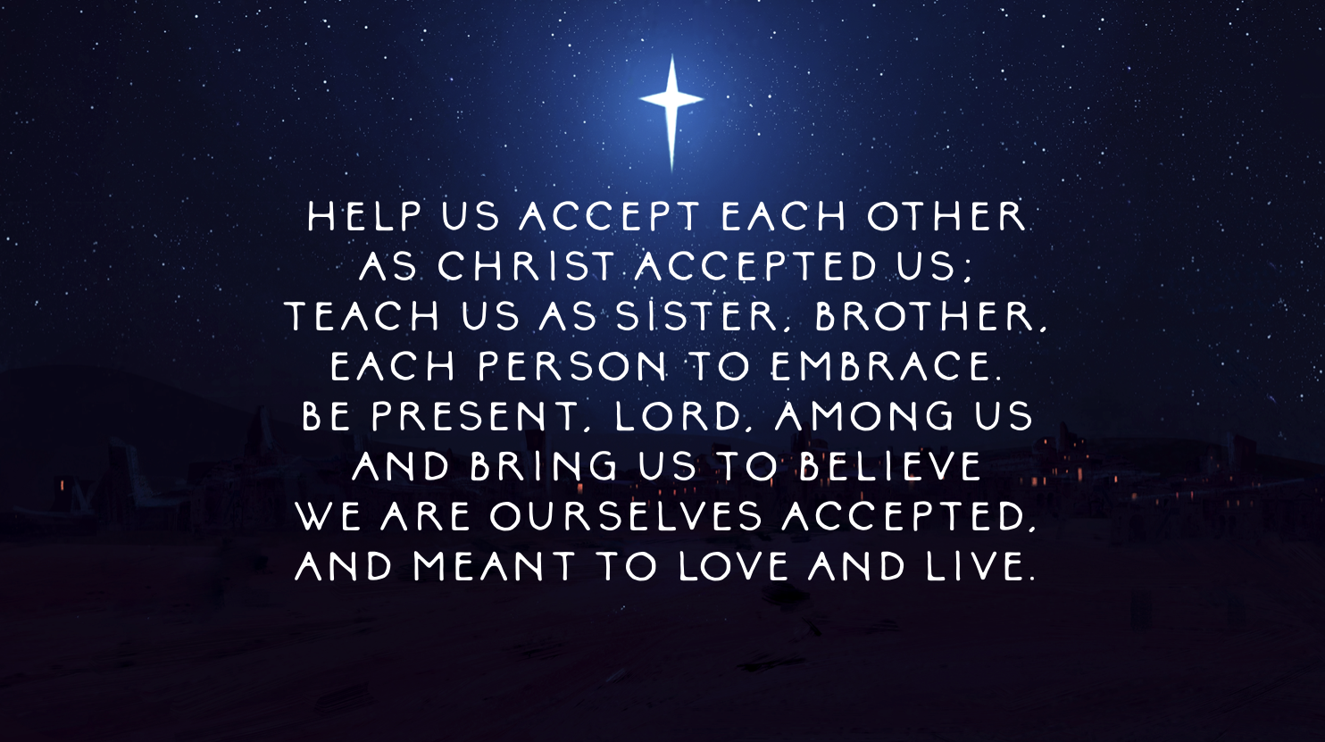
The third and final observation I’ll make this morning is this: Jesus doesn’t ask the disciples to fundamentally change who they are or what they’re good at. Notice what Jesus does not say in this passage. He doesn’t say, “Oh, I see y'all are fishermen. I’m going to make you carpenters for people.” Jesus doesn’t ask the disciples to be what they aren’t. He doesn’t ask them to change the very nature of who they are or what they’re good at; he just invites them to use those gifts in ways that build up the neighborhood and the kingdom. And this point is a critical one for the Church these days. And this is why. So many aging congregations struggle to maintain fruitful connections with younger generations because in ways they both understand and don’t understand that expect those younger generations to adhere to their expectations of what it means to be Church, and to assimilate to their structures of leadership and their way of doing things. Instead, this passage reminds us that perhaps the most Christ-like posture for us to take with younger generations is to simply and authentically ask them, “How can we help you be you? How can we support you in being the you God’s calling you to be?” Sometimes it’s not about finding the right answers but asking the right questions.

And it reminds me of the hymn, “Help Us Accept Each Other:”
Help us accept each other
as Christ accepted us;
teach us as sister, brother,
each person to embrace.
Be present, Lord, among us
and bring us to believe
we are ourselves accepted,
and meant to love and live.

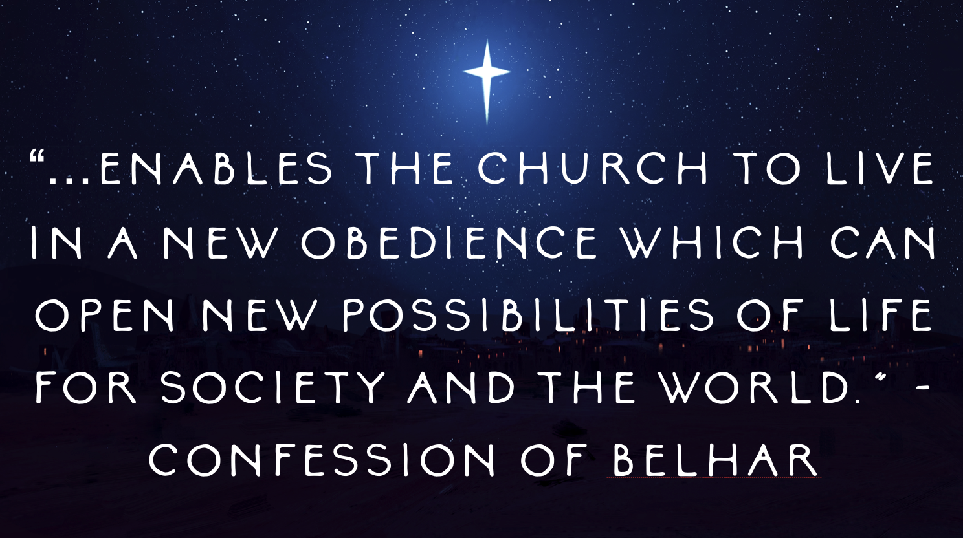
Ultimately, ministry is about joy. Sharing joy with our neighbors and equally finding joy within ourselves in gratitude for the fact that God has used us in such life-giving ways.
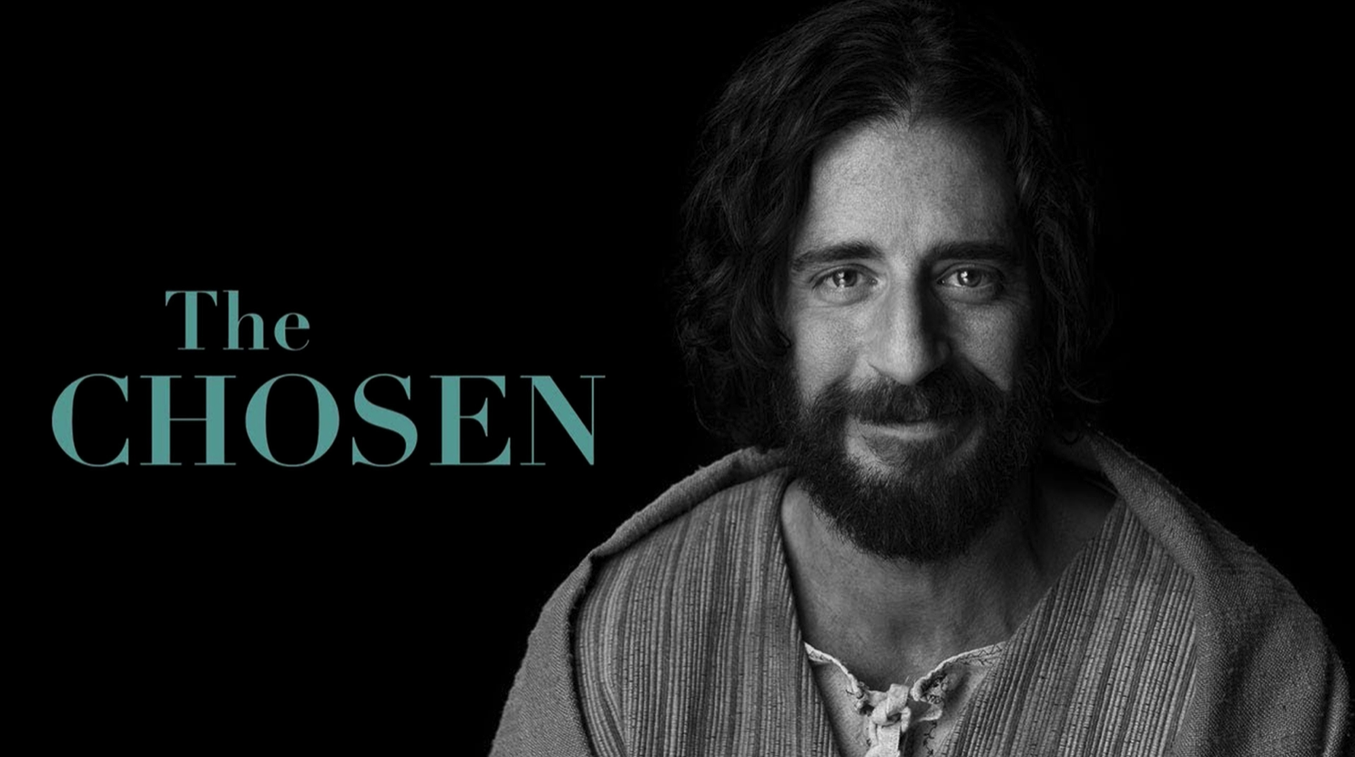
As we’ll affirm in a few minutes in our Affirmation of Faith from the Belhar Confession, the joy of ministry is what “enables the Church to live in a new obedience which can open new possibilities of life for society and the world.”
In a few weeks, the Adult Education Committee is sponsoring a weekly watch party and discussion group of the viral television series, The Chosen. A few weeks ago, Tricia and I watched the episode where the disciples are sent out two by two to do the work of healing that Jesus had been doing up to that point. Until that episode, the disciples had been perfectly content watching Jesus do all the work of healing people with various illnesses and maladies.
But one day, Jesus sits down with the disciples around a table and tells them that he’s going to send them out in pairs (again, not alone! Jesus calls us in community and sends us out in community!). The pairs are to go out and do all of the miraculous things that Jesus has been doing. The disciples respond by looking equal parts fearful and dumbfounded. “But Rabbi,” they ask, “how will we be able to do those things.” Jesus looks at them and states matter-of-factly, as if it’s the most natural and easy thing in the world, “Because I’m giving you authority to do them.”
The next episode opens with a montage of the disciples healing people on their own in the various places Jesus has sent them off to. The dialogue is intentionally muffled which very cleverly enhances the visual aspects of the scenes. So the viewers attention is focused on the facial expressions of the characters on the screen. One by one, scene by scene, the disciples are shown entering the space warily, as if they don’t know what they’re doing (because they don’t!). But what I like most about these scenes is not watching the facial expressions of the people once they are healed; their faces, understandably, light up with wonder and joy as they come to grips with the miracle of ministry that just happened to them. My favorite part of these scenes is actually watching the faces of the disciples as soon as they realize what just happened, what they just did in Christ’s name.

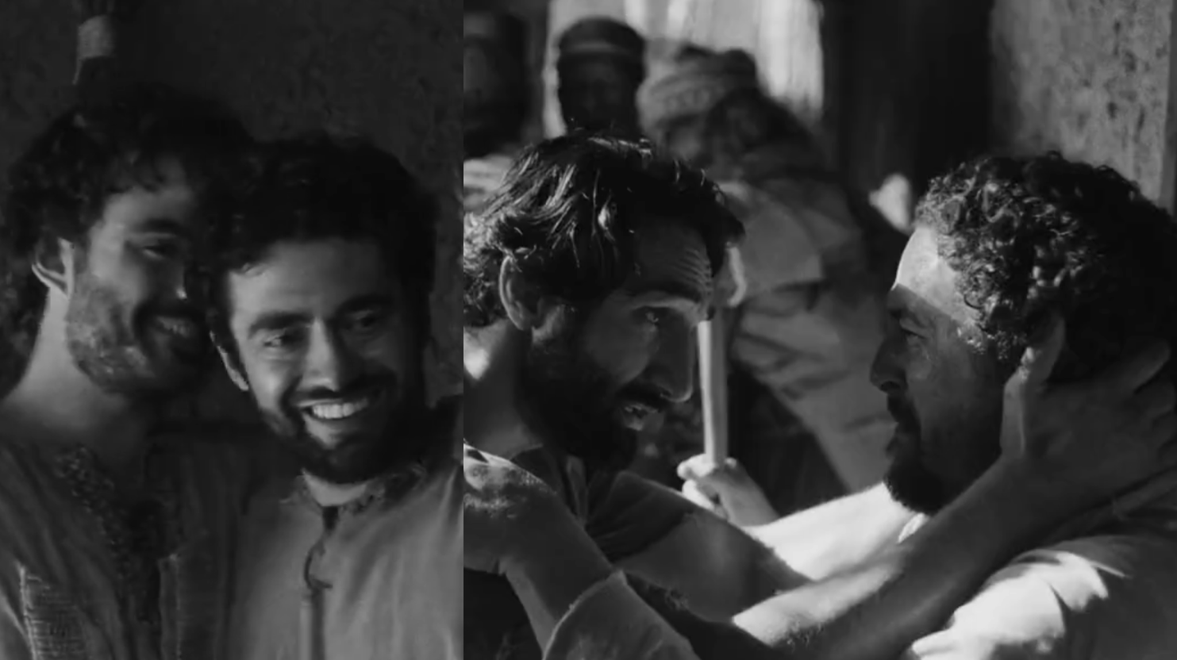
First comes the look of pure disbelief. The look of, “Oh my God, it actually worked!” But it doesn’t take long for their disbelief to turn into unfettered joy.
As the healed person celebrates, the disciples themselves cry tears of gratitude and wonder, embracing one another, smiling from ear to ear, overwhelmed with a tangible sense that they’re doing exactly what Jesus called them to do and gave them the authority to do in his name.
And that, my new neighbors, is what I hope and pray for each and everyone one of you. I pray that you find that moment of bliss when you discover yourself in a moment when your passion and the world’s need meet. I pray that you find yourself caught up in ministry, in ways both great and small, that give life to you and your neighbor. I pray that God’s promise of ministry would invigorate this congregation and strengthen each of its members. And I pray that God would give the “open ears” that the writer of Psalm 40 was given to be ready whenever that ministry moment finds us to step into action and do discipleship.
Holding the hand of someone who is dying. Hugging the friend who’s in the depth of despair. Teaching the child who’s hungry for knowledge and connection. Writing that card to the person recovering from surgery. Holding space for young men who need community and fellowship. Feeding the hungry. Clothing the naked. Bridging the divide. These are all the places of ministry where you are needed. The waters of your baptism are sufficient for your calling, my friends. You have been called. You have been authorized by Christ who sends you in his name. We believe everyone has been called to ministry and, yes, that means you, too.
In the name of God the Creator, Redeemer, and Sustainer, may all of us, God’s children, say: Amen.

