Baptism of the Lord (Year A)

__________________________________________________________________________________________

Matthew 3:13-17 (Common English Bible)

At that time Jesus came from Galilee to the Jordan River so that John would baptize him. John tried to stop him and said, “I need to be baptized by you, yet you come to me?”
Jesus answered, “Allow me to be baptized now. This is necessary to fulfill all righteousness.”
So John agreed to baptize Jesus. When Jesus was baptized, he immediately came up out of the water. Heaven was opened to him, and he saw the Spirit of God coming down like a dove and resting on him. A voice from heaven said, “This is my Son whom I dearly love; I find happiness in him.”
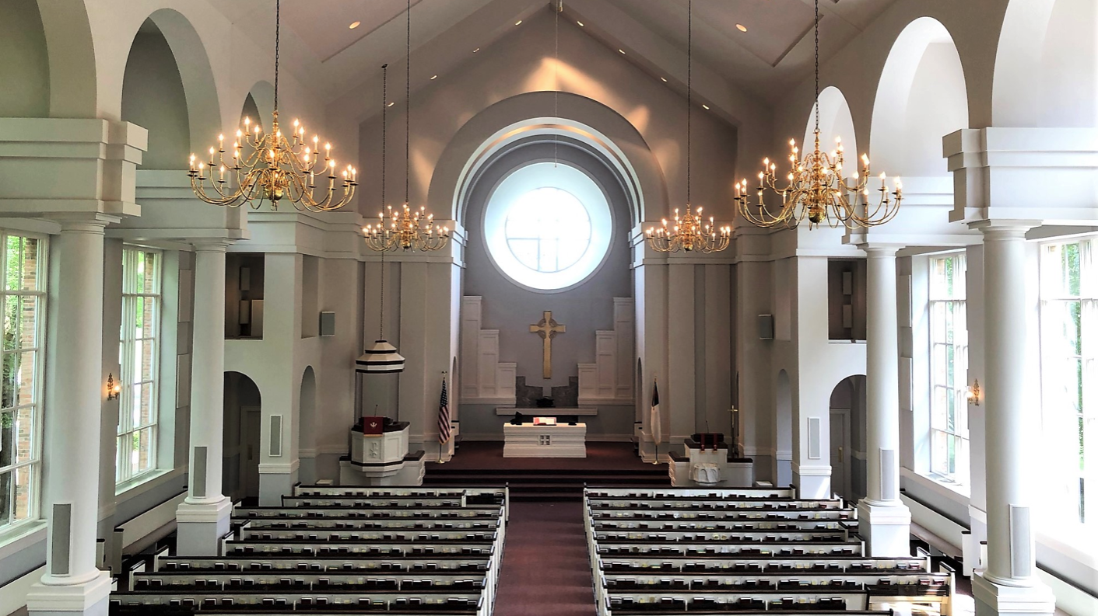
__________________________________________________________________________________________
I was baptized in this beautiful, cavernous sanctuary at First Presbyterian Church or Dalton, Georgia on June 28th, 1992 by the Rev. Jim Holderness. If that name sounds familiar, it’s because the Holderness family has roots right here in North Carolina.
In fact, the Presbyterian house not far from us on the campus of UNCG is called the Holderness House for that very reason.

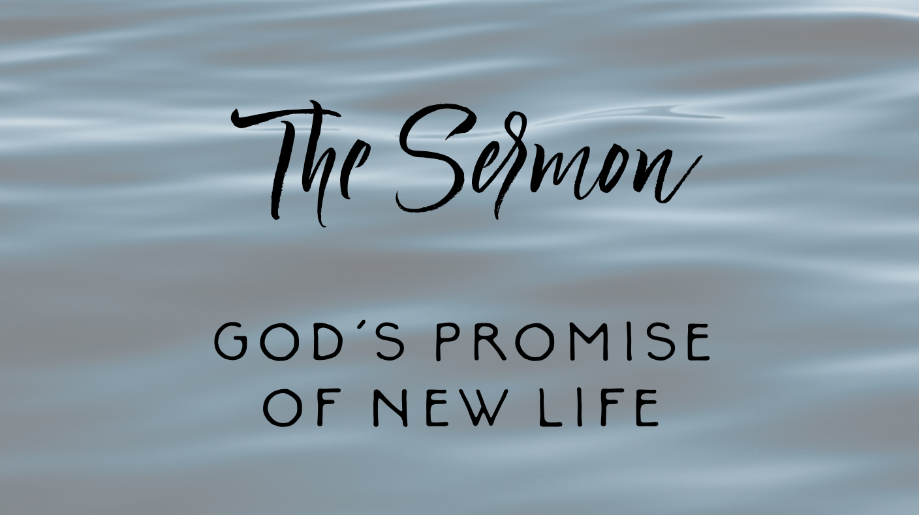
Rev. Holderness thrice anointed my head with water on that day just over thirty years ago. And perhaps exactly because I don’t remember any of that day, I’ve always gravitated towards today, Baptism of the Lord Sunday, as an opportunity for myself to remember my baptism, and to do that remembrance collectively with the people of God each Sunday after the Epiphany.
So today I want us to take a deep dive, so to speak, into baptismal theology. You see, baptism isn’t a one-time thing. Our baptism isn’t the ending, it’s only the beginning. Baptism isn’t just about saying, “God loves you and you’re now a part of this church.” Don’t get me wrong; that’s an important message about baptism, but it just scratches the surface. The truth is that we are baptized to something. We are baptized to ministry; to our calling; to our lifelong journey as Christian disciples. Each of us, in our baptisms, was called to ministry. NOT just those of us who have taken vows such as the ones I’ve taken in my ordination and the very same ones that will be taken by our newest class of elders here in a few minutes. Regardless of whether or not you’re an ordained elder; in your baptism, you are called to ministry.
We’ve talked in Elder Training the past month or two about, as Presbyterians, we don’t believe that only the elders and myself are called to ministry and “everyone else” is “just” a lay person. That’s not the way we do things in the Presbyterian Church. We believe that in our baptism everyone is called to ministry and some of us, teaching elders such as myself and ruling elders who make up the session, are called apart to equip you, the Church, to do the ministry God has called this congregation to do.
And that ministry is laid upon a foundation of promises made to us by God. And baptism is a beautiful reminder that God promises us new life through that fount of every blessing. Now, as I teased earlier this week in our weekly eNews, baptism is no mere appetizer or something that serves as nothing more than a theological garnish. Instead, baptism is, in and of itself, a five-course meal serving up for us a feast of God’s love, grace, and mercy.
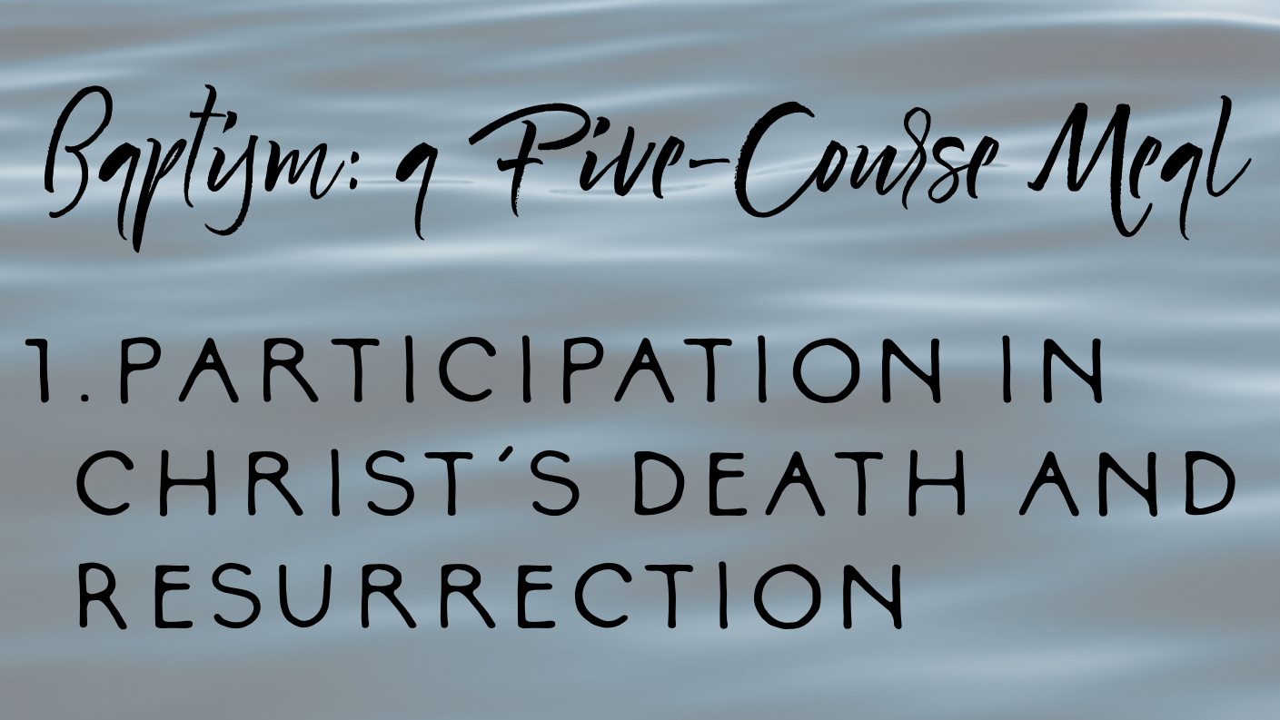
So I want us to take a few minutes to dive deep into the five meanings of baptism as laid out in a document that has been very important to me over the past decade in my teaching and preaching of the sacraments. It’s called “Baptism, Eucharist, and Ministry” or sometimes referred to as the “Lima Document” because it was written in Lima, Peru by the World Council of Churches in 1982. It’s a document that was the result of the World Council of Churches, representing the many different wings of Christianity, where they all got together to affirm the common theological ground they shared regarding the sacraments and ministry. And in the Lima Document, the World Council of Churches affirmed five meanings of Baptism and these are the basis of the five-course meal that you and I shall feast upon.
First of all, baptism represents the participation in Christ’s death and resurrection. A few days ago, Martha Higgins and I gathered by long-time GPPC member Mary Lou Lodor in what would be her final day before dying and rising in Christ. She died early on Thursday morning. On the day that Martha and I sat by her bedside, I read aloud the following words from Paul’s letter to the Romans: “If we live, we live to the Lord, and if we die, we die to the Lord; so then, whether we live or whether we die, we are the Lord’s.” These words form the foundation of the first promise of baptism: that it seals us into Christ’s death and resurrection. And Mary Lou Lodor’s baptism has been made complete because she’s been sealed into that same life-giving promise.

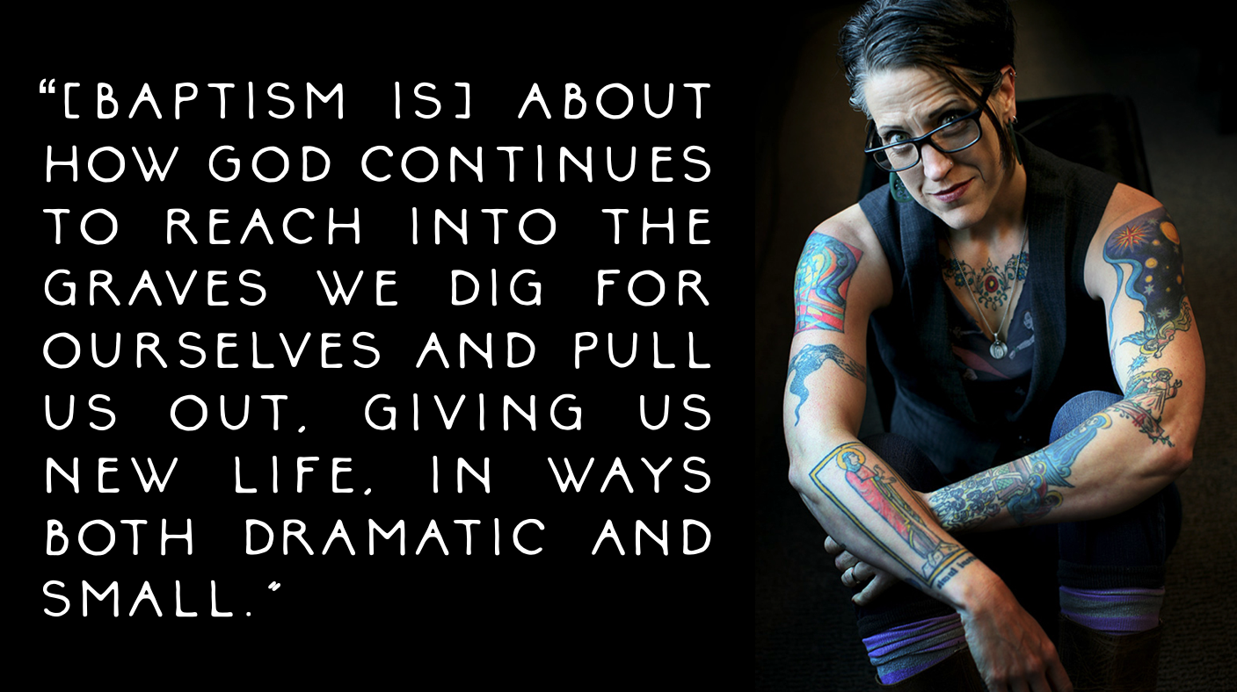
Now, here, I must be a little critical of our typical baptismal practice as Presbyterians of sprinkling. A measured amount of water sprinkled onto the head just doesn’t quite emphasize dying and rising in Christ. But full submersion baptism, on the other hand, does a great job of this. Out of curiosity, do we have any gathered here today who were baptized by full submersion? Though we don’t often think of this when we baptize an infant by sprinkling, every baptism is a death. A death to ourselves and a rebirth in the life of Christ. Whenever I fear death - for death is the thing that humanity collectively fears the most - I try to remind myself that I’ve already died! And not only have I already died, but I’ve already been resurrected. In fact, our whole lives as Christian disciples are nothing more than a series of little deaths and resurrections.
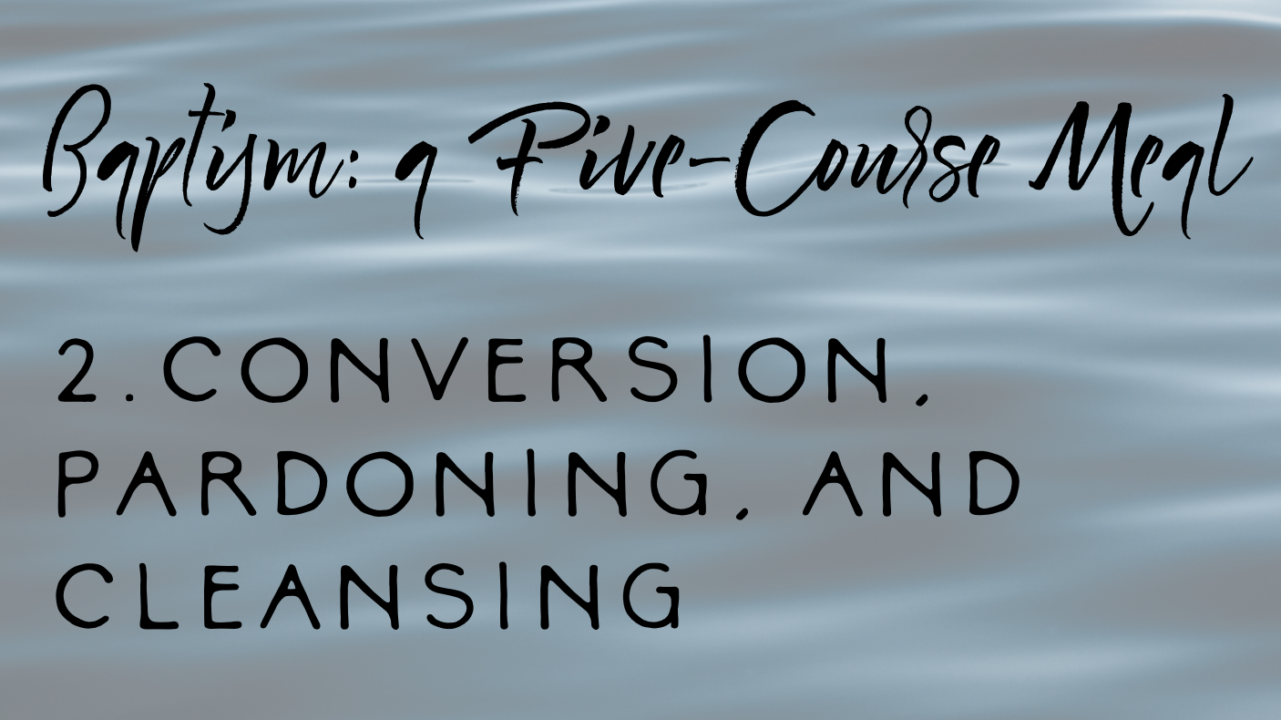
Nadia Bolz Weber put it so beautifully once: “[Baptism is] about how God continues to reach into the graves we dig for ourselves and pull us out, giving us new life, in ways both dramatic and small.”
Secondly, baptism represents conversion, pardoning, and cleansing. Now, again, this metaphor for baptism isn’t one that is emphasized much in infant baptism. I mean, when was the last time you saw a newly-baptized infant being carried up and down the aisle, their heads still glistening with the waters of their baptism, and thought to yourself, “Man, it sure is a good thing that baby repented!” I’m guessing you probably haven’t. But that doesn’t mean that we as Presbyterians shouldn’t explore this important aspect of baptism.
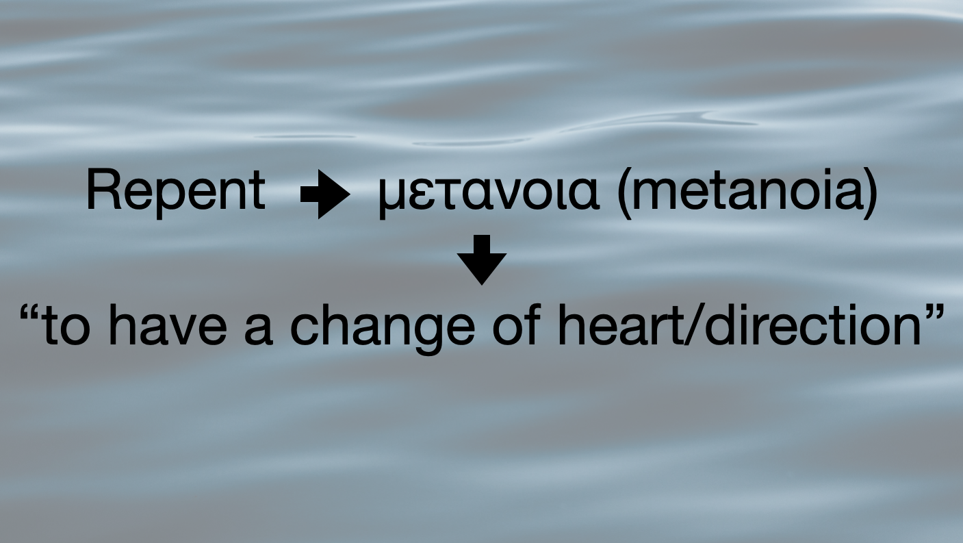
Even though when I was baptized as a toddler, long before I ever could grasp the concept of sin or evil or repentance, I’ve had countless opportunities to remember my baptism since then; countless opportunities to live into the vows my parents made on my behalf to renounce evil in its many forms and to follow Jesus Christ. Each time I remember my baptism, it’s an opportunity to practice holy curiosity and ask myself the following questions. How have I acted unneighborly towards my family, my friends, my coworkers, and the strangers I encounter and those I’ve never met? How have I both knowingly and unknowing participated in systems that have hurt my fellow human being? How can we, as the Body of Christ, renounce evil in its many forms and take a side, draw the line, and stand on the side of the line with Christ, on the side of the marginalized and the oppressed?
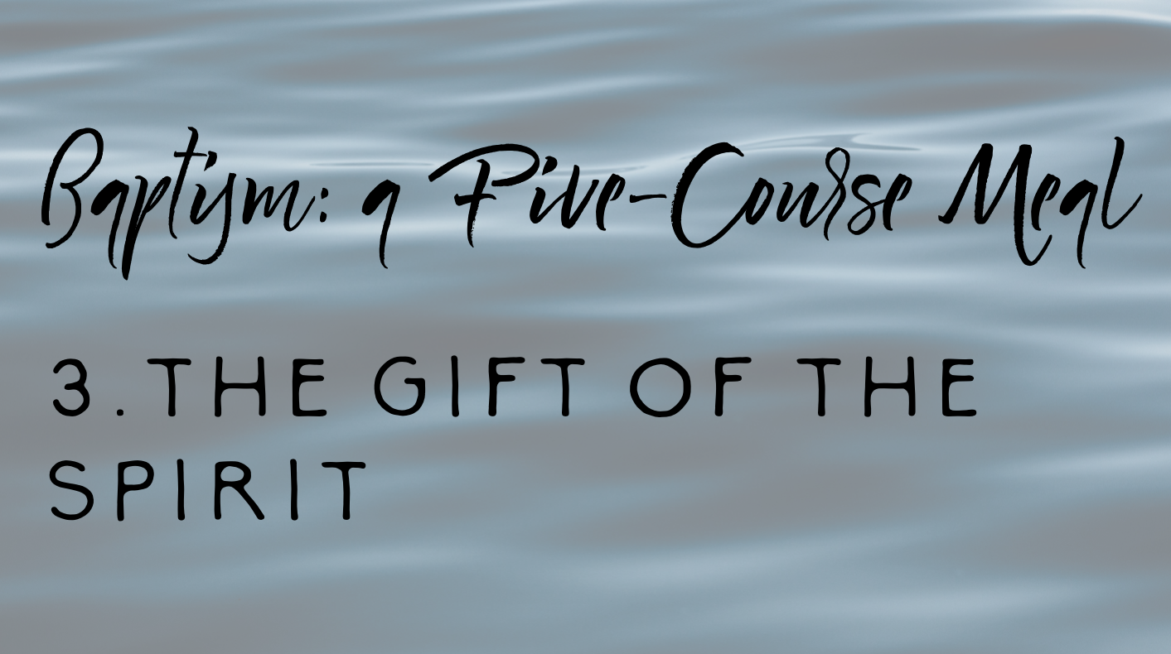
In ways both individual and corporate, our baptism demands of us that we repent or, as is a more accurate translation of that Greek word, to “to have a change of heart or a change of direction,” to turn to a more Christ-like position. It’s not about guilt. It’s not about shame. It’s not about some self-flagellation exercise of reminding us that we are sinners in the hands of an angry God. It’s about gratitude, actually, for countless opportunities, as we talked about last month in Advent, to choose a better way. It’s about thanking God for not giving up on us, even when God’s had ample reason to do so.
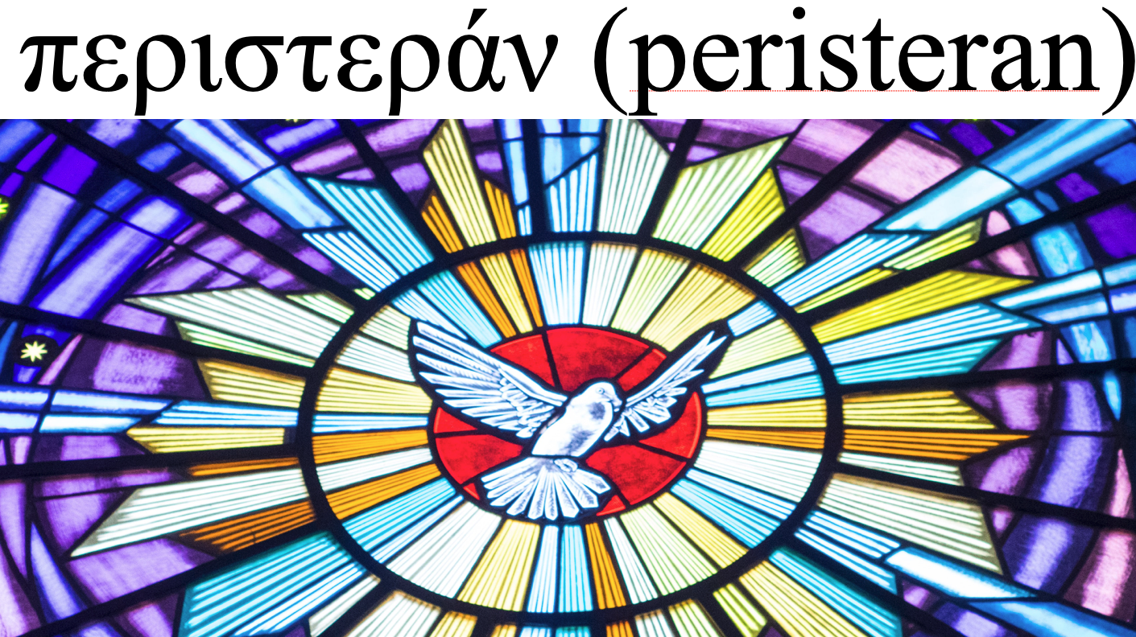
Thirdly, baptism represents the gift of the Spirit. In today’s passage from Matthew’s Gospel, scripture tells us that at the moment of his baptism, the Spirit of God descended upon Jesus in the form of a dove. Now, I learned an interesting thing this week as I was swimming laps at my new gym across the street over there, I was listening to my favorite preaching podcast, Pulpit Fiction (isn’t that a brilliant name?!),
and they talked about how most English translations of the Bible, including the Bibles in your pew, translate the Greek word περιστεράν as “dove.” When we think of a dove we think of beauty, elegance, and peace. But do you know what an even more accurate translation of that word actually is?
Pigeon! Which is quite a different connotation isn’t it?! We often associate pigeons as a nuisance. We think of them as dirty “rats with wings.” A pest. Overpopulated and everywhere whether we want them to be or not. In a way, I like that image of the Holy Spirit. Not some white-washed, picture-perfect creature but an ever-present, chaotic, and sometimes decidedly inconvenient thing that meets us in the messiness of our lives. Almost like a mustard seed, you might say.
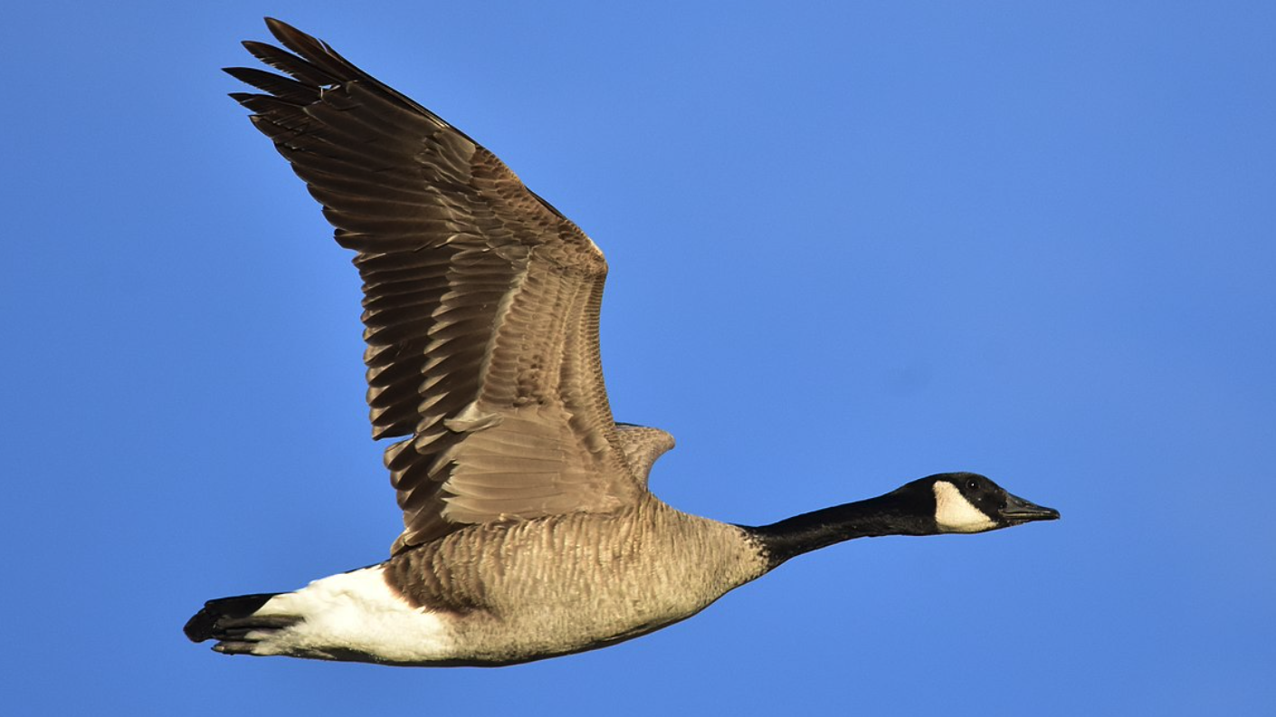
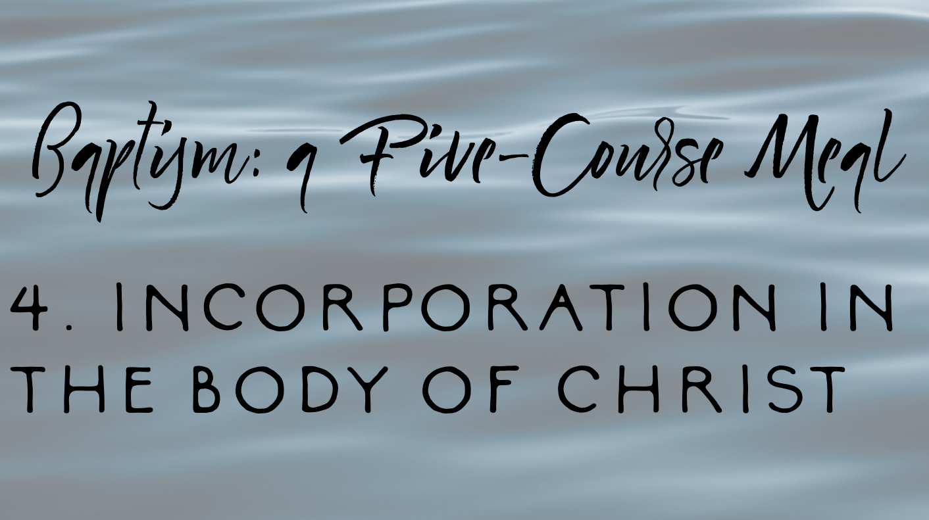
Now, whether you prefer the Holy Spirit as a dove, as a pigeon, or as Scottish spirituality prefers, a wild goose, the point still stands: baptism represents the gift of the Spirit. The same breath of God that hovered over the waters of creation, that same ruach (to use the Hebrew word), is the same Spirit that settles upon each of us in the waters of our baptism. God’s promise of new life given to us in baptism is the assurance that we do not go through this life alone, or unequipped, or unprepared. Rather we are given an Advocate - a persistent pigeon, if you will - that goes before us as a guide and beside us as a friend.
Fourthly, baptism represents incorporation in the Body of Christ. For us Presbyterians, this is probably the most familiar of the five meanings of Baptism. For those of us who practice infant baptism, there’s something just intrinsically beautiful about the theology of being welcomed into the family of God long before we could ever reciprocate or even begin to comprehend the depth and breadth of the love that makes that possible.
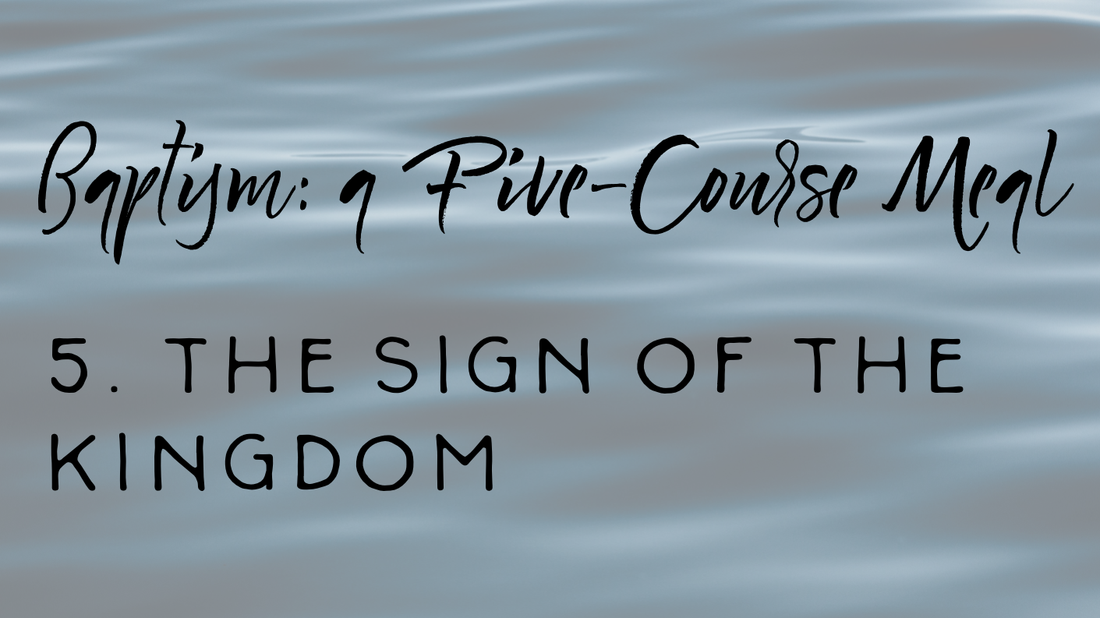
I love the fact that its wasn’t just my parents who made vows on the day of my baptism as a toddler. The people who are First Presbyterian Church of Dalton, Georgia also took vows to nurture my spiritual development throughout my life. And they did just that. They did that every time I learned to love music by playing handbells, or piano, or guitar, or trumpet in worship. They did that with every youth trip to Montreat and every summer during vacation Bible school. They did that by keeping in touch with me during my college years, and sending me care packages during finals, and welcoming me with open arms when I came home for the holidays. And they did that by supporting me financially when I was in seminary, to help me become the pastor that I am today. All of those acts of love were faithful responses of that congregation to fulfill the promise they made on the day of my baptism. All those acts were beautiful embodiments of our baptisms welcoming us into the family of Christ.
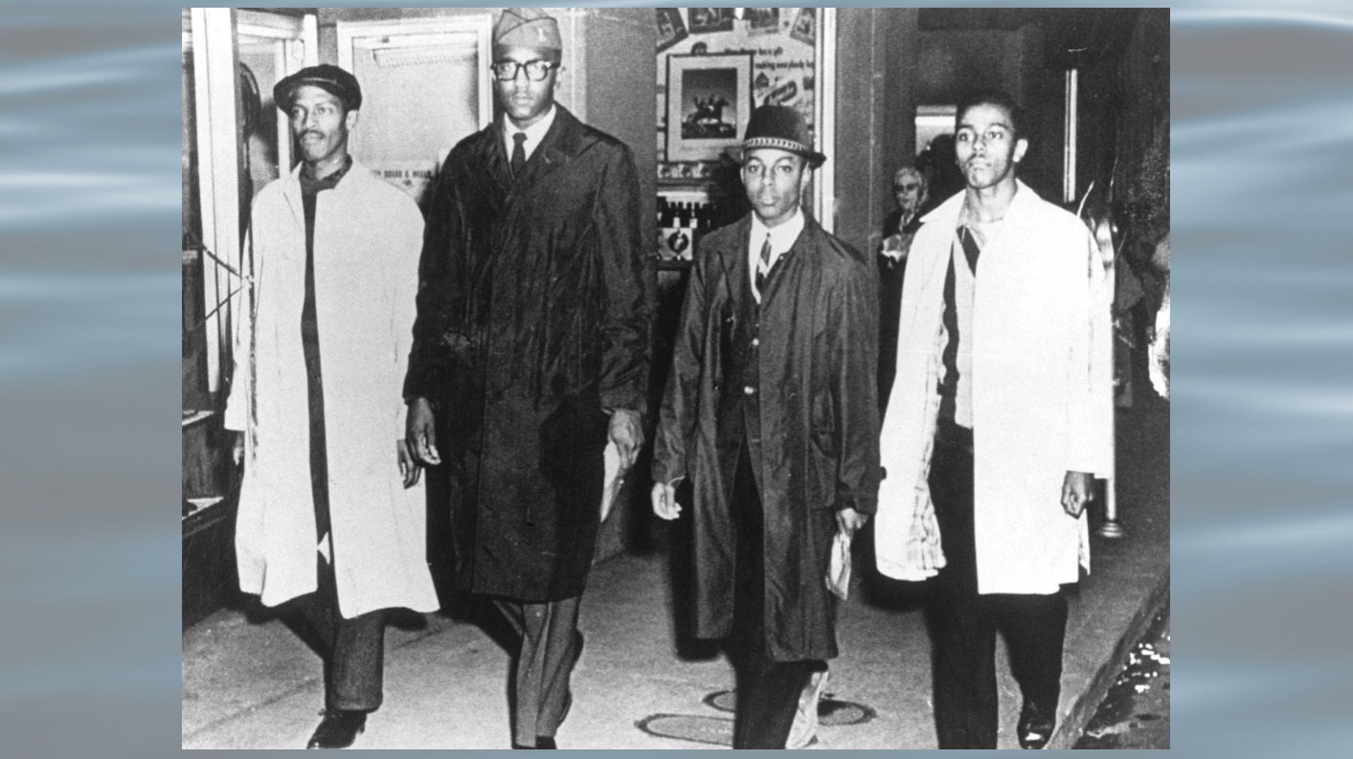
And finally, baptism represents the sign of the kingdom. I’m going to say a sentence that I’ve bet you’ve never heard or considered: every baptism is an act of protest.
On your screen, you’ll see, of course, a picture of the Greensboro Four at the Woolworth Store in 1960. I share with y’all this picture because if we take seriously the notion that baptism represents the sign of the coming Kingdom of God, then we affirm that every baptism seals us into the Body of Christ that is tasked with bringing forth the promised day of God when there will no longer be such a thing as homelessness, the promised day when all the hungry will be fed and all the naked clothed, the promised day when nation will no longer turn against nation and every weapon will be turned into gardening tools, the promised day when there are no more school shootings or opioid overdoses, no more racism or economic inequality, no more division or hatred, the promised day when God will wipe the tear from every eye and death and dying will be no more.
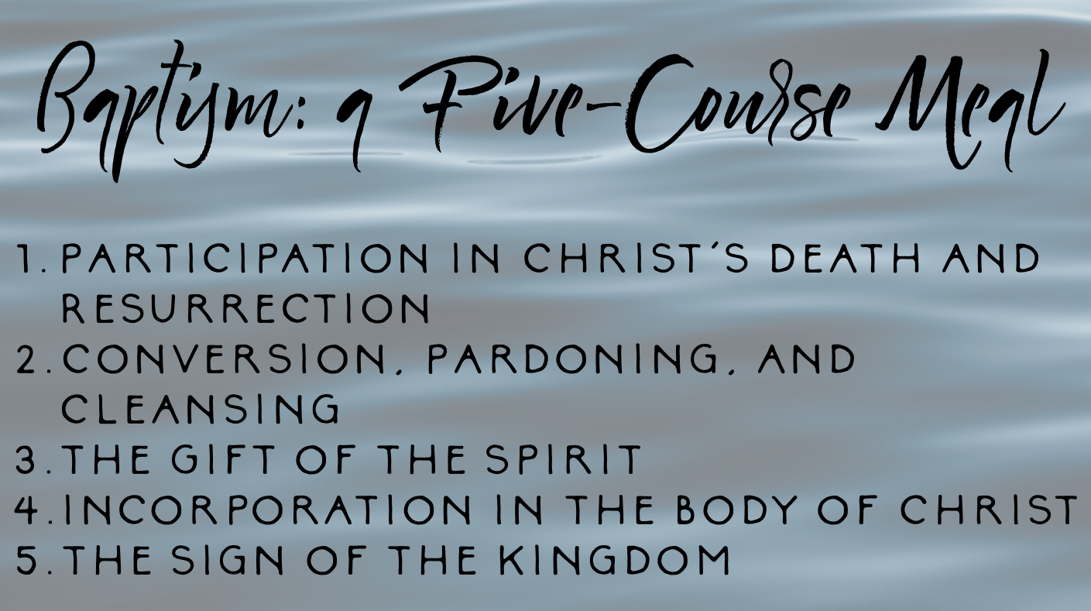
If we take those promises seriously, then each and every baptism is an act of peaceful protest; a beautiful embodiment of nonviolent resistance to any and all forms of evil that seek to divide us from God and one another. Baptism says to violence, “I don’t belong to you, I belong to God.” Baptism says to racism, “We don’t belong to you, we belong to God.” Baptism says to death and dying, “You don’t have the final word, we belong to God.”
Well, friends, there you have it: baptism as the five-course meal that fills us with God’s promise of new life. As we turn now towards the installation and ordinations of our newest elders, let us give thanks for the depth and breadth of the meaning of Baptism, and let us stand in holy curiosity of what our baptisms reveal about ourselves as disciples of the Risen Christ.
In the name of God the Creator, Redeemer, and Sustainer, may all of us, God’s children, say: Amen.

Romans 14:8

