__________________________________________________________________________________________________

Romans 12:9-21
Let love be genuine; hate what is evil, hold fast to what is good; love one another with mutual affection; outdo one another in showing honor. Do not lag in zeal, be ardent in spirit, serve the Lord. Rejoice in hope, be patient in suffering, persevere in prayer. Contribute to the needs of the saints; extend hospitality to strangers.
Bless those who persecute you; bless and do not curse them. Rejoice with those who rejoice, weep with those who weep. Live in harmony with one another; do not be haughty, but associate with the lowly; do not claim to be wiser than you are. Do not repay anyone evil for evil, but take thought for what is noble in the sight of all. If it is possible, so far as it depends on you, live peaceably with all. Beloved, never avenge yourselves, but leave room for the wrath of God; for it is written, ‘Vengeance is mine, I will repay, says the Lord.’ No, ‘if your enemies are hungry, feed them; if they are thirsty, give them something to drink; do not be overcome by evil, but overcome evil with good.
__________________________________________________________________________________________
In prepping for this sermon, I became acutely aware that the topic of the problem of evil is WAY too expansive a conversation for one sermon alone. Scores of books, dissertations, lectures, and classes have been devoted to the topic over the centuries. Philosophers and theologians have long wrestled with the idea of theodicy, which is a fancy theological term that means our search to reconcile two seemingly irreconcilable truths: on the one hand, the goodness and omnipotence of God and, on the other, the reality of evil in our world. This sermon is but the tip of the iceberg and may just leave you with more questions than it does answers, but that sometimes - whether we like it or not - is the work of faith.
First of all, what is evil and where does it come from? If we were to poll this assembly as to the definition of evil, we’d likely get dozens of different responses. Some of us were raised to think of evil in very personified terms:

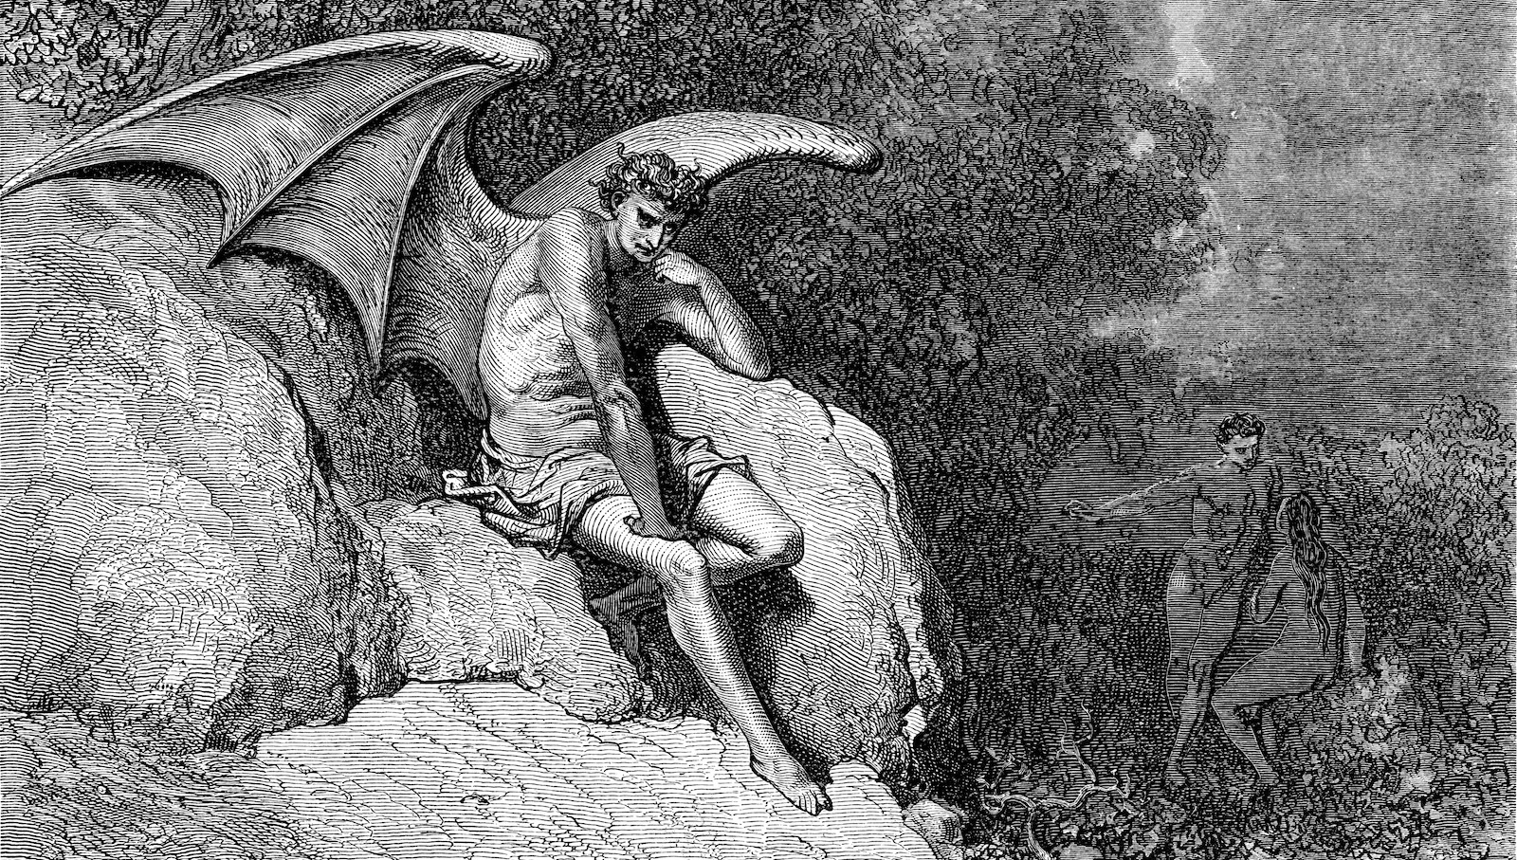
devils, demons, Satan, angels, spiritual warfare between the “good” and the “bad.” Others of us were raised in perhaps more liberal wings of Christianity where we were taught that those things are but metaphors to describe suffering, violence, sickness, and natural disasters. I, myself, prefer a “middle of the road” option proffered by C.S. Lewis in the preface to his satirical novel The Screwtape Letters:
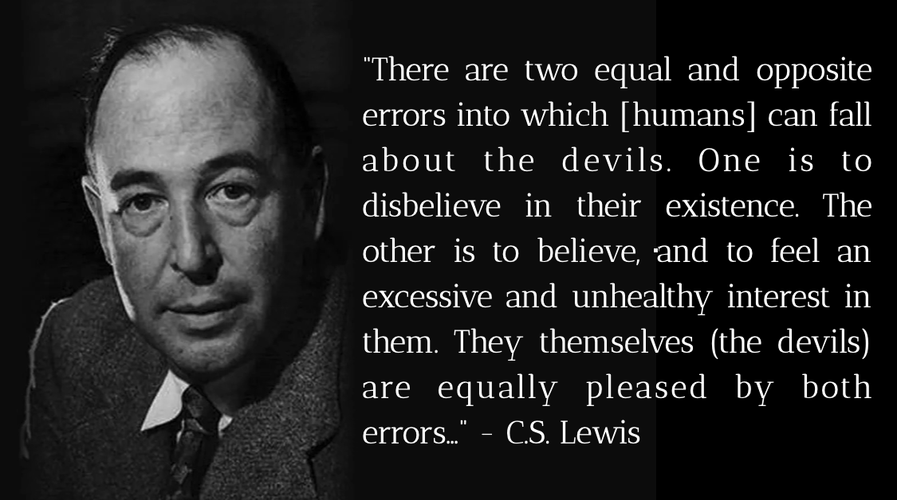

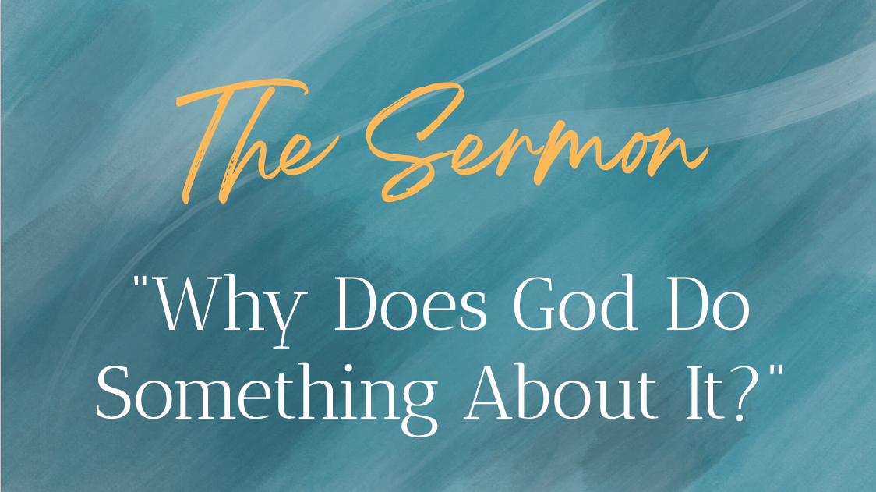
“There are two equal and opposite errors into which [humans] can fall about the devils. One is to disbelieve in their existence. The other is to believe, and to feel an excessive and unhealthy interest in them. They themselves (the devils) are equally pleased by both errors…”. Regardless of how we choose to define evil, our faith requires us to acknowledge its presence in its many forms and to seek faithful responses to that reality.
Now, as to where evil comes from? I prefer not to waste much energy on this ultimately unanswerable question. Suffice it to say that we just don’t know. If asked to trace back the beginning of evil, most of us would probably point to the stories of Adam and Eve in the garden and the subsequent murder of Abel by his brother Cain in the following chapter. And those are certainly stories - some would call them mythological - that the authors of the Bible used to do the same thing we’re trying to do today: to describe, to the best of our efforts, “where it all went wrong.” Interestingly enough, the word “sin” does not appear in either of the stories and neither does the word “evil,” except to describe the “Tree of Knowledge of Good and Evil.” The word “evil” is never used in either of those stories to describe the actions of Adam and Eve or their son Cain after he murdered his brother, Abel.
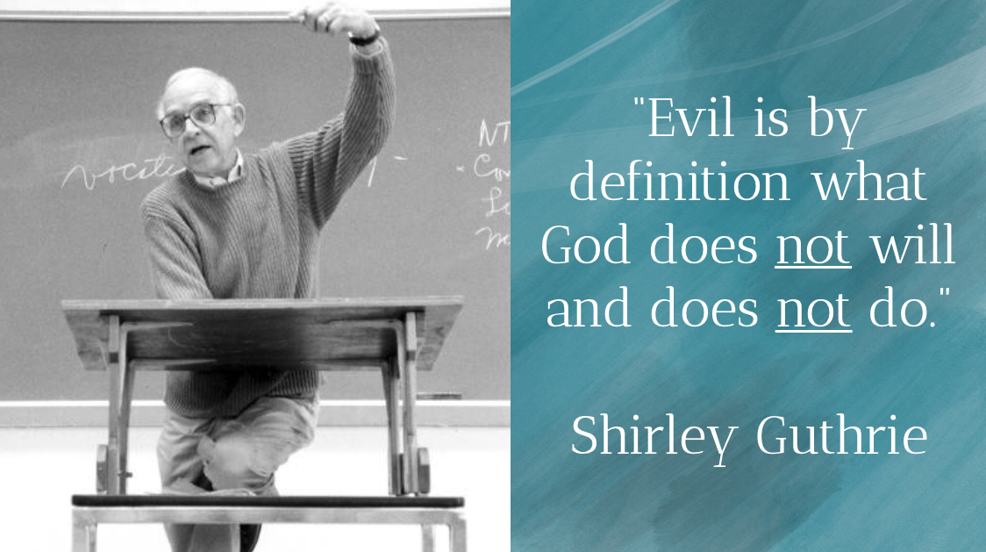
So, for the purposes of this sermon, I’ll borrow a definition of evil offered by Shirley Guthrie in the book we’ve been using to structure our discussions for Theology on Tap.
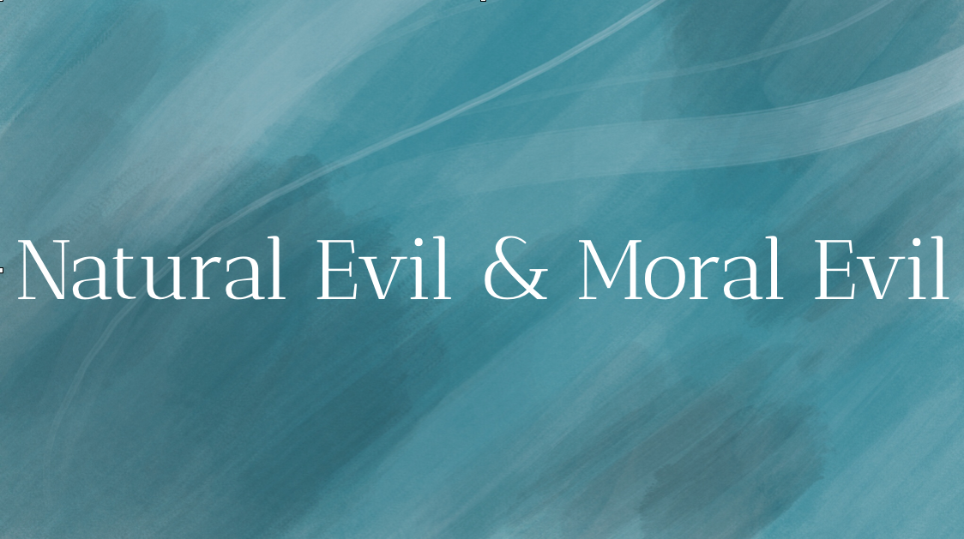
He writes “Evil is by definition what God does not will and does not do.” In general, we can categorize evil into two categories:

natural evil and moral evil. Natural evil is the cancer that suddenly robs a family of their wife and mother. Natural evil is volcano that explodes and kills thousands of people, the “good” and the “bad” alike. Natural evil is ultimately leads us to uncomfortable questions like “If there is a God, why did God let this happen - or did God actually make it happen.”
Moral evil, on the other hand, is evil that we human beings bring upon ourselves. We have ordered a society with a disgusting amount of disparity between the super wealthy and the growing number of citizens who can’t find affordable housing or healthcare. We have systems of disparity that perpetuate cycles of racism, sexism, ableism, and other forms of oppression. We can both be grateful for our veterans and service men and women AND grieve the fact that we spend more money on weapons of war and the military than we do feeding our children and investing in their education.
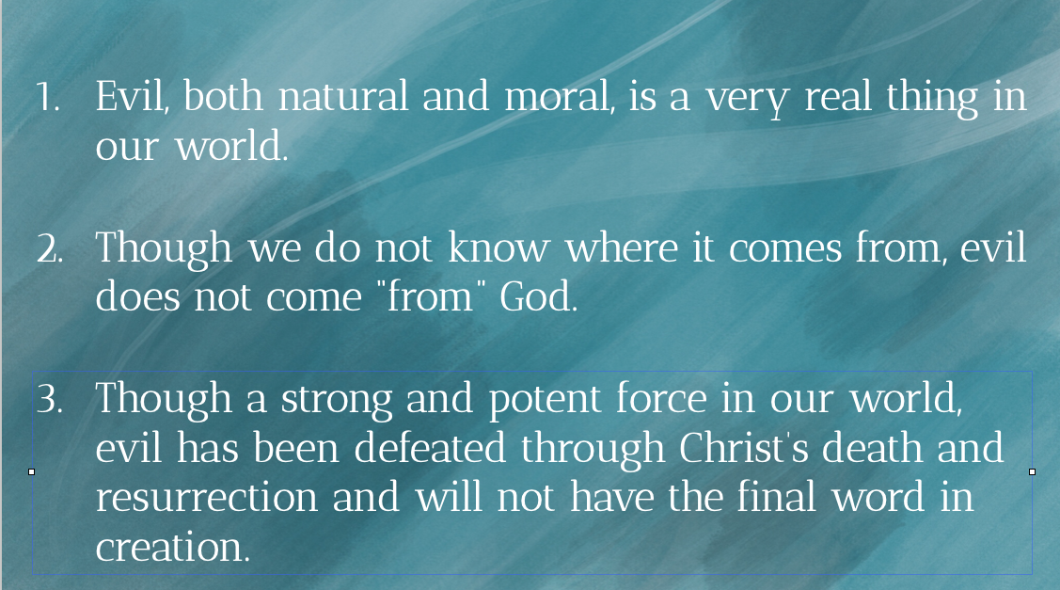
So, to reiterate a few bullet items before we turn to our response to evil.
- Evil, both natural and moral, is a very real thing in our world. To say otherwise is to gloss over the very suffering that Jesus calls us to be present in our neighborhoods and communities.
- Though we do not know where it comes from, evil does not come “from” God. We believe in the all-encompassing goodness of God and, therefore, believe that evil is the very antithesis for what God intends for all of Creation.
- Though a strong and potent force in our world, evil has been defeated through Christ’s death and resurrection and will not have the final word in creation. We believe in the all-powerfulness of God and, therefore, are promised that that word belongs to God and that word will be good.
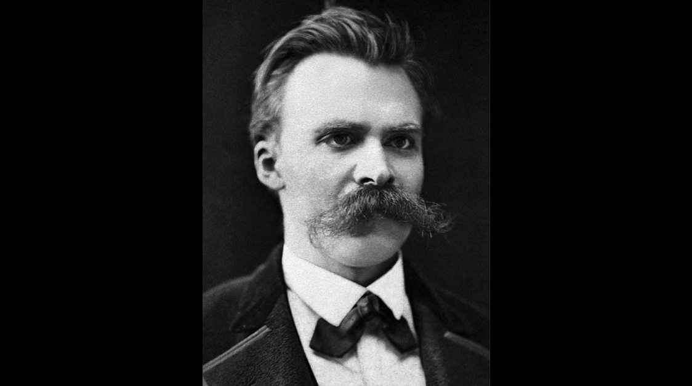
So what is a faithful response to the problem of evil?
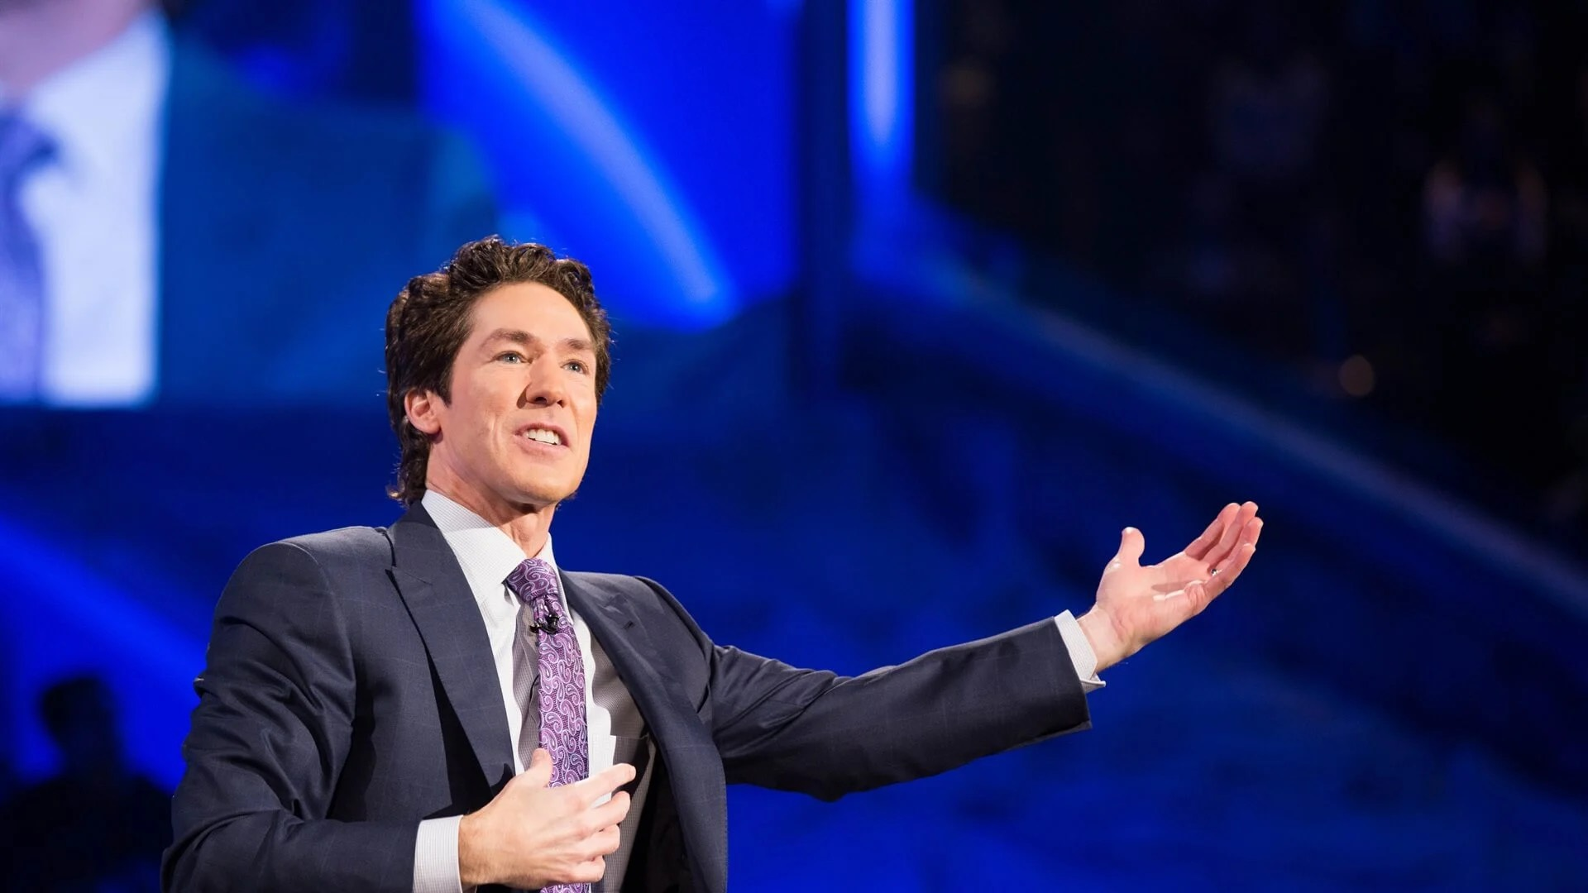
The nihilist responds by saying that nothing really matters and we should all eat, drink, and be merry the best we can before we bite the dust.
Proponents of the so-called “prosperity gospel” respond by saying that if we are suffering from evil of any kind then we simply need to pray more and be more faithful (or give more money to the church!) to compel God to ease our burden.
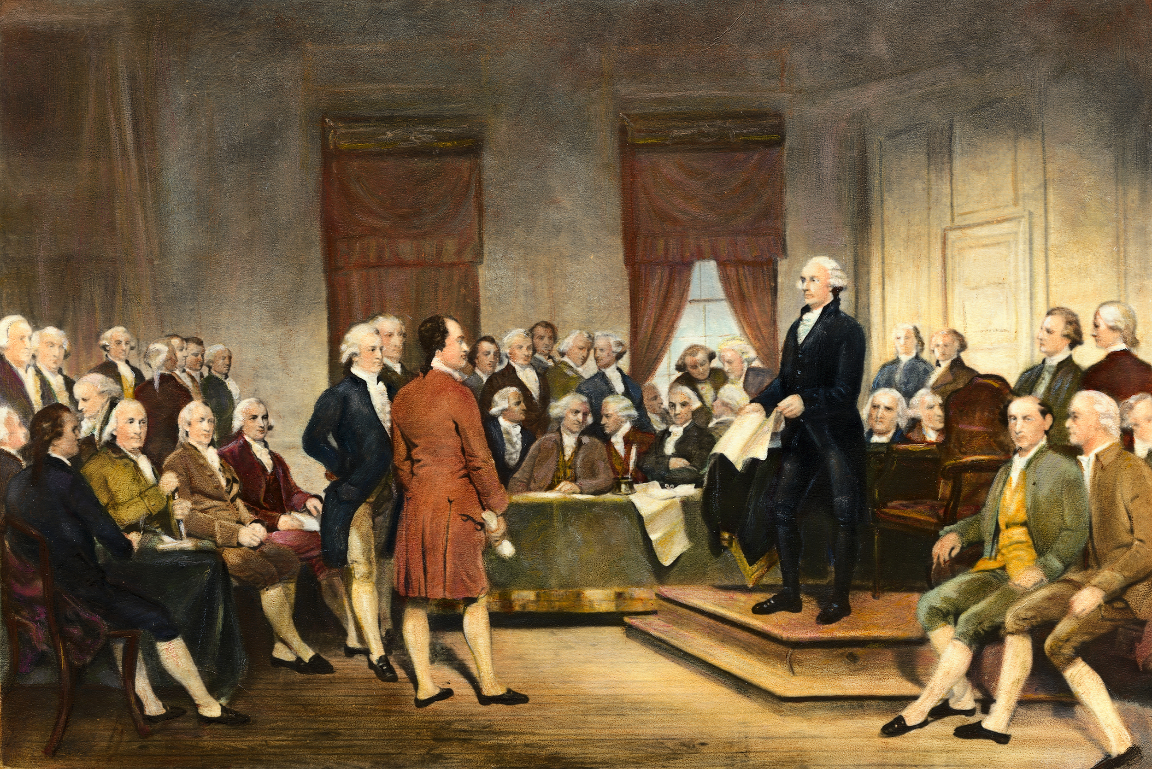
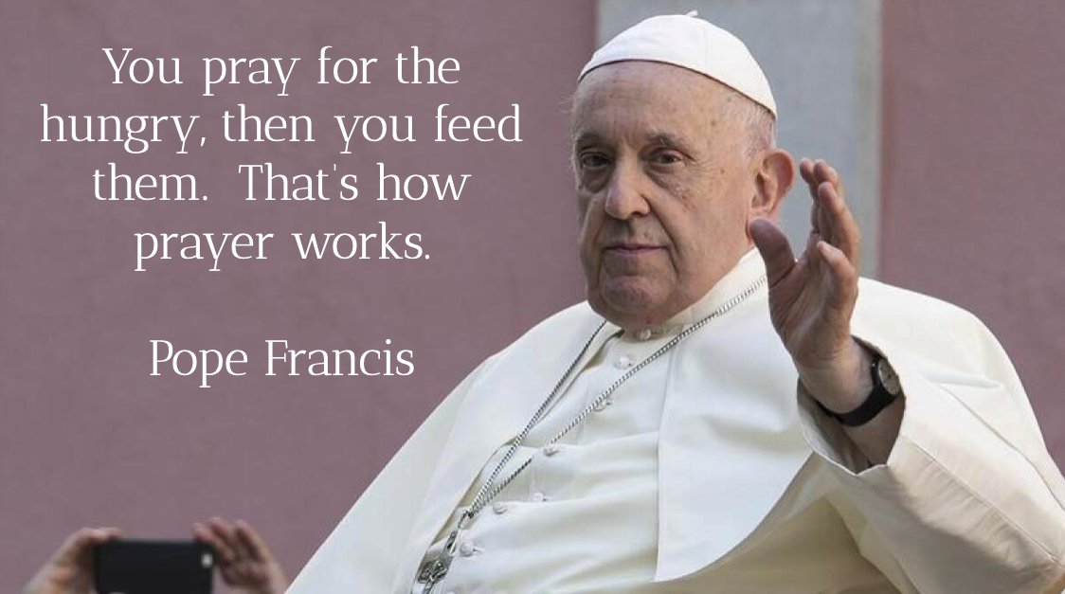
The founding fathers of our country - who weren’t Christian in the sense that we’ve come to understand it, - considered themselves deists which believed in a “clock-maker” God. They saw God as one who wound up creation like a old-fashioned clock and then sat back and remains at a distance, letting it all “play out” for better or for worse. This preserves our freewill but makes God a cruelly distant and apathetic being. So that, ultimately, isn’t a faithful, Christian response.
So, the faithful Christian response is rather simple really: get busy.

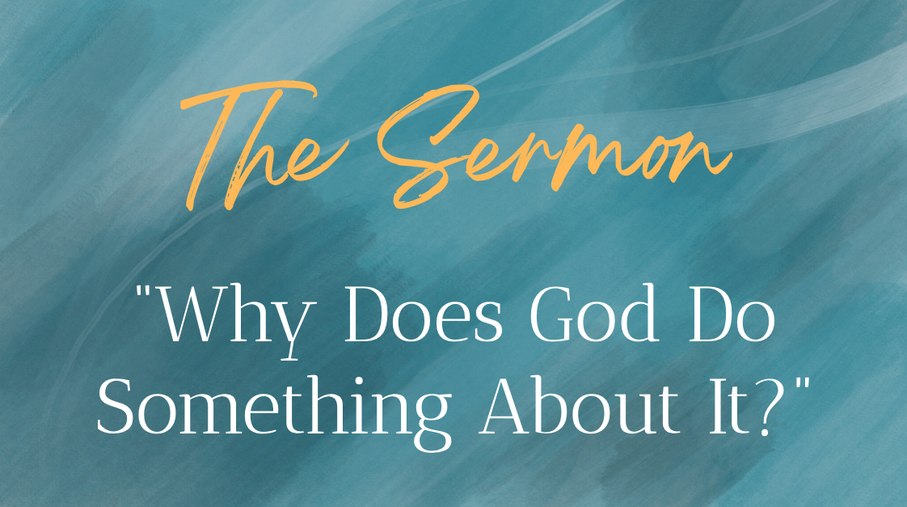
This theological statement from Pope Francis sums up the ethic of this response: “You pray for the hungry, then you feed them. That’s how prayer works.”
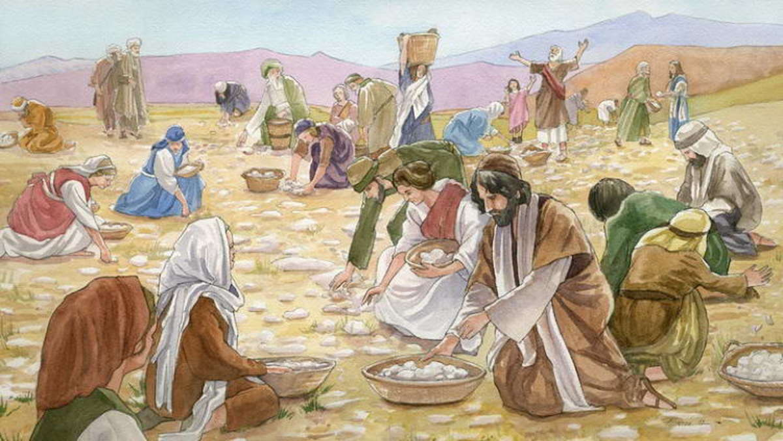
A Christian response to the problem of evil cannot dwell in the realm of trivial, easy answers or sugarcoating. Instead, we respond to evil by meeting it head on, girded by our memory and hope in the God who promises to wipe away the tear from every eye. And this is not our memory and hope alone; it is the memory and hope of the faithful who have gone before us, who have fought the good fight, and finished their race.
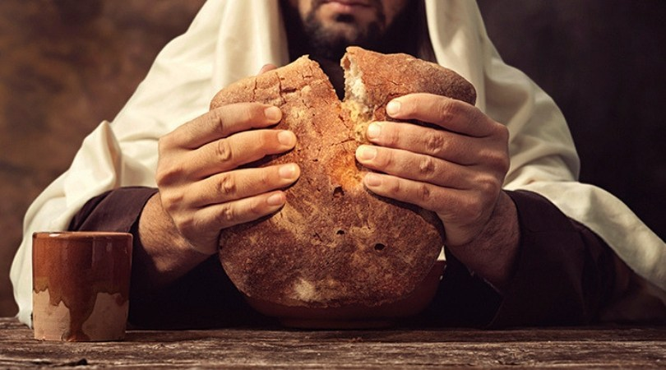
In the face of evil, we remember the memory and hope of the people of Israel who were set apart and called by God to be a holy people, a beacon of reconciliation and justice in a broken world. God didn’t call the Israelites and promise them a future free of the suffering and pain of human existence. No, the Israelites still struggled, they still experienced violence and warfare, plague and famine, trial and tribulation. But God promised to be present with them through it, to advocate on their behalf, and empower them to live out an ethic opposed to the greed and oppression of Pharaoh’s economy.
In the face of evil, we remember the memory and hope of the early Christians who first followed Jesus Christ. Each time they gathered in Christ’s name to celebrate the Lord’s Supper, they remembered Jesus’ ministry. They heard his words saying to them, “Take this bread and drink this cup. Remember the violence done to me. Remember how I stood in solidarity with the suffering of the world. Go and do likewise in my name.” The early Christians themselves lived lives fraught with uncertainty and persecution. Their social worldview was dominated by the violence of the Roman Empire, a power sustained solely through the oppression of others. And yet - and yet - they understood their faith as a calling to subvert the powers of evil in the world, trusting themselves to the authority of a Risen Christ whose resurrection has broken the back of sin and evil in the world. Some folks just haven’t gotten the memo!
Therefore it’s our job to preach that message, that euangelion, that “Good News.” It is perfectly natural, my friends, when evil rears its ugly head, to ask the question, “Why doesn’t God do something about it?” A faithful, Christian response to that question might be as follows: “God is doing something about it…through you!”
It’s ok, my neighbors, to feel at times like Frodo in the Lord of the Rings, to have moments of despair and even cynicism. “I can’t do this, Sam,” Frodo says to his faithful companion. And Sam responds: “I know. It’s all wrong. By rights we shouldn’t even be here. But we are. It’s like in the great stories, Mr. Frodo. The ones that really mattered. Full of darkness and danger they were. And sometimes you didn’t want to know the end. Because how could the end be happy? How could the world go back to the way it was when so much bad had happened?
“But in the end, it’s only a passing thing, this shadow. Even darkness must pass. A new day will come. And when the sun shines it will shine out the clearer. Those were the stories that stayed with you. That meant something. Even if you were too small to understand why. But I think, Mr. Frodo, I do understand. I know now. Folk in those stories had lots of chances of turning back only they didn’t. Because they were holding on to something.”
“What are we holding on to, Sam?” Frodo asks.
Sam responds, “That there’s some good in the world, Mr. Frodo. And it’s worth fighting for.”
J.R.R. Tolkien knew a thing or two about evil; he fought in World War I and served as a cryptographer for the British Army in World War II. And two little hobbits, the product of his theological and literary imagination, serve as a metaphor for the work we are called to do as Christians in a messy world.
Today’s passage from Romans gives us succinct instructions for how we are to live that life together: “do not be overcome by evil, but overcome evil with good.”

I was once at a Pride festival representing my last congregation in Lexington, Kentucky. I had gathered with about half a dozen of our members to go downtown to show our support of the historically marginalized LGBT community. In a corner of the festival was a section with police barriers, behind which counter-protestors could lawfully do their thing. They had the signs condemning the LGBT community, telling them that they were going to burn in hell if they didn’t repent of their “lifestyle.” A few of them had bullhorns and professed to be street preachers who were yelling their condemnations “in love.” I was wearing my clergy collar at the time and I had a few rather unkind things said to my face as well. I ignored it and kept on walking with Tricia and our dog Elsie, who was looking rather fabulous with a rainbow unicorn horn strapped to her fluffy head.
But then I heard something that made me stop in my tracks. I heard singing. In fact, I heard Gloria Gaynor. A group of people had gathered to face the street-preachers and began singing that great disco-anthem, “I Will Survive” at the top of their lungs with looks of unfettered joy. One by one, the chorus grew until their song drowned out the voices of those who were calling them such horrible things.
Friends, I recognize that we’re not all on the same page regarding our views of the LGBTQIA+ community. But I hope we can all agree that yelling at people in the name of Jesus and telling them they’re going to hell isn’t what Jesus is calling us to do and be in the neighborhood. Instead, we’re called to not be overcome by evil, but to overcome evil with good.
And I want to be perfectly clear, I’m not calling those street preachers evil. Rather, we name as evil the systems of oppression to which those people have tethered themselves. To those systems of evil, we sing a joyful song. In the midst of the evil of the world, we gather in this space to preach a word of peace in the violence, a prayer of justice in the midst of such hate, and a song of love in the midst of evil forces that have already lost the war; they just haven’t all gotten the memo yet.
In the name of God the Creator, Redeemer, and Sustainer, may all of us, God’s children, say: Amen.

Christian Doctrine, 168.

