__________________________________________________________________________________________________
Acts 10
In Caesarea there was a man named Cornelius, a centurion of the Italian Cohort, as it was called. He was a devout man who feared God with all his household; he gave alms generously to the people and prayed constantly to God. One afternoon at about three o’clock he had a vision in which he clearly saw an angel of God coming in and saying to him, ‘Cornelius.’ He stared at him in terror and said, ‘What is it, Lord?’ He answered, ‘Your prayers and your alms have ascended as a memorial before God. Now send men to Joppa for a certain Simon who is called Peter; he is lodging with Simon, a tanner, whose house is by the seaside.’ When the angel who spoke to him had left, he called two of his slaves and a devout soldier from the ranks of those who served him, and after telling them everything, he sent them to Joppa.
About noon the next day, as they were on their journey and approaching the city, Peter went up on the roof to pray. He became hungry and wanted something to eat; and while it was being prepared, he fell into a trance. He saw the heaven opened and something like a large sheet coming down, being lowered to the ground by its four corners. In it were all kinds of four-footed creatures and reptiles and birds of the air. Then he heard a voice saying, ‘Get up, Peter; kill and eat.’ But Peter said, ‘By no means, Lord; for I have never eaten anything that is profane or unclean.’ The voice said to him again, a second time, ‘What God has made clean, you must not call profane.’ This happened three times, and the thing was suddenly taken up to heaven.
Now while Peter was greatly puzzled about what to make of the vision that he had seen, suddenly the men sent by Cornelius appeared. They were asking for Simon’s house and were standing by the gate. They called out to ask whether Simon, who was called Peter, was staying there. While Peter was still thinking about the vision, the Spirit said to him, ‘Look, three men are searching for you. Now get up, go down, and go with them without hesitation; for I have sent them.’ So Peter went down to the men and said, ‘I am the one you are looking for; what is the reason for your coming?’ They answered, ‘Cornelius, a centurion, an upright and God-fearing man, who is well spoken of by the whole Jewish nation, was directed by a holy angel to send for you to come to his house and to hear what you have to say.’ So Peter invited them in and gave them lodging.
The next day he got up and went with them, and some of the believers from Joppa accompanied him. The following day they came to Caesarea. Cornelius was expecting them and had called together his relatives and close friends. On Peter’s arrival Cornelius met him, and falling at his feet, worshipped him. But Peter made him get up, saying, ‘Stand up; I am only a mortal.’ And as he talked with him, he went in and found that many had assembled; and he said to them, ‘You yourselves know that it is unlawful for a Jew to associate with or to visit a Gentile; but God has shown me that I should not call anyone profane or unclean. So when I was sent for, I came without objection. Now may I ask why you sent for me?’
Cornelius replied, ‘Four days ago at this very hour, at three o’clock, I was praying in my house when suddenly a man in dazzling clothes stood before me. He said, “Cornelius, your prayer has been heard and your alms have been remembered before God. Send therefore to Joppa and ask for Simon, who is called Peter; he is staying in the home of Simon, a tanner, by the sea.” Therefore I sent for you immediately, and you have been kind enough to come. So now all of us are here in the presence of God to listen to all that the Lord has commanded you to say.’
Then Peter began to speak to them: ‘I truly understand that God shows no partiality, but in every nation anyone who fears him and does what is right is acceptable to him. You know the message he sent to the people of Israel, preaching peace by Jesus Christ—he is Lord of all. That message spread throughout Judea, beginning in Galilee after the baptism that John announced: how God anointed Jesus of Nazareth with the Holy Spirit and with power; how he went about doing good and healing all who were oppressed by the devil, for God was with him. We are witnesses to all that he did both in Judea and in Jerusalem. They put him to death by hanging him on a tree; but God raised him on the third day and allowed him to appear, not to all the people but to us who were chosen by God as witnesses, and who ate and drank with him after he rose from the dead. He commanded us to preach to the people and to testify that he is the one ordained by God as judge of the living and the dead. All the prophets testify about him that everyone who believes in him receives forgiveness of sins through his name.’
While Peter was still speaking, the Holy Spirit fell upon all who heard the word. The circumcised believers who had come with Peter were astounded that the gift of the Holy Spirit had been poured out even on the Gentiles, for they heard them speaking in tongues and extolling God. Then Peter said, ‘Can anyone withhold the water for baptizing these people who have received the Holy Spirit just as we have?’ So he ordered them to be baptized in the name of Jesus Christ. Then they invited him to stay for several days.
__________________________________________________________________________________________
I have a confession to make: I, for the most part, am a lover of rules. Rules are what made all of the games I played in Montreat last week with our youth fun. Rules are what make us safer when we’re driving on the road, or teaching our children to navigate this world, or gathering in public spaces to celebrate. Rules helped reshape the Israelites into the people of God and leave Pharaoh’s economy of creed behind on the far side of the Red Sea. Rules are a necessary part of our existence as creatures in community with one another.
Now, I’m also cognizant of the fact that, as a straight, cis-gender, white male, I live in a world where most of the rules I encounter were made for the benefit of others like me. This is not to say that my life, or the lives of any person like me, has always been easy. It is to say, however, that the color of my skin and my sexuality or gender have never made it harder for me to jump through the hoops of rules that have led me to where I am. In fact, truth be told, it’s made it easier.
And because of that fact, we must admit that there are times when rules need to change. There are times when the “colored only” sign needs to be torn down and burned. There are times when a Baptist Church decides to ordain women and gets kicked out of the SBC as a result. There are times when archaic laws created for a patriarchal world need to be replaced with more just, equitable, and compassionate laws for all of God’s people, not just the ones in the dominate culture.
Yes, I love rules. But I also must confess that blessed are the rule-breakers, for they will break open our hearts to the wideness of God’s welcome! Without rule-breakers, our faith never changes and the Church becomes a stagnant shell of an institution that fails to breathe the breath of the ever-new Holy Spirit into the lungs of a weary world.
Our final question of our sermon series is “Where Do We Go From Here?” It’s a question that been asked a lot of this congregation, as well as countless others.
- We’ve been through a painful time of partisan division and we’ve struggled to remain a unified congregation. Where do we go from here?
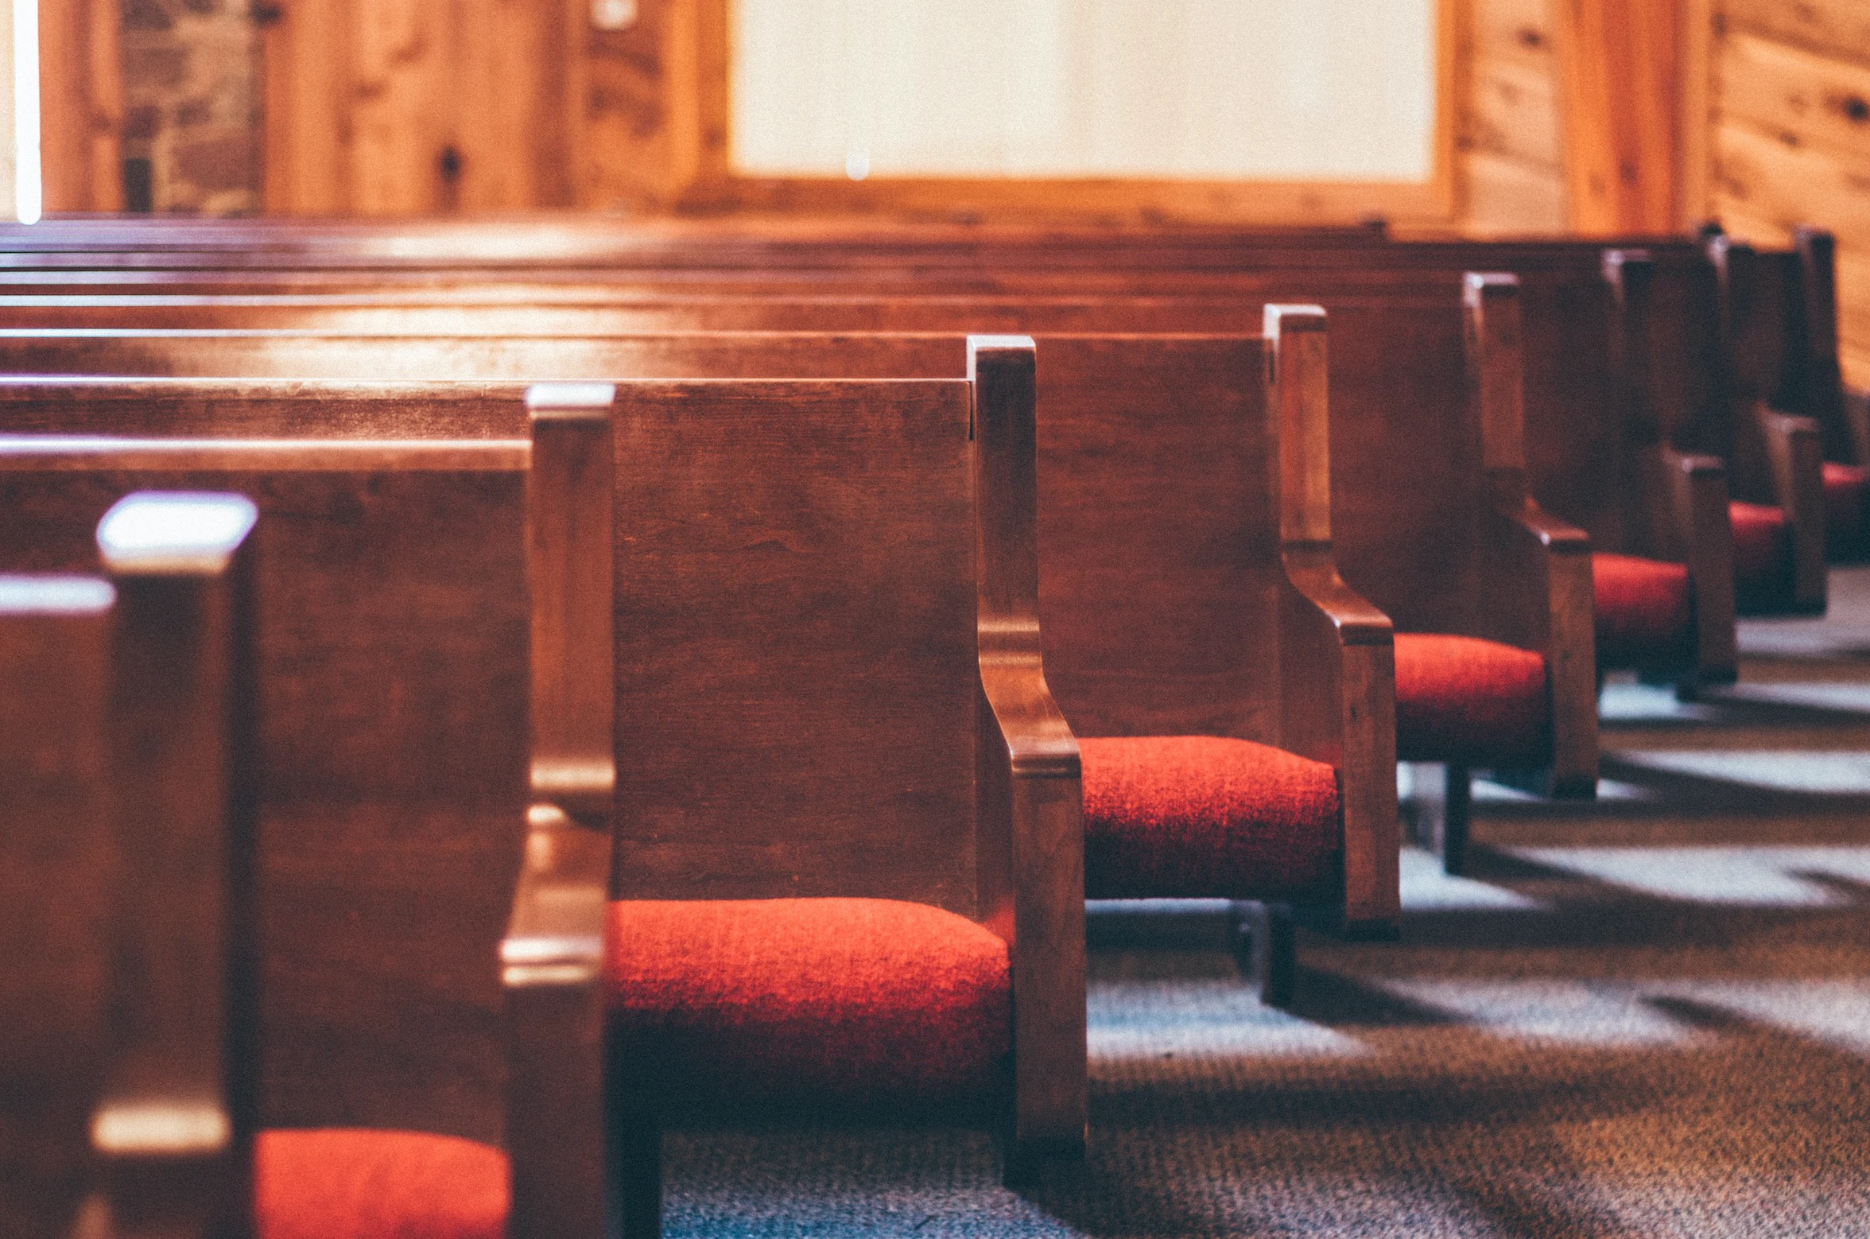
- We’ve been through a global pandemic and a lot of people, for various reasons, haven’t returned to church. Where do we go from here?

- Our children and our grandchildren have no interest in Christianity or the churches that proclaim it and we’re worried my family’s faith tradition will die with my generation. Where do we go from here?
- We have more information at our fingertips that any other generation before us, but we wonder where we can find the wisdom to know what to do with it. Where do we go from here?

We can ask ourselves that question in a million different contexts. And in whatever context you’re asking that question, God is speaking to you this day with the text from Acts 10 that Rita and I read a few minutes ago.
Peter knew the rules. He knew that they were meant to remind him who he was, as a Jewish person, in relation to God and his neighbor. But he had spent years following a man who reminded him and his fellow disciples that knowing the law is one thing and living the heart of the law is sometimes something completely different. Jesus touched unclean people; this was against the rules. He broke bread with people who had to sell their bodies to make ends meet and persons with leprousy; this was against the rules. His disciples picked grain and he healed people on the sabbath; this was against the rules. And Jesus caught a lot of flak for those things, as have people throughout the millennia who have peacefully protested rules that have existed only to divide and dehumanization, to malign and marginalize.

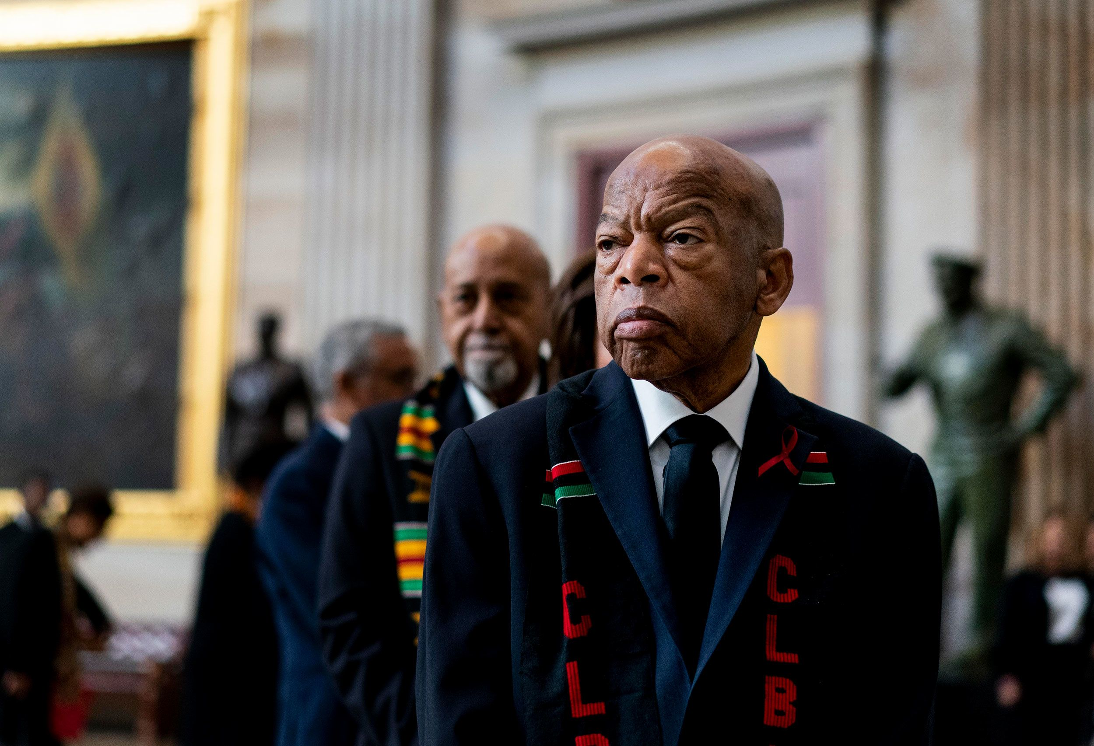
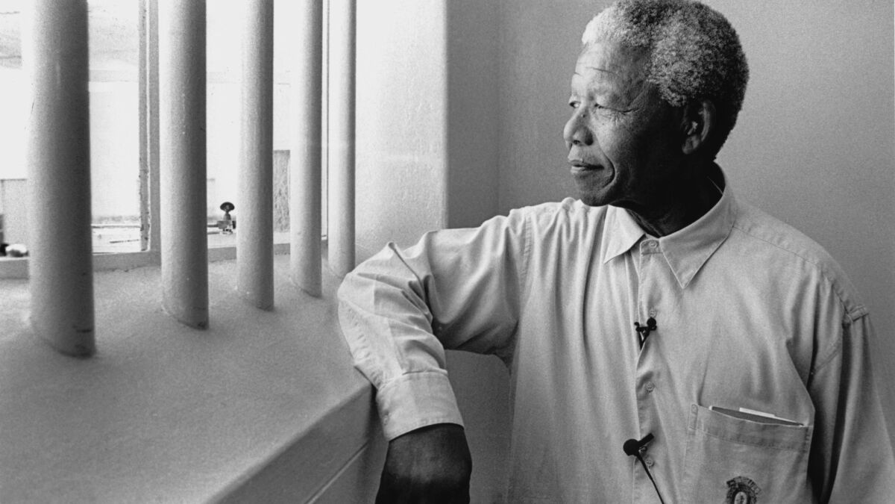
John Lewis was spat on and beaten.
Nelson Mandela was imprisoned.

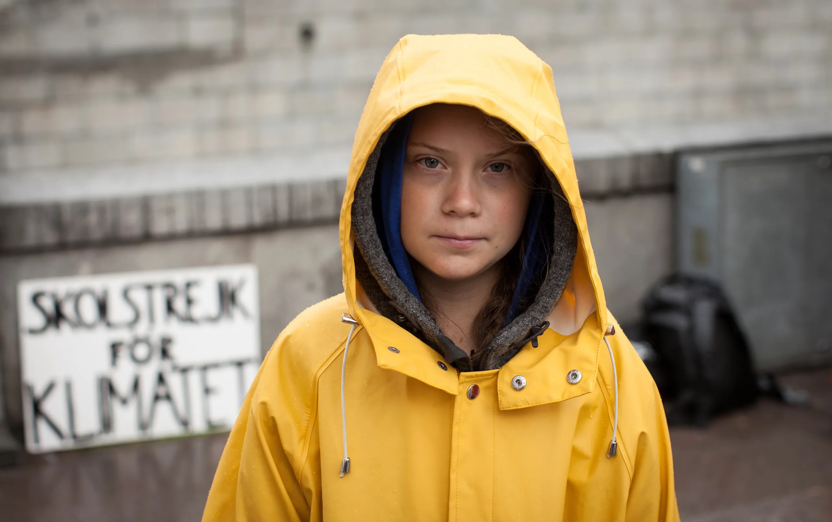
Malala Yousafzai was shot in the face.
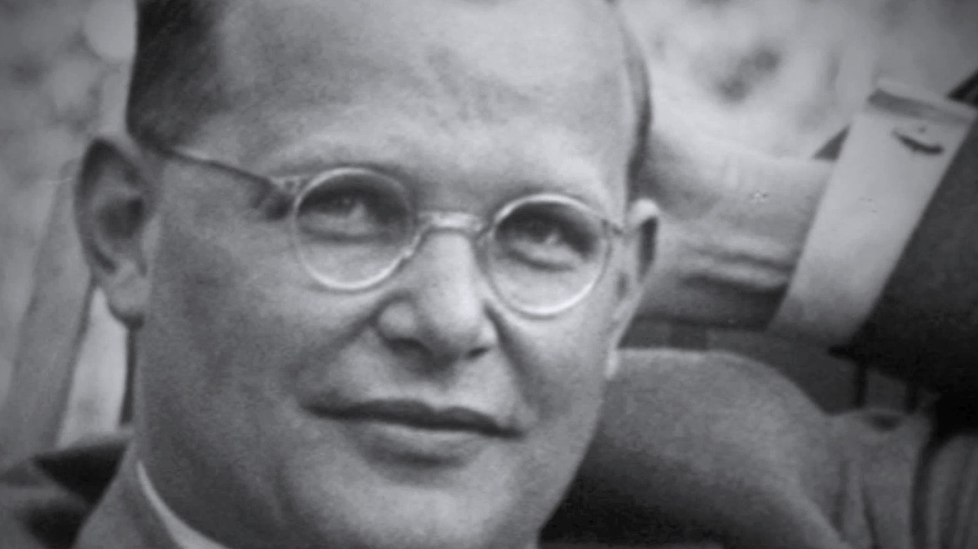
Greta Thunberg has been ridiculed and dismissed.
Dietrich Bonhoeffer was hanged by the Nazis.

And, still, despite the violence they endured, those agents of holy rule-breaking led and are leading us to a place where the rules better reflect and respect the full diversity of God’s creation. You see, the Church hasn't always been on the right side of history. There have been times when we’ve clung to rules that might not have been intended to divide and marginalize when they were created, but have come to a place to be interpreted in ways that do just that.
And friends, it not just rules that are “in the books,” so to speak. It’s about customs and norms, practices and traditions. In our reading of the book, “Growing Young: Six Essential Strategies to Helping Young Adults Discover and Love Your Church,” we’ve learned that congregations can often default to behaviors and practices that can unknowingly act as barriers to maintaining and strengthening relationships with our young adults, youth, children, and their families. My hope and prayer is that we can grow together as a community that understands that our highest allegiance isn’t to any rule, or law, or practice, or custom, or norm, or tradition. But our highest allegiance is to the very God that compelled Peter to widen God’s welcome and to understand that the rules and customs of humanity, and even those given to us in scripture, must never intentionally or unintentionally function as barriers to meaningful connection and service to and with our neighbors.
And so, amid the uncertainties of the paths before us, where do we go from here? What does Acts 10 have to tell us about charting a course in the choppy waters of our messy world?
- We can’t go from here prioritizing our traditions and customs over our mandate to serve one another in Christ’s name. When our prioritization goes the opposite direction, we cease to be the Church.
- We can’t go from here by staying on the roof. In today’s passage, Peter’s revelation that he must never call profane that which God has called clean stays in the abstract until he descends from the roof to meet face-to-face with Cornelius. The Church cannot stay on the rooftop, or the sanctuary, or the Sunday school room, or the committee meeting discussing the importance of diversity and inclusion. The Gospel cannot remain in the abstract, in the theoretical or hypothetical. The Gospel must be as tangible and concrete as the water Peter used to baptize Cornelius and his family.
- We can’t go from here with a subconscious desire to go back to the way things were. That isn’t happening. It never happens that way. It’s long past time for us to let that go and lean into the future God has planned for us.
So where can we go from here?
- We can go from here trusting that whenever God calls us to cross a line that divides us from our neighbor, God will be waiting for us on the other side, no matter where it takes us. Peter hesitated when God implored him to expand his understanding of God’s welcome, but he pushes through that hesitation in the hope that God would meet him in the face of the stranger he was being called to minister to and with. And God followed through with that promise. SHOW BBT SLIDE
- We can go from here by focusing on intentional, authentic, and vulnerable connection. My friend and colleague, Ruth Santana Grace was the preacher at Montreat Youth Conference last week and she had a line in one of her sermons that I commend to y’all: “I’ll take being in relationship over being right any day of the week.” In today’s text, God calls Peter to stop focusing on what was “wrong” and “right” in terms of legalism, and instead focus on the immediate physical and spiritual needs of the person in front of him. We’d do well to make that our focus as well.
- We can go from here by reminding ourselves that the best is yet to come. Peter was given the blessed and gargantuan task of building Christ’s Church in his name. But he wasn’t called to do it alone. God knew that this opportunity was far too great to be done by any one person. And so, God surrounded Peter with people different from him to build his Church. Therefore, like Peter, we can trust that the best is yet to come. However, we must always remember that when we say that the best is yet to come, we are not saying that the easy is yet to come. Being Church is hard, y’all, and these days it can seem harder than ever in a culture that, for worse or for better, doesn’t automatically afford the Church the trust that it once did. We go from here in trust that God is with us and in hope that God will strengthen us for the roads ahead.
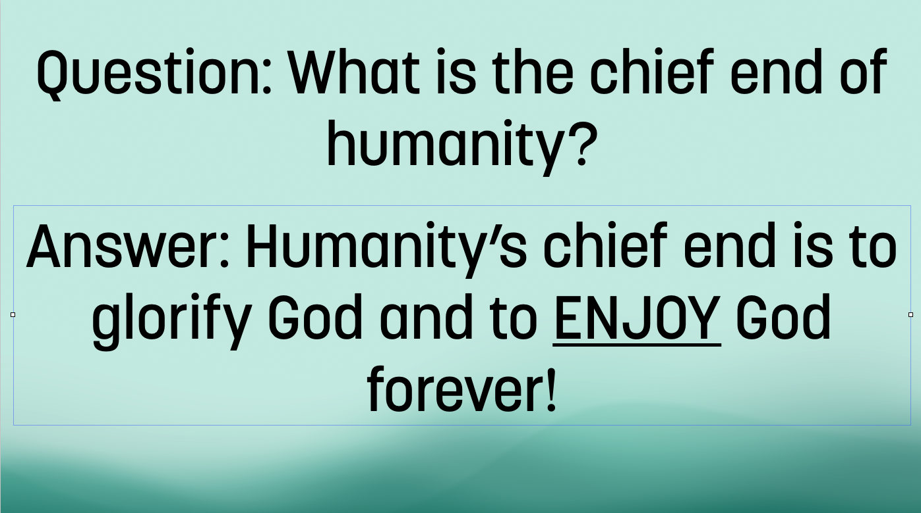
- And having just gotten back from Montreat with the High School Youth, I would be remiss if I didn’t give a shout out to this year’s theme: In Joy. Let us never forget the first question of the Westminster Shorter Catechism.

What is the chief end of humanity? To glorify God and to ENJOY God forever.
Friends, we go from here in joy! In all that we do, in all who we are, and in all that God is calling us to be, we do in joy because it is the joy we find in God through each other than fuels us for the journey ahead.
In the name of God the Creator, Redeemer, and Sustainer, may all of us, God’s children, say: Amen.

