Trinity Sunday (Year B)

__________________________________________________________________________________________

Matthew 20:1-16

‘For the kingdom of heaven is like a landowner who went out early in the morning to hire laborers for his vineyard. After agreeing with the laborers for the usual daily wage, he sent them into his vineyard. When he went out about nine o’clock, he saw others standing idle in the market-place; and he said to them, “You also go into the vineyard, and I will pay you whatever is right.” So they went. When he went out again about noon and about three o’clock, he did the same. And about five o’clock he went out and found others standing around; and he said to them, “Why are you standing here idle all day?” They said to him, “Because no one has hired us.” He said to them, “You also go into the vineyard.” When evening came, the owner of the vineyard said to his manager, “Call the laborers and give them their pay, beginning with the last and then going to the first.” When those hired about five o’clock came, each of them received the usual daily wage. Now when the first came, they thought they would receive more; but each of them also received the usual daily wage. And when they received it, they grumbled against the landowner, saying, “These last worked only one hour, and you have made them equal to us who have borne the burden of the day and the scorching heat.” But he replied to one of them, “Friend, I am doing you no wrong; did you not agree with me for the usual daily wage? Take what belongs to you and go; I choose to give to this last the same as I give to you. Am I not allowed to do what I choose with what belongs to me? Or are you envious because I am generous?” So the last will be first, and the first will be last.’
__________________________________________________________________________________________
Brené Brown is an educator, researcher, and widely-read author of six number-one New York Times bestsellers, most of which are on the topic of emotional awareness, shame, vulnerability, and leadership. If you have not read her stuff, I highly recommend her because much of what she writes about has do to with how we relate to one another in ways that are both healthy and unhealthy. The Gospel, at its core, is nothing more or less than that: it’s relating to one another in ways that follow Jesus’ mandate to live together as the Beloved Community.
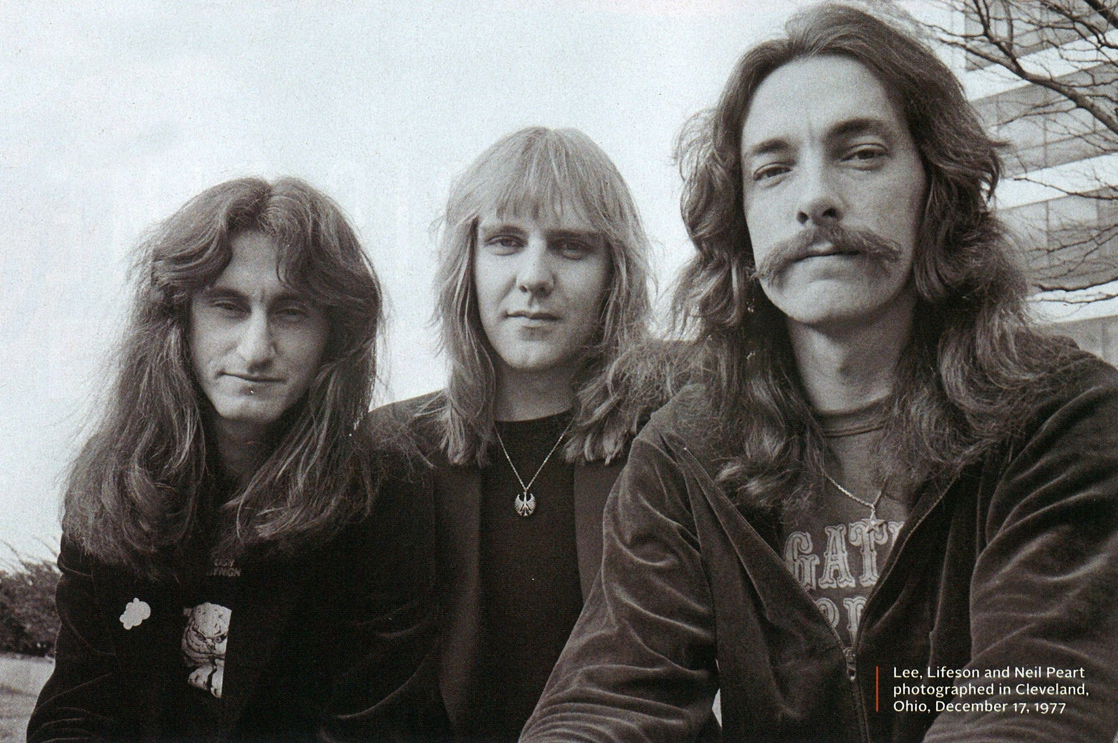
Brené Brown and I have at least two things in common.
First of all, we are both fans of the famous progressive rock band, Rush.
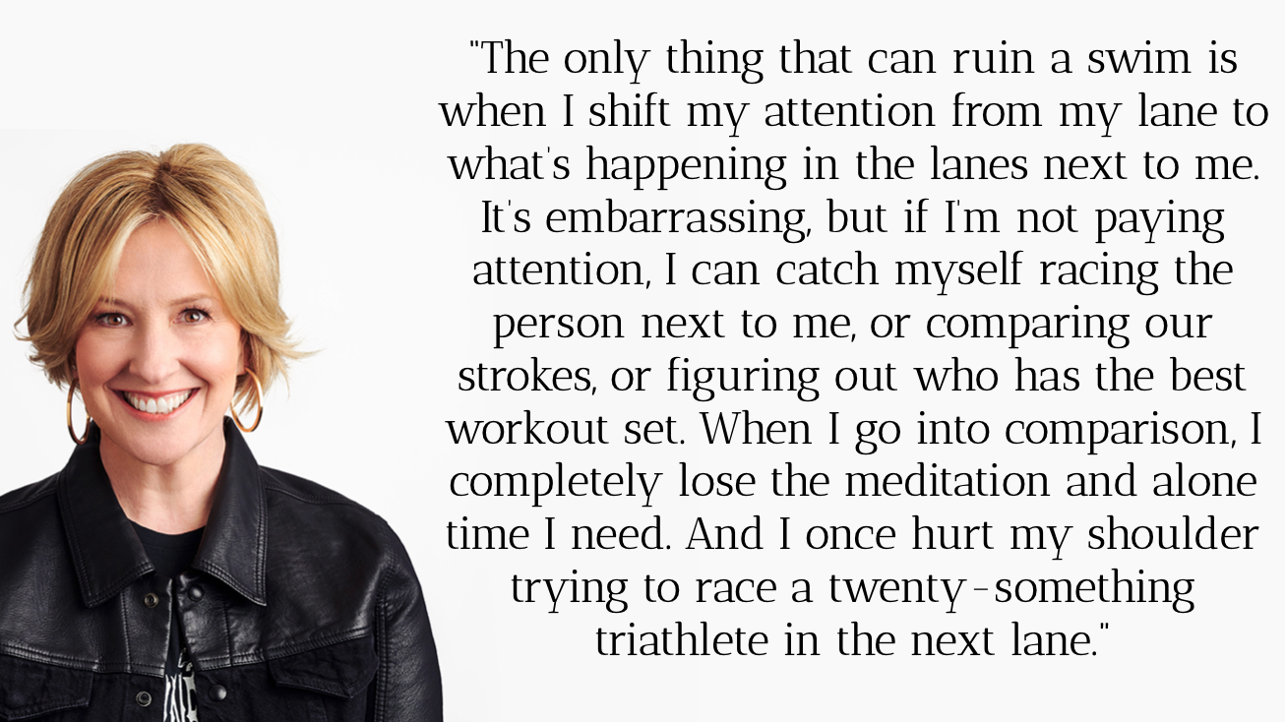
Secondly, we are both swimmers. She describes her love of swimming as being the perfect trifecta for introverts like us: it’s simultaneously exercise, meditation, and alone time. She says the following about her swimming practice:
“The only thing that can ruin a swim is when I shift my attention from my lane to what’s happening in the lanes next to me. It’s embarrassing, but if I’m not paying attention, I can catch myself racing the person next to me, or comparing our strokes, or figuring out who has the best workout set. When I go into comparison, I completely lose the meditation and alone time I need. And I once hurt my shoulder trying to race a twenty-something triathlete in the next lane.”

Comparing ourselves to one another is rarely something that nourishes our souls or builds up healthy community. Upward social comparison leaves us depressed and envious. Downward social comparison often leaves us with a superiority complex, self-righteousness, and makes us decidedly unneighborly. But comparing ourselves to one another seems to be, well, unavoidable. We compare ourselves to one another almost subconsciously. I know the feeling well. When I’m swimming at Club Fitness right around the corner on Lendew Street, and I see someone in the lane next to me, I automatically assess who’s swimming faster. And, just like Brené Brown, that’s usually the precise moment that I stop focusing on my stroke and fall out of rhythm and, in general, leave the meditative space that I came to the pool precisely to find.
If I have a college triathlete swimming in the lane next to me, I immediately compare myself to them and feel like I’m too slow. If someone next to me is swimming rather slowly, for whatever reason, I give myself a mental pat on the back for being faster and that leaves me feeling, well, not that great either because that’s not the person I feel Jesus is calling me to be.
I believe it was Teddy Roosevelt who first coined the phrase: “comparison is the thief of joy” and perhaps he was on to something.
Scripture is replete with examples of people comparing themselves with another because, let’s face it, it makes for some rather juicy stories. The first, of course, was Adam and Eve, who listened to the snake and compared themselves with God. Their son, Cain took the comparison game even further and his brother Abel was the collateral damage. Leah and Rachel. Jacob and Esau. Saul and David. All of these stories involve conflict that begins with one person is being compared to another, either by themselves or another character in the plot.
Today’s passage is an example of such comparison.
This parable tells us a story of a vineyard owner who has the audacity, and the generosity, to pay everyone the same amount, no matter how long they worked for him that day. To be clear, he doesn’t shortchange anyone; he pays the workers who worked the longest no less than what he originally agreed to pay them. It’s just that he decides to pay everyone that amount; and that bothers the workers who had been there since daybreak.
I always find it a bit funny that the landowner seems to deliberately cause this argument. You see, he lined up everyone to be paid. You take your paycheck and then you walk away. If he had started with the people who had been there all day, they would have taken their money and left and would have been none the wiser as to their employers’ graciousness. But the landowner deliberately starts with the workers who had only been there the shortest because he wanted those who had been there all day to see what he was doing. He was stirring the pot and he knew it.
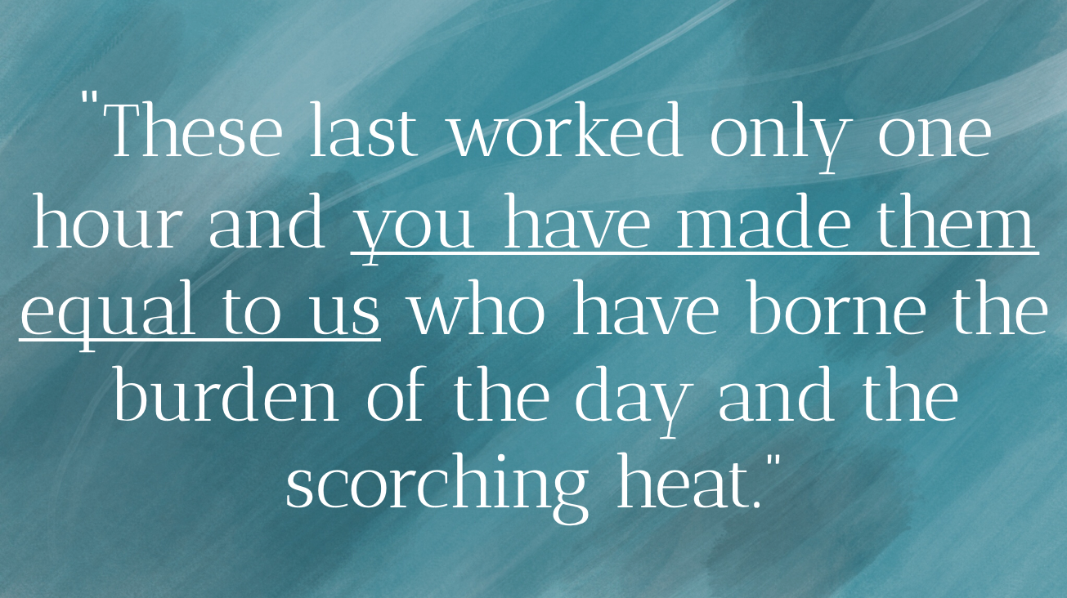
And that stirred pot whipped up some pretty nasty words from the workers who had been there all day:
“These last worked only one hour,” they snarl, “and you have made them equal to us who have borne the burden of the day and the scorching heat.” Brené Brown would probably say that these disgruntled workers weren’t paying attention to their own lane in the pool. Instead, they lost focus on their own journey and started gazing in the neighboring lanes.
Comparison rarely builds up community. And Jesus’ message through this parable is one way of telling his followers that the economy of God’s kingdom is not driven by the forces of comparison - upward or downward. And this is good news for the neighborhood because we have scientific research suggests comparison is the thief of joy and a barrier to meaningful relational connection. In her book, Atlas of the Heart, Brené Brown quotes the research of one Frank Fujita who says the following of comparison: “Social comparisons can make us happy or unhappy. Upward comparisons can inspire or demoralize us, whereas downward comparisons can make us feel superior or depress us. In general, however, frequent social comparisons are not associated with life satisfaction or the positive emotions of love and joy but are associated with the negative emotions of fear, anger, [and] shame…”
If comparison tends to lead us to the emotions of fear, anger, and shame, then we should pay attention to that. Because while none of those emotions - or any emotions for that matter - are in and of themselves “bad,” decisions that are made from a place of fear, anger, or shame tend to lead us to unhealthy places in our relationships. To use today’s parable as an example, the workers who had been there all day could have chosen instead to celebrate that generous gift and reflect that generosity themselves towards others. Instead, their downward comparison led them to anger.
So where does that leave us? When we’re tempted to think we’re “not enough” because we practice upward comparison or - on the flip side - consider others “not enough” because of our downward comparison, what do we do with that? What’s the Christian response to living in a world hardwired for comparison?
Well, first of all, we must acknowledge that comparing ourselves to others is an inescapable part of being human. There’s just no way around it: comparing ourselves is just something that we do in ways that we realize and in ways that we don’t. Though comparison isn’t an emotion, per se, we can still treat it as such. While we may not be able to avoid doing it, we do have the power to choose how we respond to it.
How might we respond to the temptation of upward social comparison? Those moments when the person in the lane next to us is swimming faster. Well, we can acknowledge that they are swimming faster, and wish them well in their lane and return our focus to our own. This takes time. This takes practice.
And then how might we respond to the temptation of downward social comparison? Those moments when the person in the lane next to us is swimming slower. Well, we can wish them well on their swim, help them to swim faster if that’s something they ask for, and then return our focus to our lane. Again, this takes time. This takes practice.
From a theological perspective, we are reminded on this communion Sunday, that no matter how fast or slow we swim, so to speak, we all eat at the same table and partake of the same cup and the same bread. To use today’s parable as a metaphor, we are all invited to partake of the same cup and the same bread whether you’ve been here for years and years and years or whether today is your first time stepping into a church. We receive the same grace, the same forgiveness, and the same salvation. And we can choose to resent that or we can choose to celebrate it.
Friends, I get it. I feel “not enough” a lot. More often than not, what threatens my mental health is less when others compare themselves to me but when I compare myself to others. As a parent, I compare myself to other parents. As a pastor and preacher, I compare myself to other pastors and preachers. I do this, too, as a musician, a hymn writer, a swimmer, and so on and so forth.
And if I’m not careful, y’all, the rabbit hole of comparison can swallow me up and, ironically, become a self-fulfilling prophesy. So, if you, like me, know that struggle, I offer to you some of the following concrete things I try to do to help mitigate that rat race. This list is neither comprehensive or universal; these things may or may not work for you and I encourage you to find whatever works best for you on your spiritual journey.
- First is therapy. My weekly visit to my therapist, Laura, is a chance for me to explore my emotions and talk with a trained mental health professional about how I can respond to those emotions in ways that are healthy for me and those I love. When I’m tempted to focus on other lanes in the pool, my therapist often encourages me to focus on my lane and how I can have the best swim possible for me in that moment.
- Second is practicing sabbath. Rest, in whatever ways and forms we can find it and practice it, is a necessary reset button that redirects our focus to a place of gratitude. If comparison is the thief of joy, then gratitude is the enemy of comparison.
- Thirdly and finally, is to surround myself with people who remind me that I am enough. Now, it might be tempting to think that if we surround ourselves with people that remind us that we are enough that that would lead us to a place of apathy, that it would lead us to abandon any attempts for self-improvement or growth. But that’s just not true, at least not in my experience. In fact, I find the opposite to be true. When I surround myself with people who remind me that I’m enough, it actually inspires me to continue to be the best version of myself that I can be. To surround ourselves with people who remind us that we’re enough is in no way to suggest that we are not to be held accountable when we hurt someone or mess up. In order to be a healthy human being, I need the same people who tell me that I’m enough tell me lovingly when I’ve done something to hurt someone else so that I can fix that behavior.
Ultimately, the Christian response to comparison is to see one another the same way that God sees us: as people swimming in different lanes that are all worthy of the same Good News. And that means we uplift one another and encourage each other as we all swim our races, so to speak.
I opened this sermon with Brené and I’ll close it with Bluey.
There’s an episode called “Baby Race” that starts with Bluey asking her mom if she is better at the monkey bars than her little sister, Bingo. Chili, the mom, decides to tell Bluey about how she started walking as a baby.
While surrounded by all the other moms and their babies, Bluey was the first one to roll over. Chili, naturally, beams with pride. Fast forward a few months and Chili and Bluey are back with the same group of moms and their kids. Much to Chili’s dismay, another child named Judo starts to sit up on her own before Bluey does. Later on, by the time Bluey learns to do the same, Judo has already learned how to crawl and then walk.
As Chili begins to teach Bluey how to crawl, Bluey decides to roll around instead.
Then, instead of crawling, Bluey shuffles around on her bum instead and then eventually begins to crawl…backward. As the other children begin to walk, she gets worried. She takes Bluey to the doctor to make sure she’s not doing anything wrong and the doctor insists this is completely normal. This does little to sooth Chili’s feelings of inadequacy as a new parent.
Another mom notices Chili’s situation and comes over to their house one day. Her name is Bella, a pink poodle who is the mother of nine kids. Chili is amazed at this fact and says to Bella, “You must have learned a thing or two,” to which Bella replies, “I have. And there’s something you need to know:
you’re doing great.”
From then on, Chili lets Bluey just do her thing and run her own race. In time, she begins to walk and all is well.
Friends, there are so many voices in the world that tell us that we’re not enough. Not rich enough, or popular enough, attractive enough, powerful enough, etc. We don’t need more voices like that. What we do need more of is voices like Bella who can assure us that we are, in fact, enough. That we're doing great.

The Church is called to be that voice in the neighborhood. As followers of Jesus Christ, our faith in him is rooted in a man who practiced radical hospitality to persons who knew what it was like to be compared to others in ways that dehumanized them and caused them harm. So if we take his message seriously, we are then called to the Table where God’s voice gives us the assurance that we are enough just as we are to receive God’s grace and mercy.
In the name of God the Creator, Redeemer, and Sustainer, may all of us, God’s children, say: Amen.

