Resurrection of the Lord (Year A)

__________________________________________________________________________________________

John 20:1-18

Early on the first day of the week, while it was still dark, Mary Magdalene came to the tomb and saw that the stone had been removed from the tomb. So she ran and went to Simon Peter and the other disciple, the one whom Jesus loved, and said to them, ‘They have taken the Lord out of the tomb, and we do not know where they have laid him.’ Then Peter and the other disciple set out and went towards the tomb. The two were running together, but the other disciple outran Peter and reached the tomb first. He bent down to look in and saw the linen wrappings lying there, but he did not go in. Then Simon Peter came, following him, and went into the tomb. He saw the linen wrappings lying there, and the cloth that had been on Jesus’ head, not lying with the linen wrappings but rolled up in a place by itself. Then the other disciple, who reached the tomb first, also went in, and he saw and believed; for as yet they did not understand the scripture, that he must rise from the dead. Then the disciples returned to their homes.
But Mary stood weeping outside the tomb. As she wept, she bent over to look into the tomb; and she saw two angels in white, sitting where the body of Jesus had been lying, one at the head and the other at the feet. They said to her, ‘Woman, why are you weeping?’ She said to them, ‘They have taken away my Lord, and I do not know where they have laid him.’ When she had said this, she turned round and saw Jesus standing there, but she did not know that it was Jesus. Jesus said to her, ‘Woman, why are you weeping? For whom are you looking?’ Supposing him to be the gardener, she said to him, ‘Sir, if you have carried him away, tell me where you have laid him, and I will take him away.’ Jesus said to her, ‘Mary!’ She turned and said to him in Hebrew, ‘Rabbouni!’ (which means Teacher). Jesus said to her, ‘Do not hold on to me, because I have not yet ascended to the Father. But go to my brothers and say to them, “I am ascending to my Father and your Father, to my God and your God.” ’ Mary Magdalene went and announced to the disciples, ‘I have seen the Lord’; and she told them that he had said these things to her.
__________________________________________________________________________________________
Two weeks ago today, my feet were anointed up here as the newest pastor of this great congregation by my friend and colleague, Shavon. A few days ago, we gathered in this very room to celebrate the Lord’s Supper on the evening on which Christ was betrayed. There, more feet were anointed that evening and blessed for the journey of Christian discipleship. Acknowledging that we have different forms of mobility and that we can speak of feet both literally and metaphorically, we gave thanks for the places our feet have taken us on this Lenten journey.
On Ash Wednesday, our feet carried us forward in this room, as our bodies were marked with ash, symbolizing that we come from dust and to dust we shall return. We celebrated that dusty deaths are not the final word, because dust is the stuff of creation for a God who molded us from the dust of the earth.

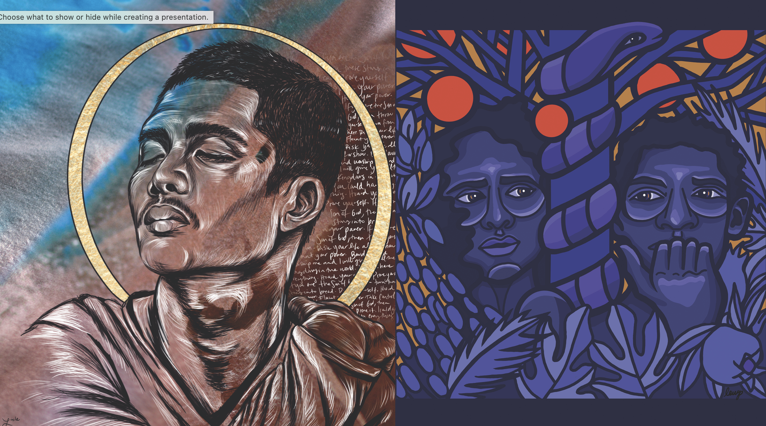
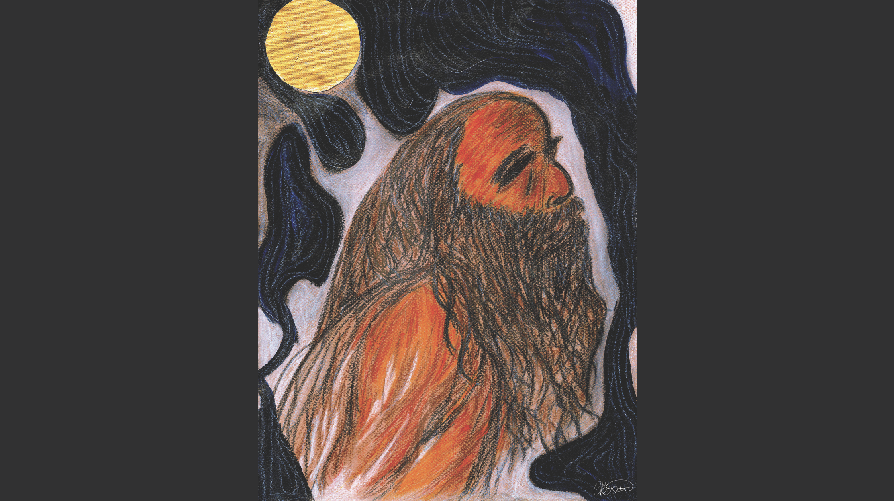
On the first Sunday in Lent, our feet carried us with Jesus as he was tempted in the wilderness and with Adam and Eve in the Garden, and we practiced holy curiosity for what voices heal us and remind us of our beloved-ness.
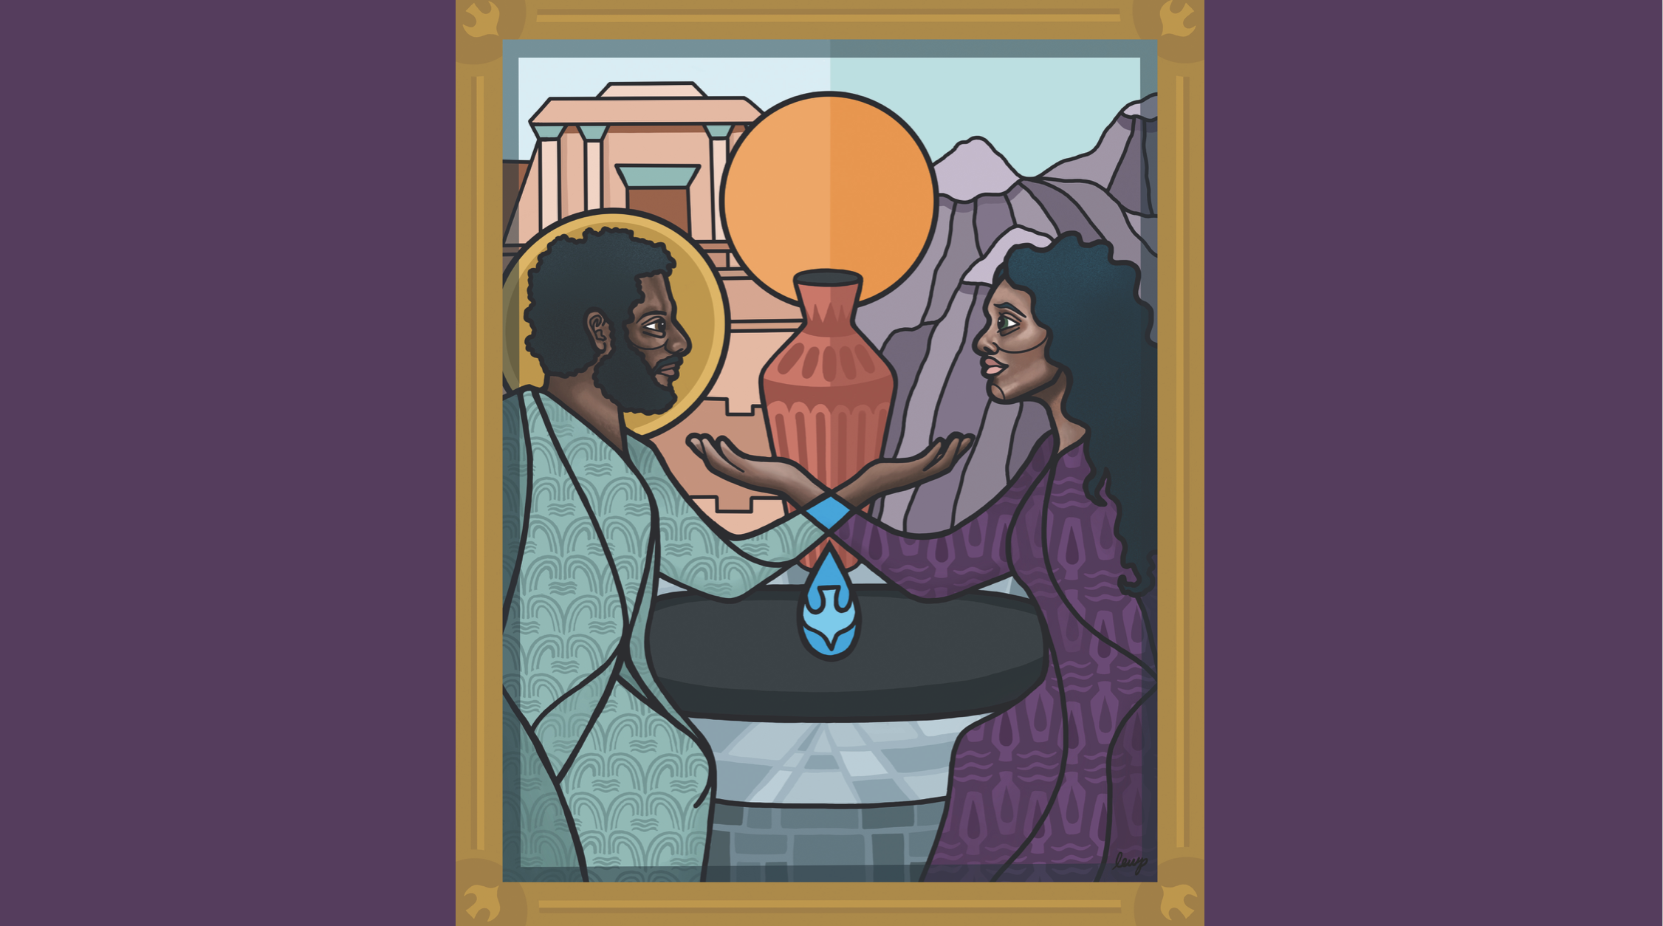
On the second Sunday in Lent, our feet carried us with Nicodemus who came to Jesus at night, asking the questions that keep us awake, questions about new life and new beginnings.

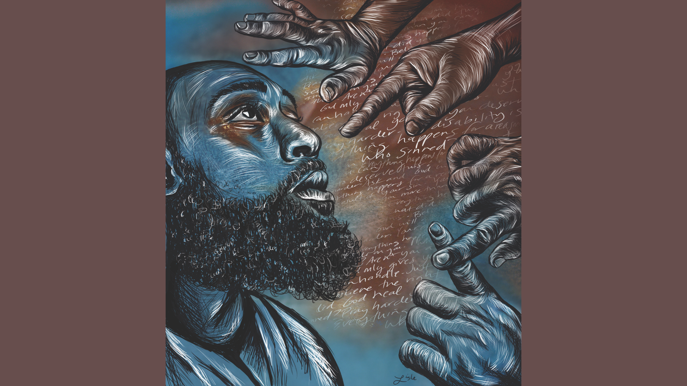
On the third Sunday in Lent, our feet carried us to a well in the heat of midday, as Jesus respected the dignity of a marginalized woman to ask for a drink of water.
On the fourth Sunday in Lent, our feet - or our wheelchairs and walkers, our crutches and canes - carried us through the story of Jesus healing the man born in blindness. We asked ourselves how we can be more hospitable and inclusive of our neighbors with disabilities.
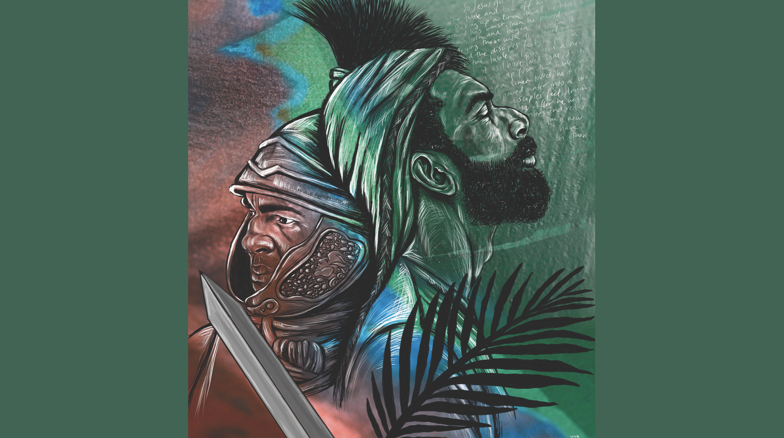
On the fifth Sunday in Lent, our feet carried us through a valley of dry bones, and we asked ourselves “Can these bones live?” We listened to the words of Ezekiel, and our own words of affirmations, which tells us that resurrection is both possible and promised.
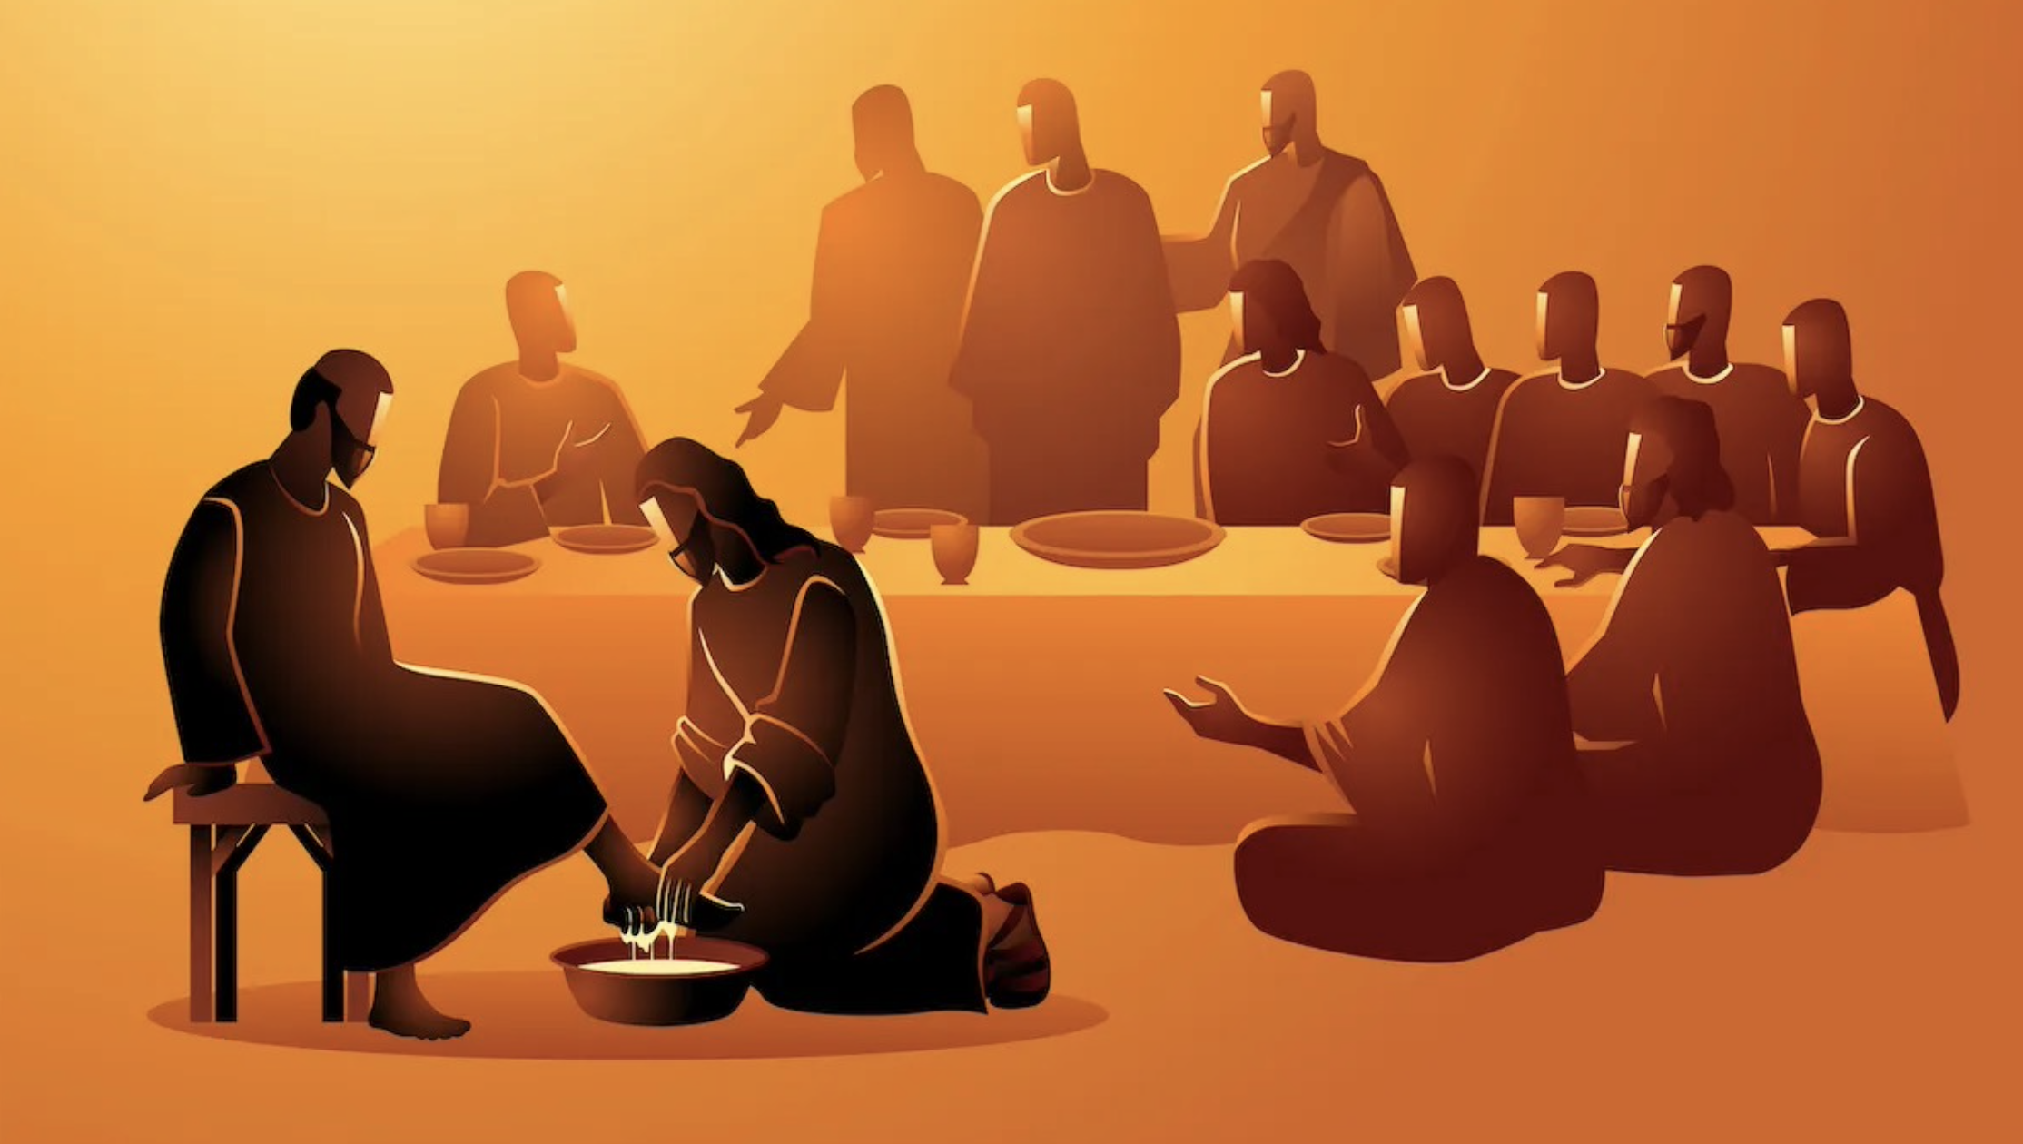
Last week, on Palm Sunday, our feet carried us to a peaceful protest, following Jesus on his entry to Jerusalem, where we lamented the mass shooting at a Nashville church school and reminded ourselves that Jesus’ procession was a non-violent alternative to the Roman Empire’s worship of weapons of war.
On Thursday, our feet carried us on the path of washing, anointing, and blessing, for we knew there was a difficult road ahead.

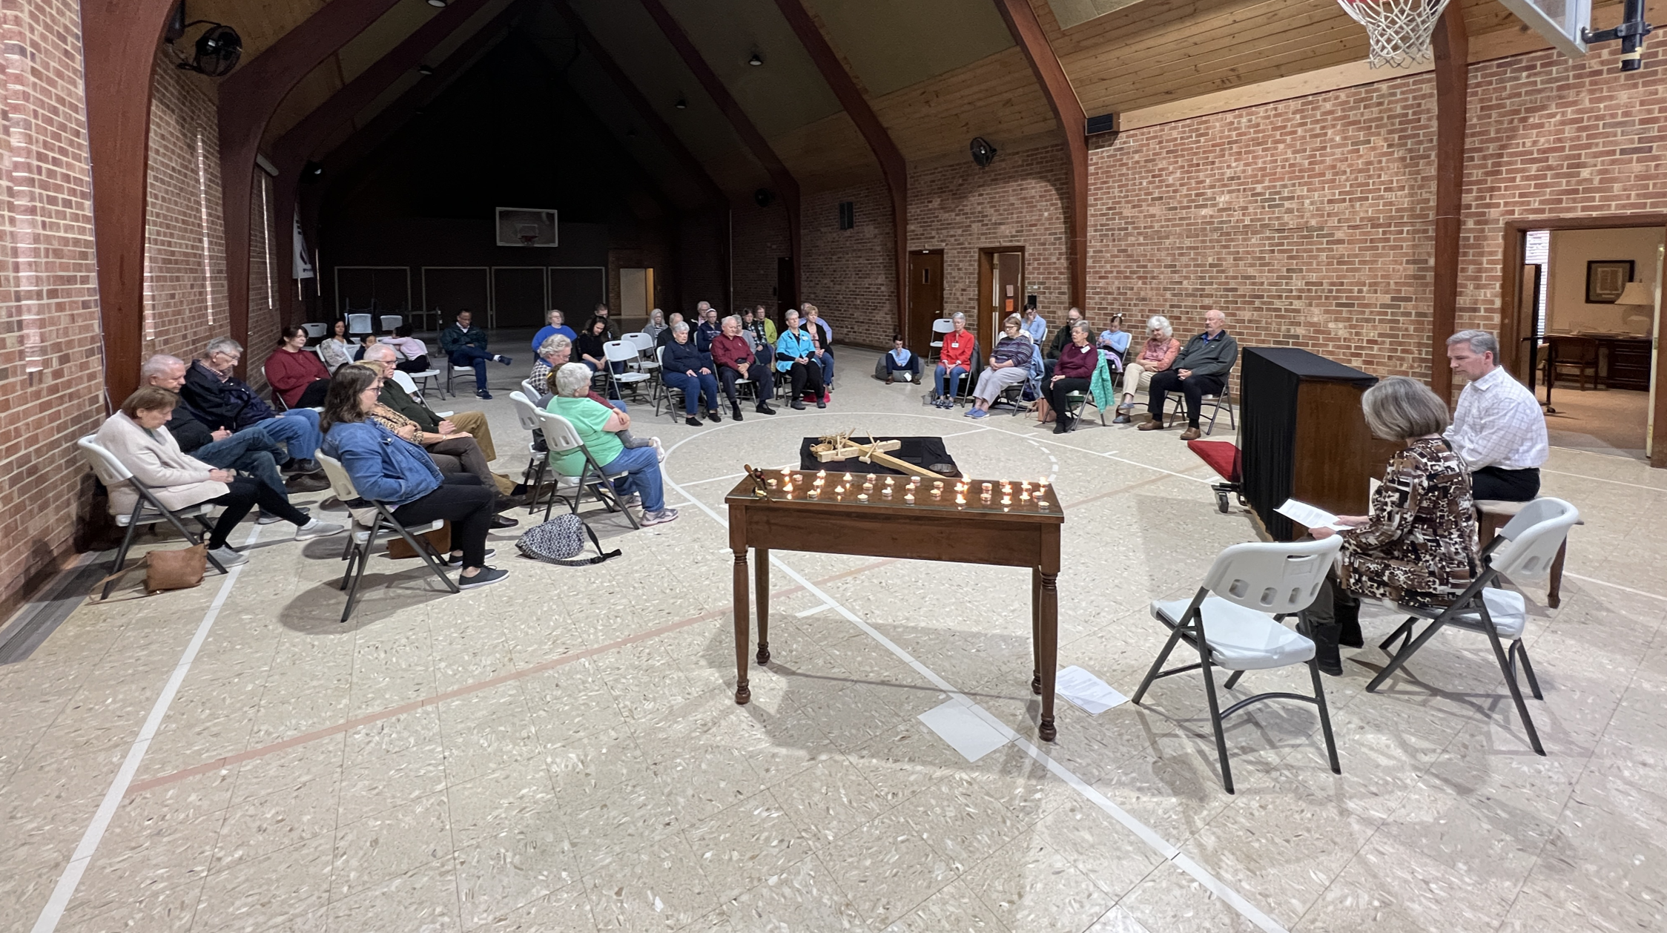
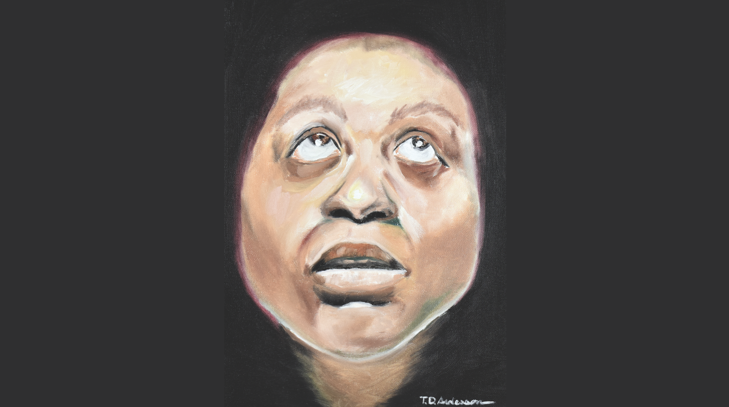
And on Friday, our feet took us to a place of solemn silence to bring our laments to the cross. We looked death directly in the face and said, “You go ahead and have your moment; but don’t get too comfortable!”
And, now, dear neighbors, our feet have brought us to a very different place! Together, we are in a place that is decidedly uncomfortable for death.
Today we find Mary Magdalene, one of Jesus’ followers and, therefore, we would rightfully call her a disciple. In my mind, she deserves a place in the stained glass windows behind me just as much, if not more so, than the 12 men who stand there today. Why? Because she showed up. In the Gospels, quite often, the women do a much better job of showing up than the men do. Judas betrayed Jesus. Peter denied Jesus. The rest of them scatter. But the women show up. They’re the ones at the foot of the cross when Jesus died. They’re the ones that come to the tomb to care for Jesus’ body.
In Luke’s version of the resurrection, Mary Magdalene does not come alone. Instead, she is accompanied by a woman named Joanna, Mary the mother of James, and other women whose names we don’t know. The women are told by angelic messengers that Christ is risen and they go to preach the first ever Easter sermon to the men who scoff at them, calling their testimony nonsense in a biblical example of “mansplaining.”
But there is no mansplaining in John’s version of the events. In fact, the male disciples don’t say a single word in today’s passage. The Gospel writer John has decided that a woman named Mary is the more trustworthy preacher to bring us the good news this day. And so, it is my privilege this day to tell you about a disciple named Mary. Her name was Mary Magdalene. Her name literally means “Mary, the Tower.” Because she is, as Diana Butler Bass has written, a tower of our faith, for without her testimony, without her Easter sermon, where would we be?
Mary is the tower of our faith, as I said before, because she showed up. And that’s what disciples do; they show up at the tomb. You see, Christian discipleship is just as much allowing our feet to take us to places of death as it is gathering on days like today to celebrate resurrection.
When the mass shootings happen and our children are sacrificed to a culture of violence, Christian disciples, like Mary, show up at the tomb.
When the terminal cancer diagnosis jolts us like the sound of a nail being hammered into a cross, Christian disciples, like Mary, show up at the tomb.
When immigrants are mistreated, and refugees are turned away, and trans persons are used as political weapons, Christian disciples, like Mary, show up at the tomb.
When someone we love begins deteriorating in body, mind, or spirit, Christian disciples, like Mary, show up at the tomb.
We show up because Mary showed up. She shows up at a place of death. She is the first to witness the empty tomb and tells Peter and the other disciple, whom we only know as “the disciple whom Jesus loved.” And the two of them approach the tomb and notice a rather curious thing. They see the linen that Jesus wore folded neatly which is an odd thing; for no grave robber would ever take the time or effort to steal a body and then have the clothes pressed, laundered, and folded impeccably. The male disciples, we’re told, “believed,” but the text doesn’t tell us exactly what they believed. And perhaps the ambiguity of their “belief” is the reason that they…just…go home. A rather anticlimactic ending for their portion of this story.
But Mary stays. She stays and weeps, the text tells us. And you and I, my friends, know what it’s like to weep by the tomb. We know what it’s like to be overwhelmed by the brokenness of the world and, when resurrection first gives us a preview, we sometimes just don’t know what to do with it. We don’t know what to do with it because it’s such an unfathomable mystery that seems just too good to be true that it just seems cruel when we don’t understand what it means. And so Mary, the tower of our faith, weeps and so do we.
But through the tears she sees someone who see assumes must be the gardener; you see, the comprehension of the resurrection hasn’t quite made it through yet. And how true is that in our lives! Resurrection comes knocking but, because we are human, our lament sometimes prevents us from seeing newness standing right in front of us!
The man asks two questions. First, he asks “Why do you weep?” In previous sermons, I’ve often quipped that this seems a cruel question because the answer seems quite obvious. But I’ve softened my stance on Jesus’ question, if only because “why are you weeping” is such a more pastoral thing to say to someone in a moment of grief rather than empty platitudes or saying “there, there” or “it’ll be ok” or “just look on the bright side.” Sometimes, Christian discipleship is showing up in another person’s grief and simply saying, “I’m here. I’m listening.”
And then the man asks another question: “Who are you looking for?” In my mind, this is the Resurrected Christ saying to Mary, “What is it that’s keeping you from seeing me?” You see, there’s a veil that’s keeping Mary in the dark. And asking that question is Jesus’ way of discovering what it will take to lift that veil. And he comes to the conclusion that the power that will lift that veil from Mary’s teary eyes is something incredibly simple, and human, and intimate: her name.
“Mary,” Jesus says. And, just like that, the veil is lifted. The veil is lifted because her name is uttered. The Resurrection calls her forward by name and she reciprocates by calling out Jesus’ name: Teacher.
The artwork you see on the TV screen and on the front of your bulletin is an artistic depiction of this blessed moment when Mary hears her name. You can see in her eyes the lingering grief, but a grief nevertheless that is making room for something else, something new, something resurrected. She is called by name and that’s exactly what it takes to pierce through the grief and lament and make way for healing, restoration, and resurrection.
And that’s what I hope you find this day. I hope you hear the resurrected Jesus calling you by name.
It doesn’t matter how old or young you are; Jesus calls you by name.
It doesn’t matter where you come from, or who you love, or how you love, or who you vote for; Jesus calls you by name.
It doesn’t matter whether you have a disability, are cis-gender or trans, or have light skin like me or darker skin like Jesus and Mary; Jesus calls you by name.
It doesn’t matter, y’all, what you’ve done or what you’ve left undone. It doesn’t matter how many times you’ve tried your best but you’ve fallen short, time and time again; Jesus doesn’t care; he calls you by name.
It doesn’t matter whether you’re like Mary right now and can finally see resurrection. It doesn’t matter if you’re like Peter and the other disciple, who believe but don’t quite know what they believe, and just can’t stand to be at the tomb any more; Jesus calls you by name.
Jesus calls you by name, friends, and I pray that that naming may pierce the weathered and worn parts of your soul. I pray that resurrection finds you and holds you and anoints you with daily manna to keep going, to keep witnessing, to keep serving, to keep seeking, to keep loving, to keep showing up in at the tombs of this world.
Because Jesus has named you this day just as he named Mary. And that name was all it took for Mary the Tower to go and preach the first ever Christian sermon which, lest we get too worried we’re not qualified to preach it, was no more than five words: “I have seen the Lord.”
And, so my friends, each time we gather in this space, and outside of it, to worship God, we preach that five word sermon: I have seen the Lord.
Each time we feed our hungry neighbors, or write the card to the grief-stricken, or show kindness to the immigrant, the refugee, the lost and forsaken, we preach that five word sermon: I have seen the Lord.
Each time we hold space for community, and bridge the divide, and call ourselves repairers of the breach, we preach that five word sermon: I have seen the Lord.
Every time we defiantly sing our alleluias in a world that thinks the tomb is still sealed by stone, we preach that five word sermon: I have seen the Lord.
Y’all, the Risen Christ has spoken. He has called us by name. Our feet have been anointed to tell the good news. Our feet have been blessed to carry that euangelion into a hungry world. And, therefore, like Mary the Tower, we will show up. We will show up in the broken places of the world and share the promise that the way things are aren’t the way things will be. We will show up. We will look up. We will speak up. We will seek up. All while preaching that five-word sermon: I have seen the Lord.
In the name of the Resurrected Christ, let all of us - God’s Easter preachers - say: Amen.

