2nd Sunday after the Epiphany (Year A)

__________________________________________________________________________________________

Psalm 40

I waited patiently for the Lord;
he inclined to me and heard my cry.
He drew me up from the desolate pit,
out of the miry bog,
and set my feet upon a rock,
making my steps secure.
He put a new song in my mouth,
a song of praise to our God.
Many will see and fear,
and put their trust in the Lord.
Happy are those who make
the Lord their trust,
who do not turn to the proud,
to those who go astray after false gods.
You have multiplied, O Lord my God,
your wondrous deeds and your thoughts towards us;
none can compare with you.
Were I to proclaim and tell of them,
they would be more than can be counted.
Sacrifice and offering you do not desire,
but you have given me an open ear.
Burnt-offering and sin-offering
you have not required.
Then I said, ‘Here I am;
in the scroll of the book it is written of me.
I delight to do your will, O my God;
your law is within my heart.’
I have told the glad news of deliverance
in the great congregation;
see, I have not restrained my lips,
as you know, O Lord.
I have not hidden your saving help within my heart,
I have spoken of your faithfulness and your salvation;
I have not concealed your steadfast love and your faithfulness
from the great congregation.
Do not, O Lord, withhold
your mercy from me;
let your steadfast love and your faithfulness
keep me safe for ever.
For evils have encompassed me
without number;
my iniquities have overtaken me,
until I cannot see;
they are more than the hairs of my head,
and my heart fails me.
Be pleased, O Lord, to deliver me;
O Lord, make haste to help me.
Let all those be put to shame and confusion
who seek to snatch away my life;
let those be turned back and brought to dishonor
who desire my hurt.
Let those be appalled because of their shame
who say to me, ‘Aha, Aha!’
But may all who seek you
rejoice and be glad in you;
may those who love your salvation
say continually, ‘Great is the Lord!’
As for me, I am poor and needy,
but the Lord takes thought for me.
You are my help and my deliverer;
do not delay, O my God.
__________________________________________________________________________________________
Our current sermon series is called “New Year, Same Promises” and last week we explored the Sacrament of Baptism to affirm “God’s Promise of New Life.” Today, we’ll journey through Psalm 40 to explore “God’s Promise of Faithfulness.”
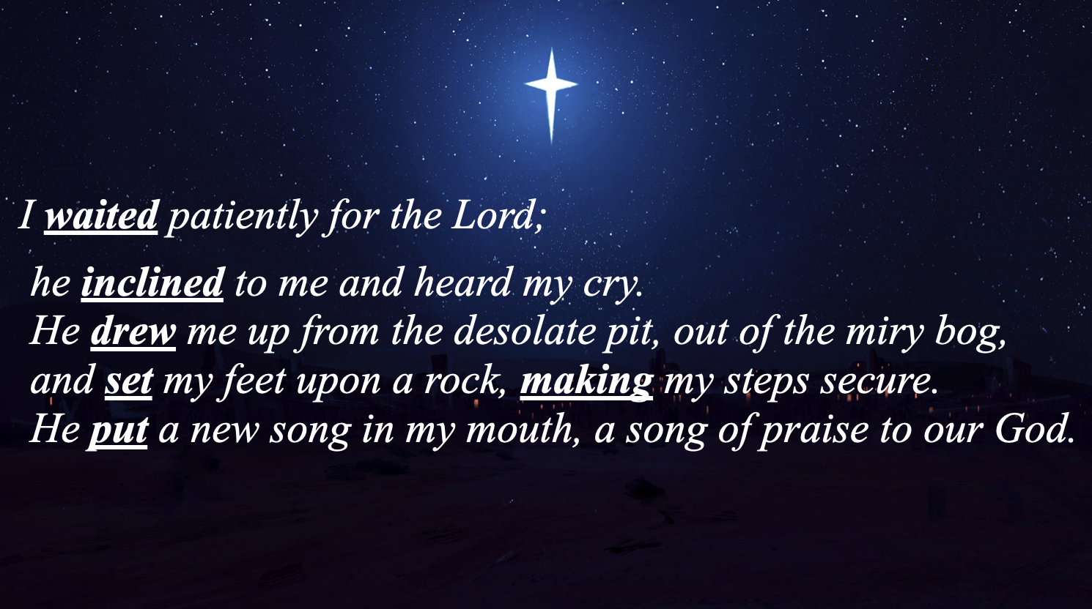
So, let’s take a stroll, shall we? It’s a walk that I reckon you’ve walked before. That’s the beautiful thing about the psalms; they’re nothing more or less than a vocabulary of our faith. The timeless wisdom of the Psalms is that their stories are our stories.
As is almost always the case when I come to a text, I look for the verbs. Our first verb, the verb belonging to the Psalmist is “wait.” How many of us like to wait? We don’t live in a culture that rewards waiting or fosters within us much of a tolerance for it. The internet and our smartphones put a world of information at our fingertips that we can access in a matter of seconds. But you and I know that information and wisdom are two very different things. The psalmist has a great deal of wisdom, because she knows that her wait isn’t some passive act of laziness or apathy. On the contrary, the psalmists’ wait is an active one, a kind of anticipatory wait like we practice in the seasons of Lent or Advent. It’s a wait filled with paying attention. And God gives the psalmist plenty to pay attention to. Because while the Psalmist waits, she pays attention to some verbs that belong to God.
First of all, God inclined. Isn’t that what we want most from God? To hear our plea, to not be apathetic to our struggles, our anxieties, our fears. Anyone who has ever shook their fists at the heavens and asked God, “Where are you?” knows what it means to ask for God’s inclination. And so, the psalmist expresses that her tears have been seen and her cries heard. And then after God inclined God’s ear, God drew her up from the desolate pit, out of the miry bog.
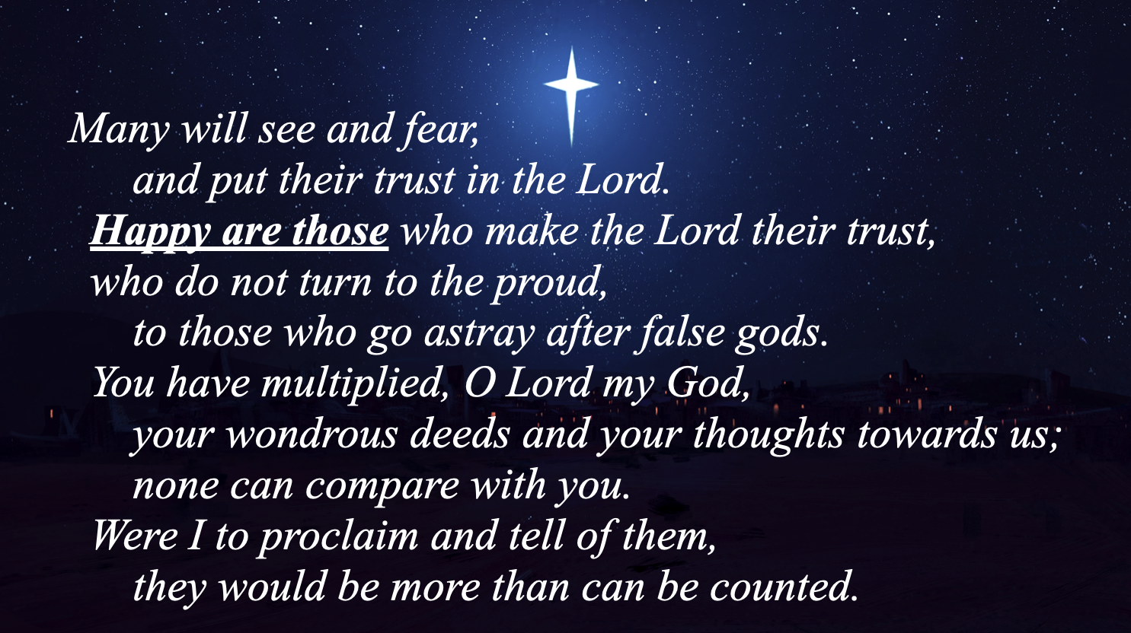
My guess is you’ve been in a place like that. A place where the promises of God seem to ring hollow, silenced by your fears and anxieties. A place where you feel like you’re just one more disappointment away from giving up all hope. I know that feeling. And it ain’t fun. Placing our trust in God in no way diminishes the reality of those places. They happen and, truth be told, no amount of faithfulness on our part can protect us from those desolate pits. It’s part of being human. But the psalmist sings a song of “both/and” and not “either/or.” It’s not we either are faithful or we find ourselves at times in places of hopelessness. It’s that we can both be faithful and still find ourselves in miry bogs. But the psalmist knows that the story doesn’t end there. Because God gets four more verbs: drew, set, made, and put. God drew her up, set her feet upon solid ground, made her steps secure and put a new song in her mouth, a song of praise to our God.
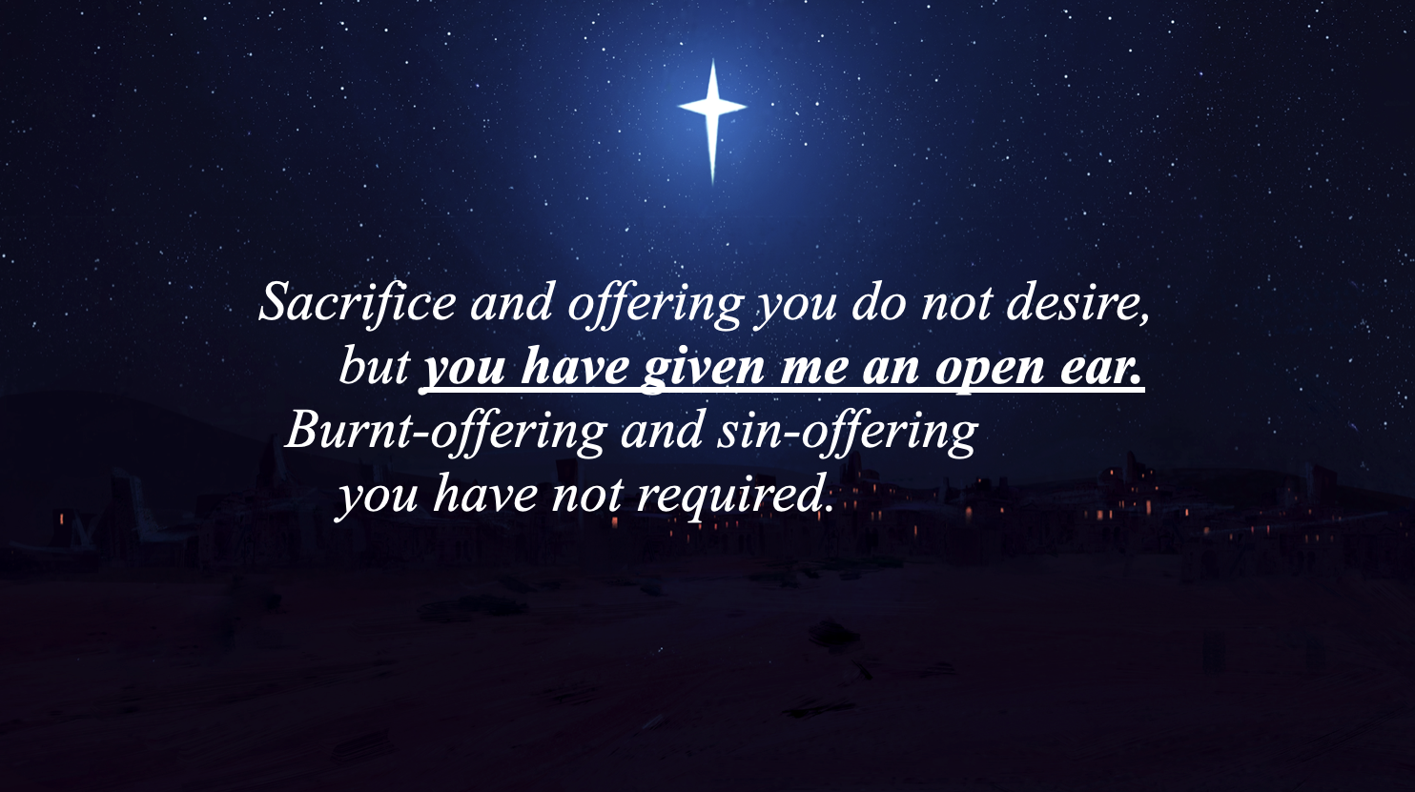
Next, our psalm turns to the wisdom that is found when we take the time to wait for God to see what God is up to. The key to knowing that we’ve switched to the genre of wisdom literature are three little words: “happy are those…”. Whenever those words show up, namely in the Proverbs or Psalms, you know that the author is about to drop some wisdom. Another feature of the Psalms is that often in psalms of petition such as this one (we haven’t gotten to the petition yet but it’s coming!) is the psalmist goes to pains to plead their case by separating them from those who do not fear or trust in the Lord. (Remember: “fear” isn’t just about being afraid. It’s actually much more about standing in awe of the magnificence and sovereignty of God). The psalmist implores us to join her in making the Lord our trust. To know who it is that we worship and make sure to distinguish between the one true God and the many false idols that compete for our allegiance and attention. Then the psalmist closes out this section with an affirmation of the impossibly long list of wondrous deeds and thoughts of the Lord.
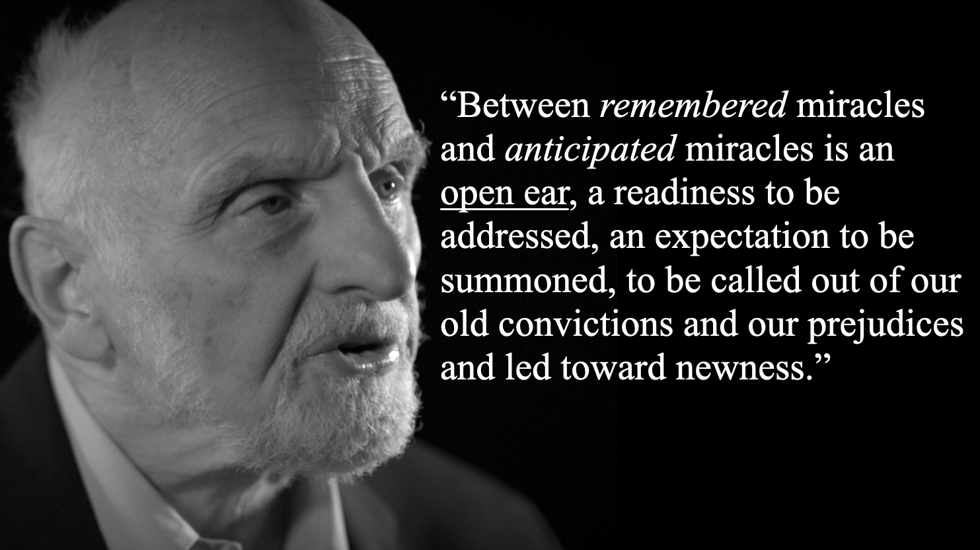
Before turning to petition, I’d like to highlight one particularly evidence of wisdom in verse six. In it, the psalmist says “you have given me an open ear.” That’s such a wonderful phrase for at least two reasons. First of all, the psalmist recognizes that the only way to stand in awe of God’s faithfulness is by listening. Paying attention. Holy curiosity. Slowing down and leaving the rat race of the world for awhile, long enough to sing this song of praise. And secondly, the verb “have given” is an intriguing one worthy of our attention. The psalmist does not say “I have an open ear” or “I have opened my ear.” She says that God has given her an open ear. That’s a really beautiful sentiment. We live in a country where we’re told to have pride in “doing it ourselves” and “picking ourselves up by our bootstraps.” It takes no small amount of wisdom to articulate that there are some things that we can’t do for ourselves. The open ear of the psalmist is not something she did for herself; it’s a gift from God, and therefore a gift received with humility and gratitude.
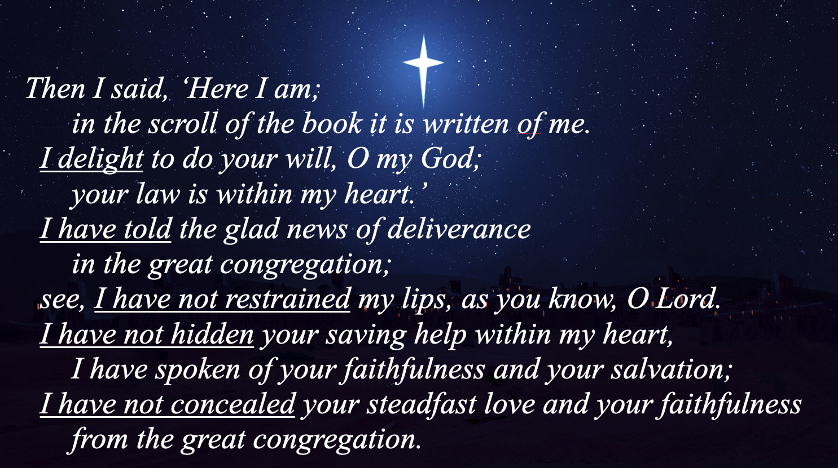
Of this passage, Walter Brueggemann has said the following: “Between remembered miracles and anticipated miracles is an open ear, a readiness to be addressed, an expectation to be summoned, to be called out of our old convictions and our prejudices and led toward newness.”
And now we come to what I like to call the bargaining section of the psalm. How many of y’all have prayed the following prayer, “I’ve held up my end of the bargain, God. Now it’s time for you to do the same!” This is the part of the psalm where the psalmist has the audacity to remind God of all the faithful acts she’s done.
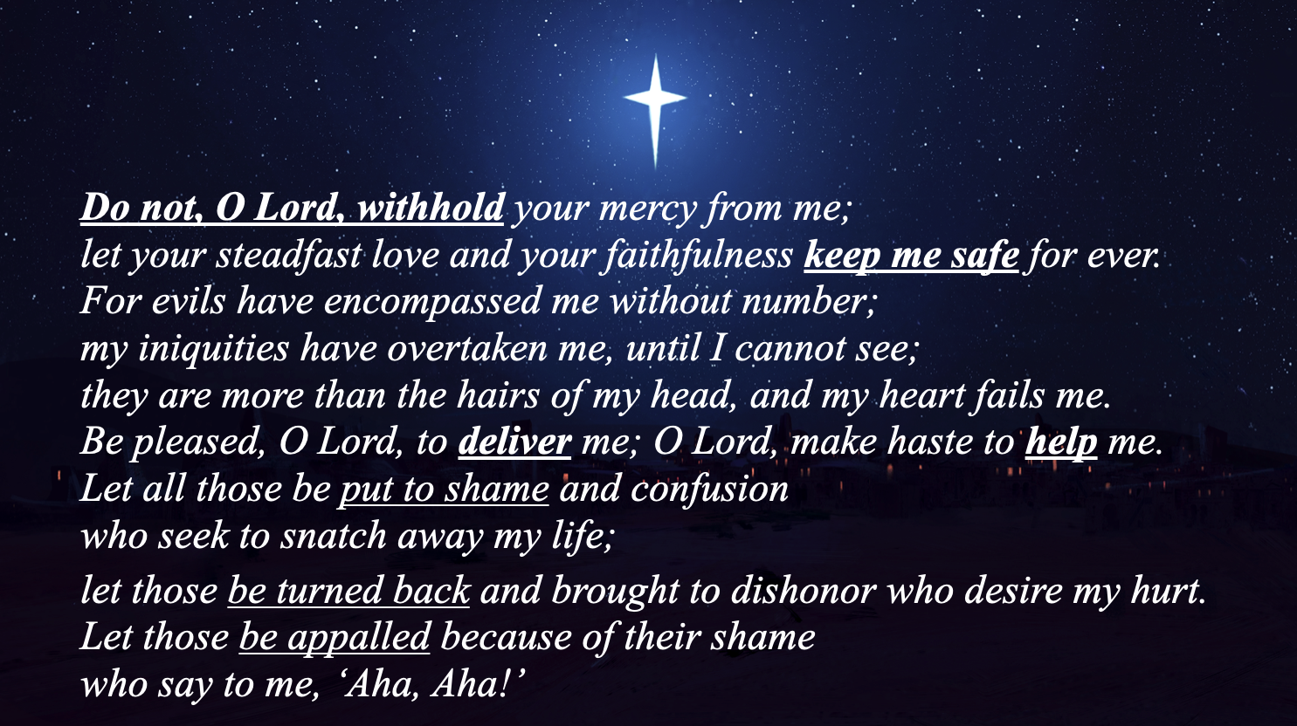
First of all, the psalmist has delighted in God’s will. And they haven’t been silent about it; they’ve told the glad news, they have not restrained their lips, refused to hide these wonderful things from her neighbors, and lived not a life of concealment but a life with open arms ready to gobble up as much steadfast love and faithfulness that she can get her hands on. Sometimes, the greatest act of faithfulness you and I can ever muster, is simply an acute awareness of just how desperately we need God’s faithfulness. And the psalmist gives us a master class in how to do just that.
And now comes the petitions. It’s important to recognize that the psalmist doesn’t open with the petitions; because they have the wisdom of every kid who has ever gone to their parents to ask for something. “Oh dad, you’re looking awfully handsome today.” “Mom, is that a new perfume? I love it!” And “Did I mention that I got straight A’s on my last report card?” Every kid knows that you don’t come of the gates with the ask. You gotta butter them up first! Well, the ain’t the psalmist’s first rodeo! They know to remind God of what God has done in the past, what they themselves are doing faithfully in the present, in order to compel God to remain faithful in the future.
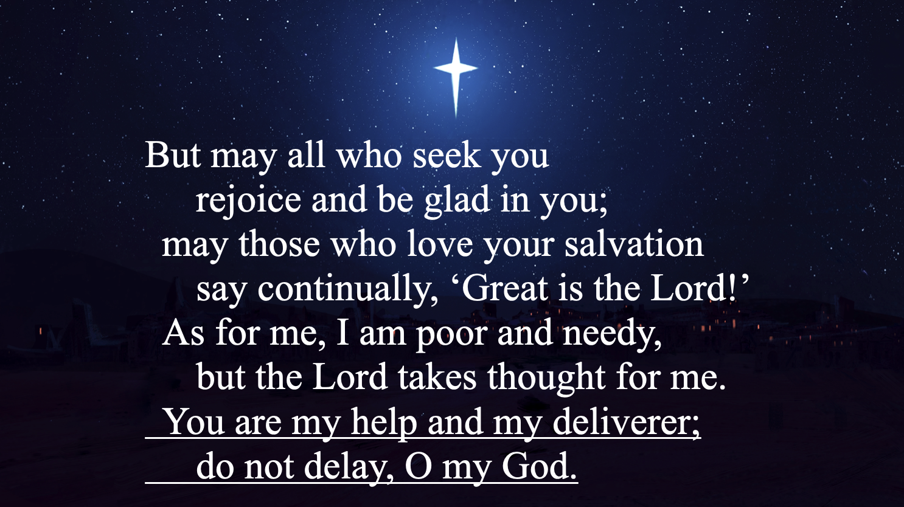
And the psalmist needs a double portion of that faithfulness because the obstacles are stacking up. Evils have encompassed them, iniquities have overtaken them, and because of that, their heart fails. And so they ask four things for themselves: That God keep the supply of mercy flowing and, in so doing, keep them safe; and then they ask for deliverance and help. Specifically, of course, deliverance from those who are seeking to snatch away her life. There are many things that seek to snatch away our life. These days it can feel like inflation is trying to snatch away our life; or at least our financial ability to provide for it and the lives of those we love. Political division seeks to snatch away our life; teaching us the lie that those who disagree with us are enemies to be defeated instead of neighbors to loved. The decline across the board of denominational Christianity can seek to snatch away our life; teaching us the lie that our job is be the biggest and most influential church on the street instead of simply remaining faithful to what God is calling us to do here at now. There’s so much, dear neighbors, that seeks to snatch away our lives; and we would do well to have the wisdom of the psalmist to know just how much we need to keep open ears not to their voices, but to the singular voice of the God to whom we eternally belong.
As we come to the end of our stroll through Psalm 40, our final movement is one of blessing, promise, and urgency. The psalmist wishes that they, and the congregation on whose behalf they speak, would continue their holy work of rejoicing and being glad in God blessing. The promise is given that, though the author is poor and needy, their circumstances do not prevent God from considering their plight and providing for their care.
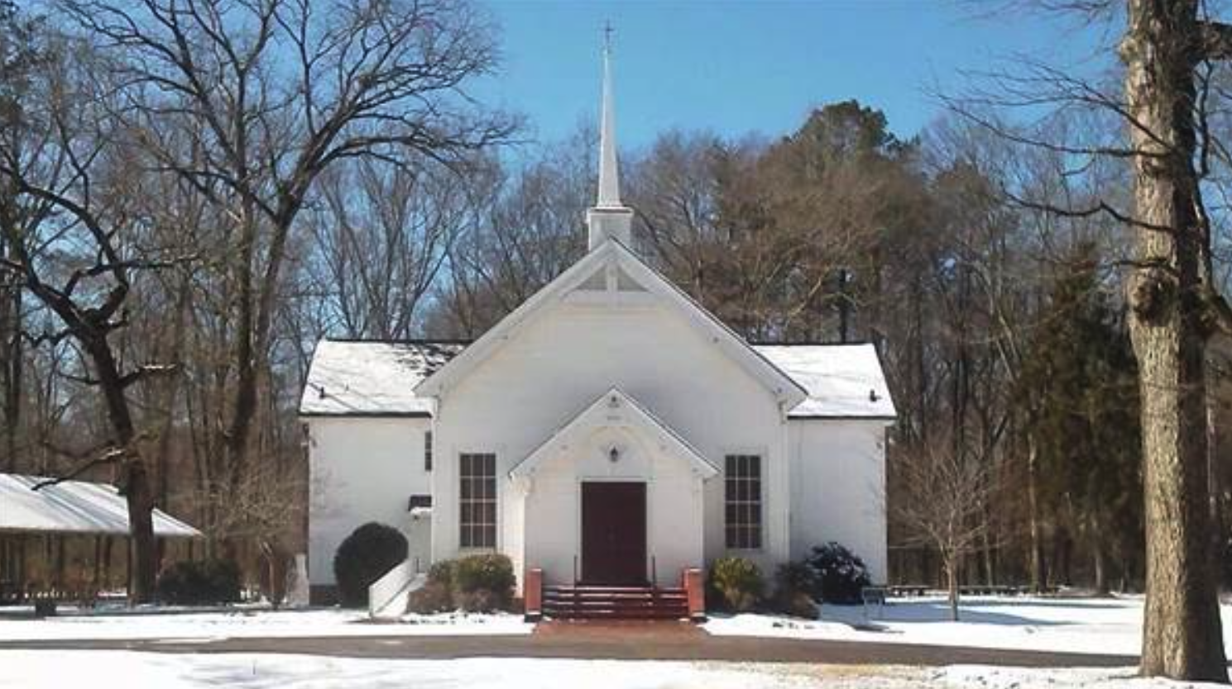
And the final sentence brings us to a very different place than the opening lines of this prayer. We began the Psalm with the assurance of the Psalmists’ patience. But the last line suggests that the Psalmists’ patience does have its limits! “You are my help and my deliverer; do not delay, O my God!”
I’ll close today with a story of a little church in Northwest Georgia that to me is a lovely embodiment of the faithfulness of Psalm 40. It’s called Silver Creek Presbyterian Church near Rome, Georgia. In May of 2013, nearly ten years ago, the congregation went through a very painful split over the usual disagreements of theology and politics. One morning, half of the congregation woke up to learn that their pastor, most of the session, and the other half of the congregation had left to start another church in another Presbyterian denomination. The half that remained felt abandoned and broken. Families and friends found themselves on different sides of the conflict and those who remained struggled to redefine themselves as a congregation on the other side of such a devastating fissure.
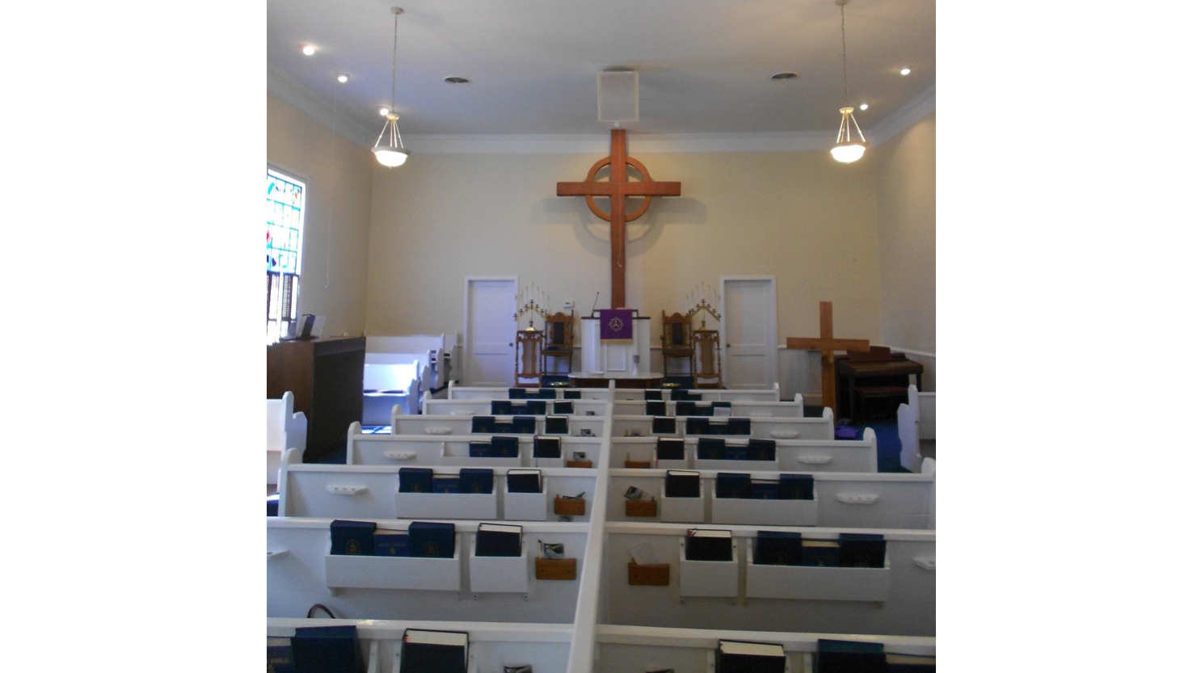
Well, it just so happened that at the time I was the program director at my Presbytery’s summer camp and the week of the split was the same week as staff training. So I and the rest of the staff offered to lead worship for that first Sunday after the split.
We gathered in their small sanctuary decked out in our staff t-shirts and led a bittersweet worship service, praising God and confessing our brokenness. Together, we were Church and we shared laughter and tears, comforted one another, and sought to find the Peace of Christ in the midst of such pain. At the end of the service, I sat at the piano at the end of the service and led the congregation in the hymn we’ll sing here in a few minutes, “Great Is Thy Faithfulness.”
To this day, it remains for me the most poignant time I’ve ever sung that hymn. Because sometimes the places when we trust most heavily on God’s faithfulness are those when we’ve fallen short of maintaining the unity of the Body of Christ. Sometimes, the times when we trust most in God’s faithfulness is when we’re most acutely aware of how desperately we need it. As today Psalm ends, “I am poor and needy, but the Lord takes thought of me.” And the poignancy of that particular singing of “Great Is Thy Faithfulness” on that day back in the summer of 2013 is more about what has happened since than what happened then.
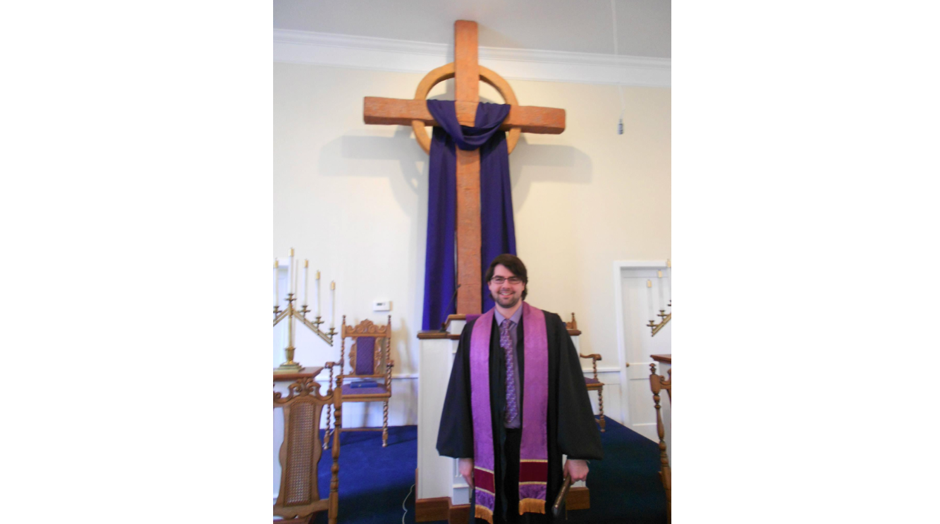
As it turns out, my home church was in the middle of a very similar split, so I had a tremendous amount of empathy for the people of Silver Creek Presbyterian Church because I knew exactly how painful that was. I was in seminary at the time, and they asked if I would preach and lead worship for them for a couple months while they looked for their next pastor. And for a seminarian looking for any opportunities to preach, it was like hitting the jackpot!
So for about four or five months, I drove the hour or so from Atlanta to Rome, Georgia to lead worship for them. In a way, they were my first church. Even though I was never officially their pastor, they’re the first church I ever got to know pastorally and preach on a regular occasion.

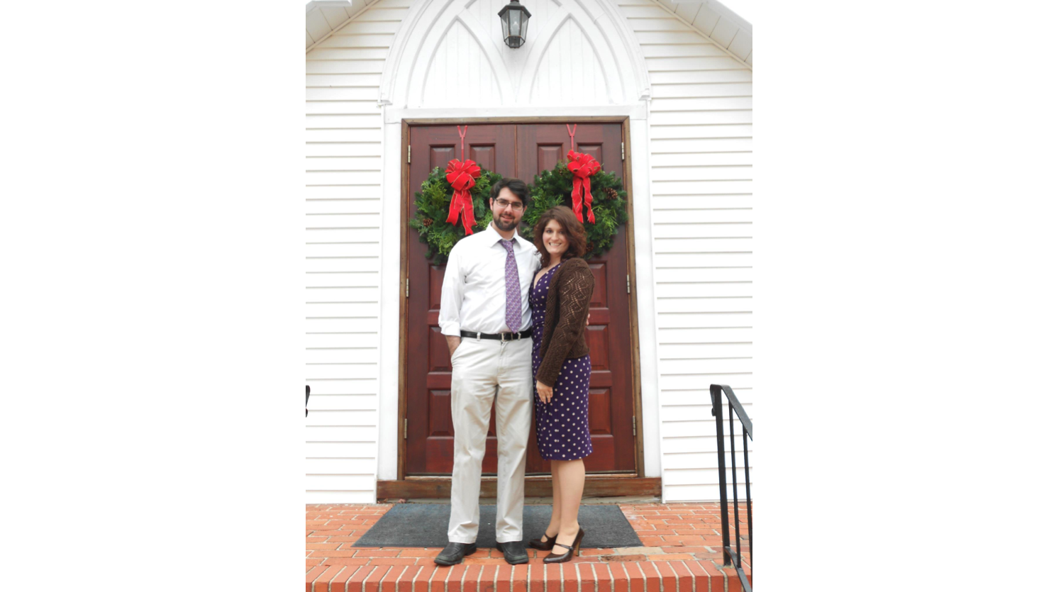
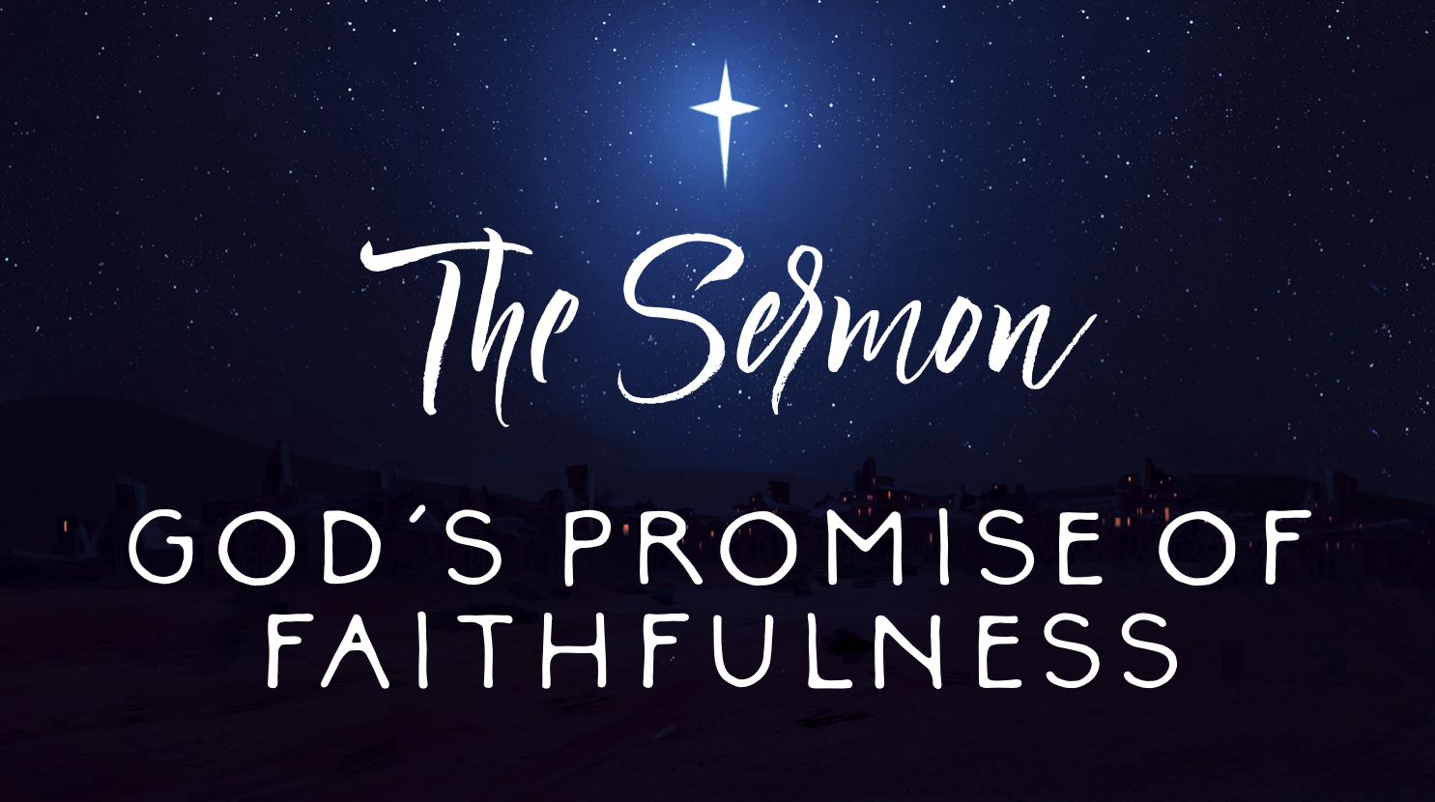
I had started to date Tricia not long before and they took the two of us under their wings and welcomed us as family. And when I left Silver Creek Presbyterian Church to serve as the interim Director of Music at Tricia’s dad’s church, they left me with this portrait of their church building and they all signed the back with messages of love. And I’m happy to report that they’re doing just fine!
Because God’s faithfulness is able to take broken situations and make them new. Though we fail time and time again on our end of the bargain, the story of our faith is that God’s faithfulness endures. Through conflict, through pain, through death and dying, through illnesses and despair, God’s faithfulness stubbornly finds ways to resurrect us, heal us, and promises us new life. And so together, let us practice holy curiosity to have “open ears” to pay attention to that promise and live into it!
In the name of God the Creator, Redeemer, and Sustainer, may all of us, God’s children, say: Amen.

