2nd Sunday of Advent (Year A)

__________________________________________________________________________________________

Luke 1:26-38

In the sixth month the angel Gabriel was sent by God to a town in Galilee called Nazareth, to a virgin engaged to a man whose name was Joseph, of the house of David. The virgin’s name was Mary. And he came to her and said, ‘Greetings, favored one! The Lord is with you.’ But she was much perplexed by his words and pondered what sort of greeting this might be. The angel said to her, ‘Do not be afraid, Mary, for you have found favor with God. And now, you will conceive in your womb and bear a son, and you will name him Jesus. He will be great, and will be called the Son of the Most High, and the Lord God will give to him the throne of his ancestor David. He will reign over the house of Jacob for ever, and of his kingdom there will be no end.’ Mary said to the angel, ‘How can this be, since I am a virgin?’ The angel said to her, ‘The Holy Spirit will come upon you, and the power of the Most High will overshadow you; therefore the child to be born will be holy; he will be called Son of God. And now, your relative Elizabeth in her old age has also conceived a son; and this is the sixth month for her who was said to be barren. For nothing will be impossible with God.’ Then Mary said, ‘Here am I, the servant of the Lord; let it be with me according to your word.’ Then the angel departed from her.
__________________________________________________________________________________________
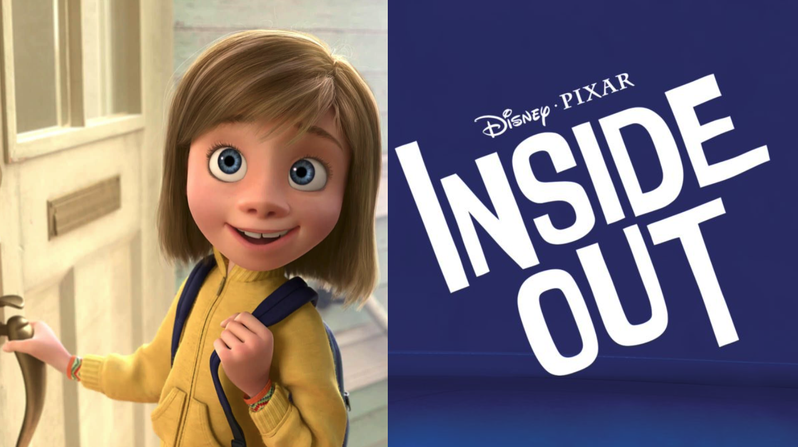
In 2015, one of my family’s all-time favorite movies came out, the Disney-Pixar film “Inside Out.”

It follows an 11-year-old girl named Riley who is navigating the complex feelings that she encounters when her dad gets a new job and they have to leave their life in Minnesota and move to San Francisco. Having just moved ourselves, and along with the fact that it’s been a bit of a bumpy ride for my family these past few months, I know all too well just how emotionally challenging such a big change can be.
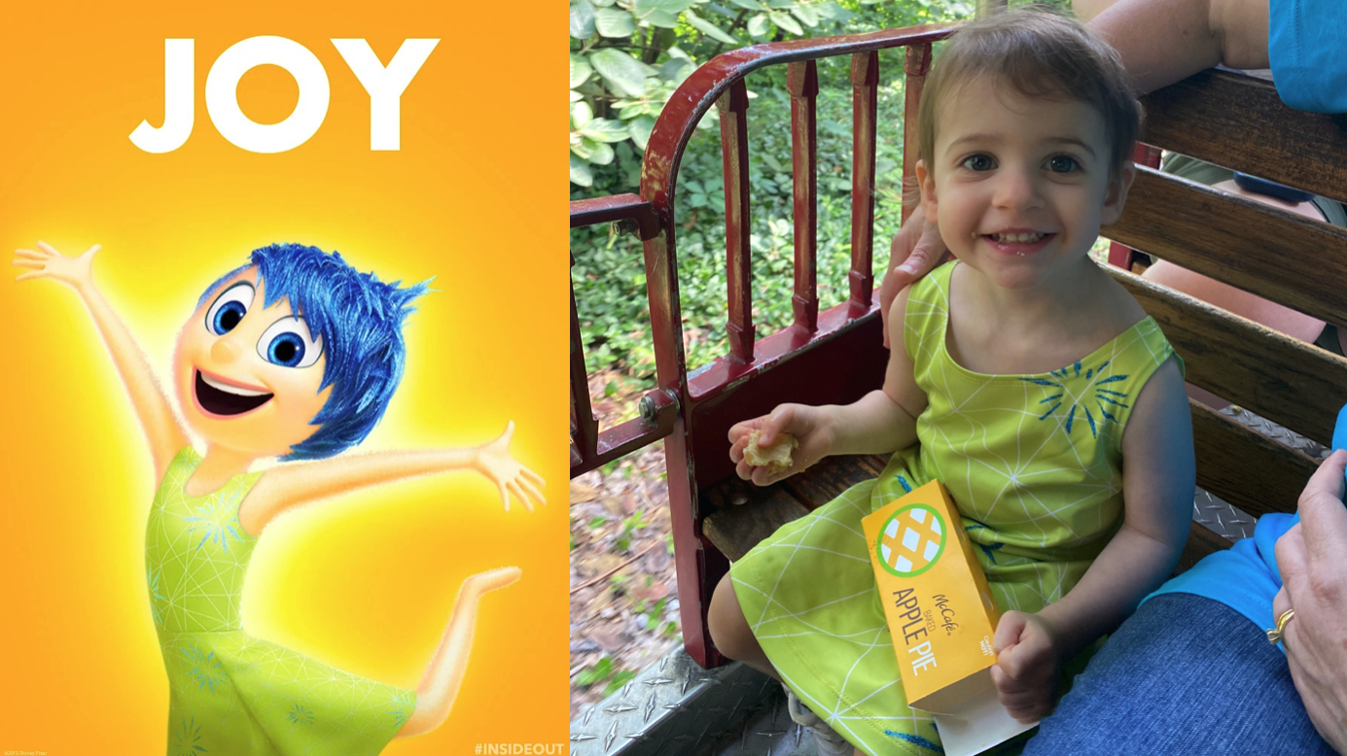
The movie quickly introduces us to the emotions living inside Riley’s head.
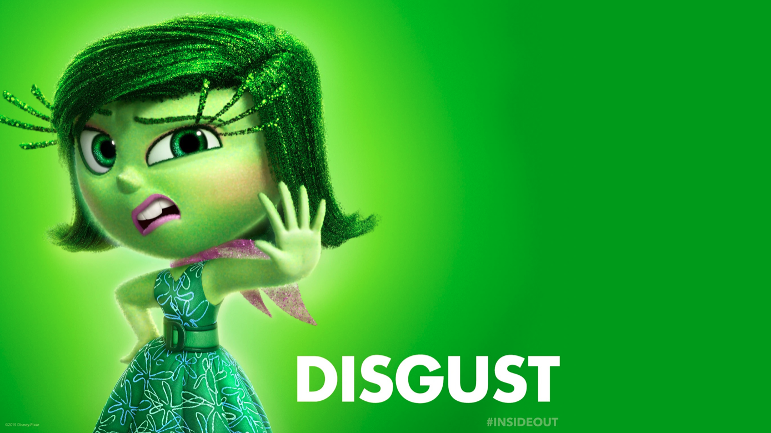
First, we have Joy. She’s the emotion that makes Riley happy, silly, playful, content, and all things bubbly. On the screen you’ll find a picture of Hazel Grace earlier this year dressed up as Joy, her favorite character. Although Hazel Grace, along with the rest of us, certainly has many more emotions than joy.
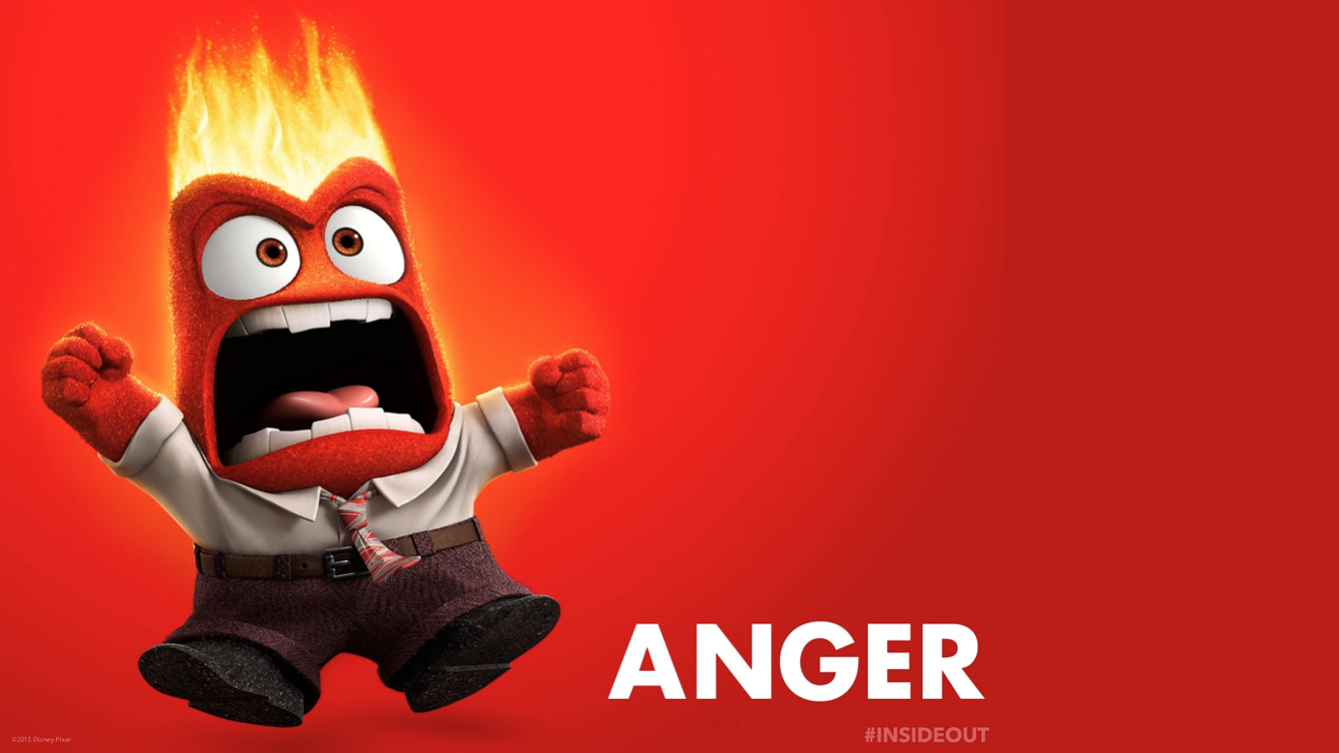
We also have Disgust. She keeps Riley from being poisoned; physically and socially. Disgust is the emotion that’s very invested in keeping Riley out of embarrassing or shameful situation.
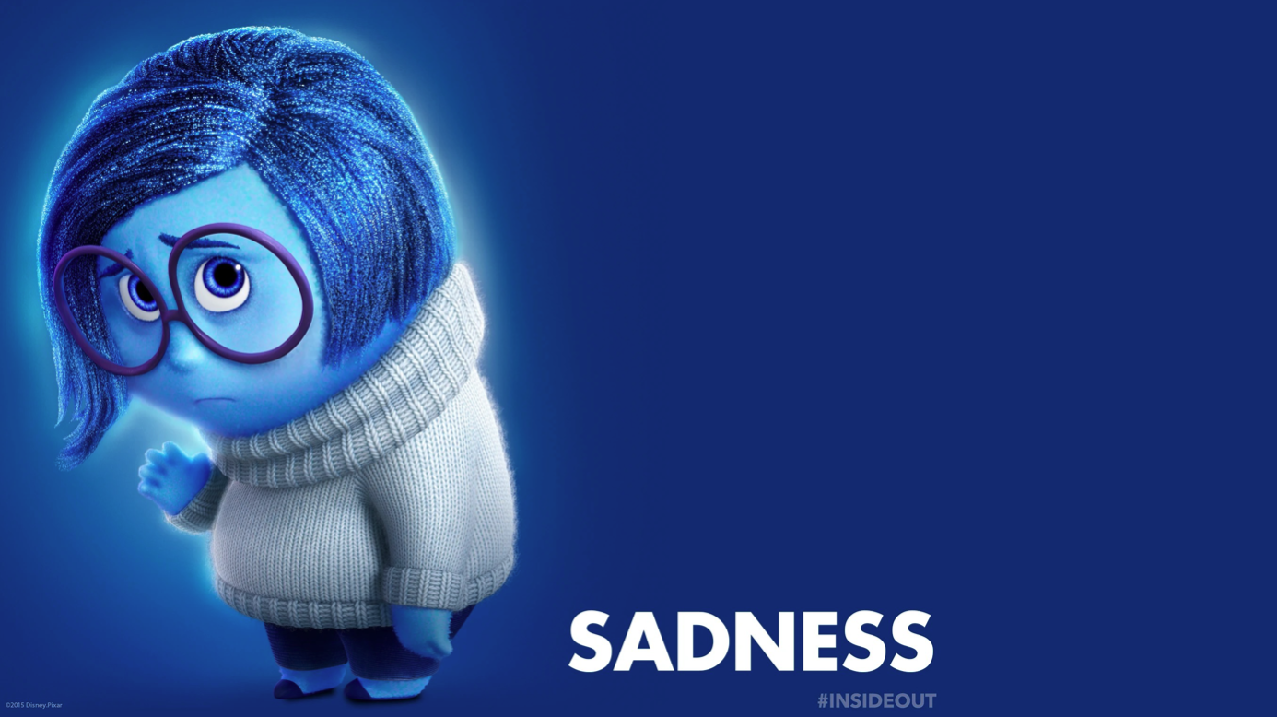
Then we have Anger. He cares very deeply about things being fair. He’s the emotion that fuels Riley’s reactions when she’s upset, impatient, cranky, and frustrated.
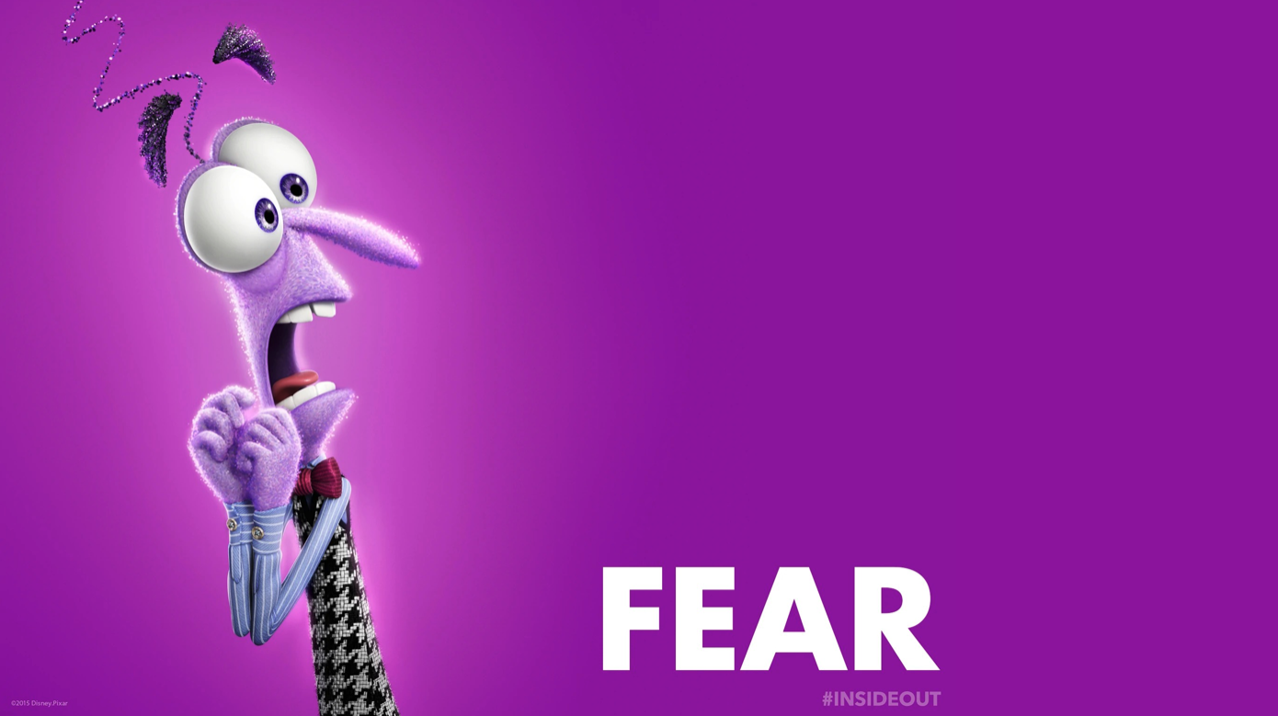
Then we have Sadness. At first, we don’t really know what purpose sadness serves but that becomes clear later on in the movie and I won’t spoil it for those of y’all who haven’t seen it. But Sadness is the emotion that, of course, allows Riley to feel down, depressed, nostalgic, and grieved.
And finally, we have Fear. He’s really good and keeping Riley safe. And this is the emotion that I want us to focus on today, because today’s sub-theme is “God Meets Us In Our Fear.” Does anyone know what is one of the most common phrases in the Bible? “Be not afraid” or its various iterations: fear thou not, fear ye not, fear not, or what have you. And I think that’s because there are a lot of fearful situations in the Bible, particularly situations when people had unexpected and dramatic encounters with God.

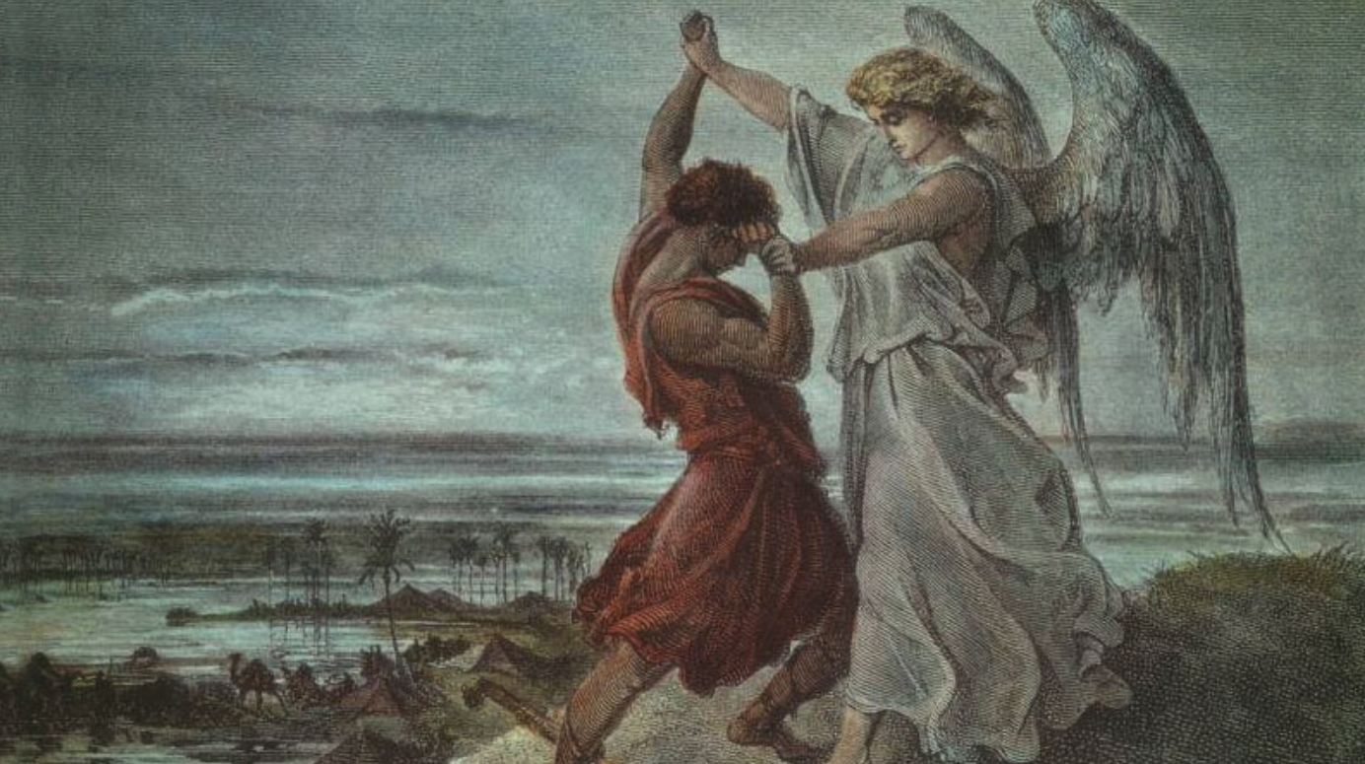
Such as, Moses and the burning bush.
Or Jacob wrestling with the angel of God.
Or Zechariah being struck mute when he didn’t believe that his elderly wife would conceive John the Baptist.
Or, as we explored a few weeks ago, Saul being struck blind on the road to Damascus.
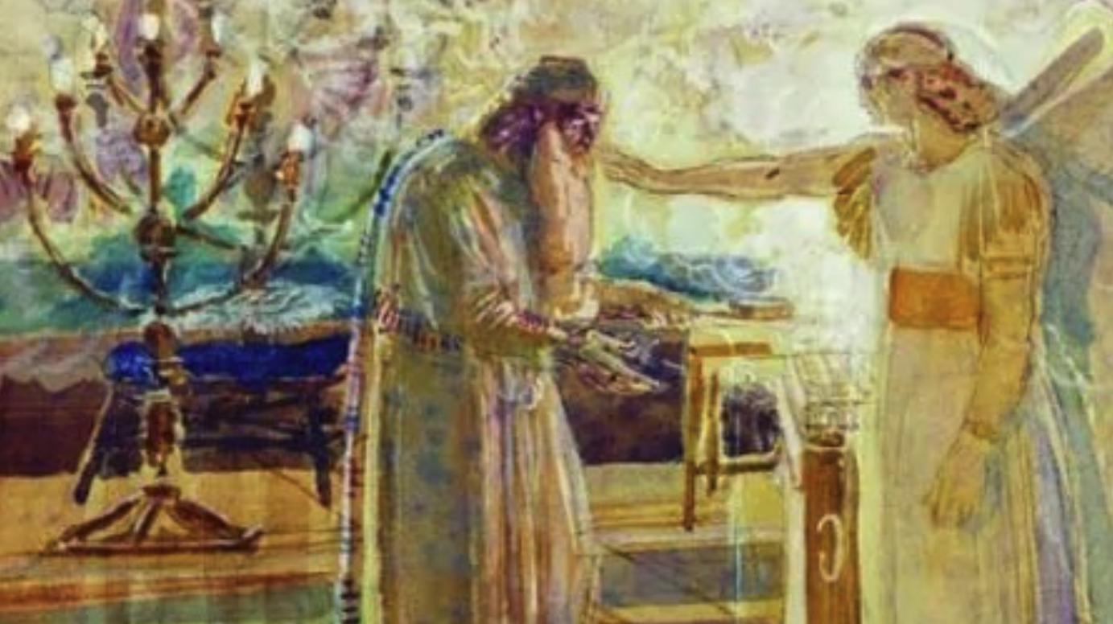
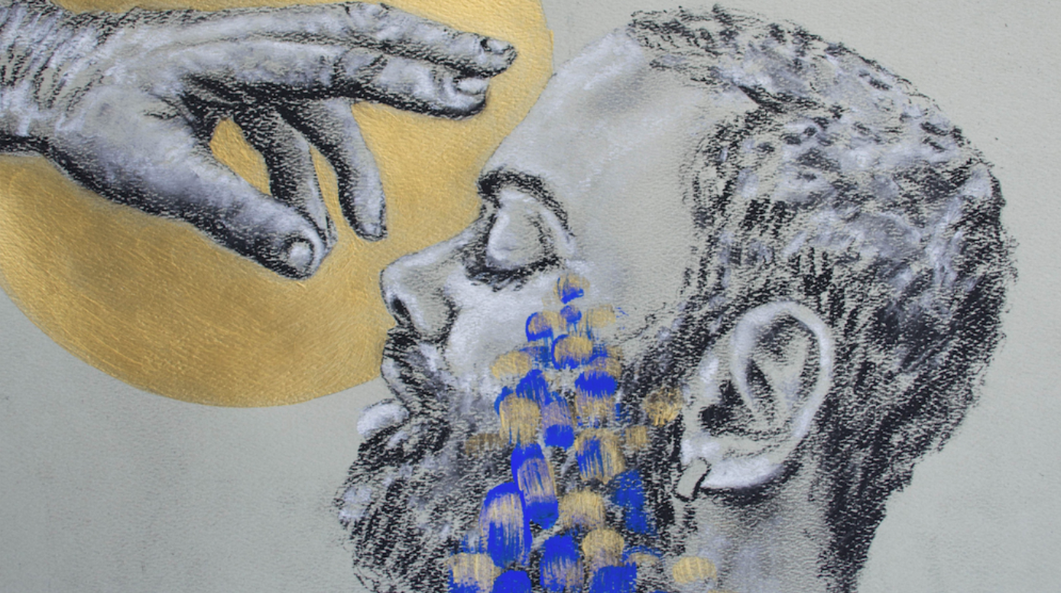

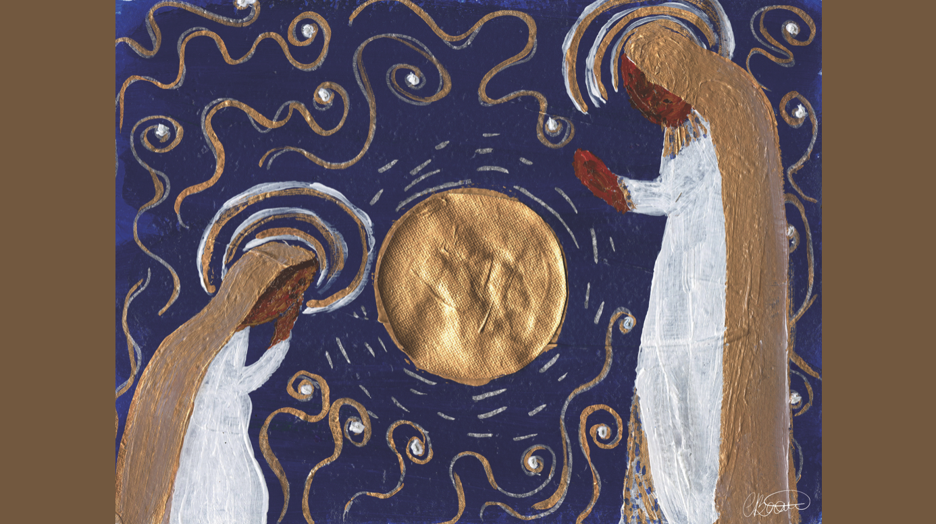
Or, today’s passage from Luke’s Gospel, the story of Mary’s annunciation. We’re introduced to Mary who, we’re told, is a virgin, a phrase that could either refer to her having never known a man intimately and/or simply a very young woman, probably a teenager. She is alone and all of the sudden and angel named Gabriel appears to her. Despite this messenger’s words of greetings that hold within them an assurance that she is favored by God, Mary is terrified.
Many English translations, including the version of the Bible you’ll find in your pew, says that Mary was “perplexed.”

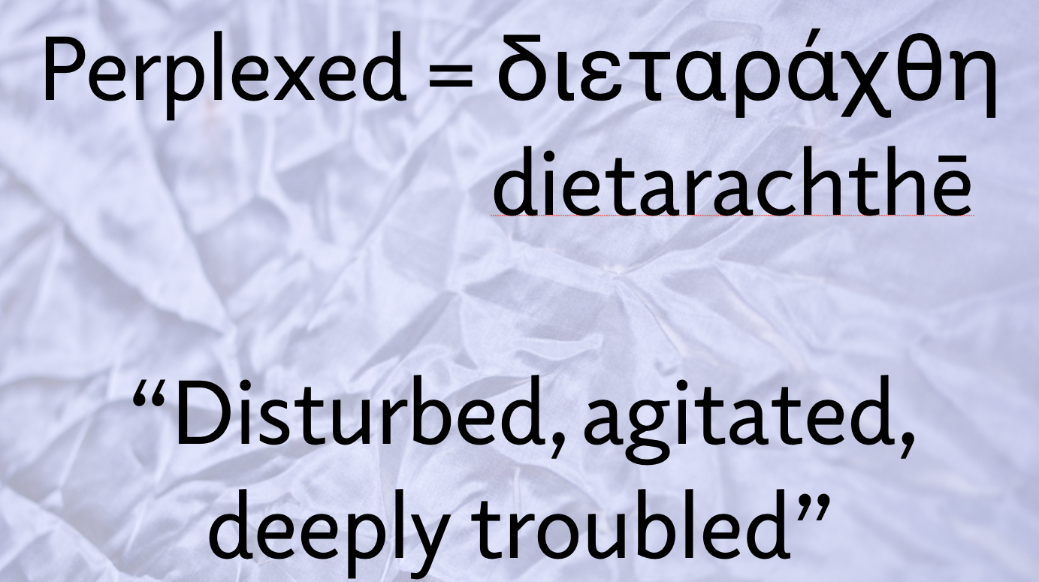
But this is a rather soft translation of the Greek word dietarachthē, which is actually more accurately translated as “disturbed, agitated, or deeply troubled.”
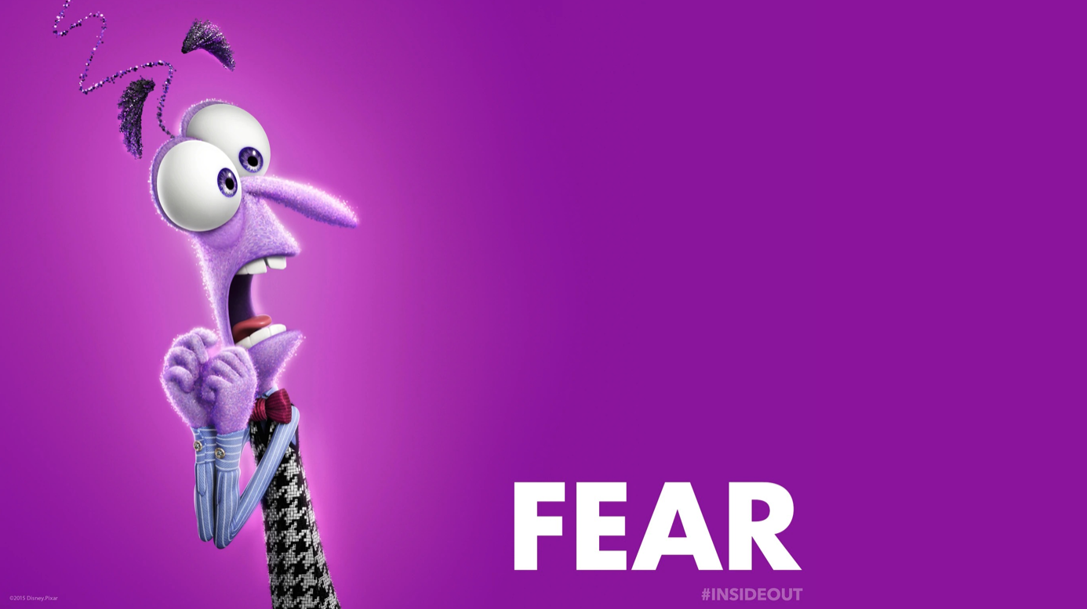
Simply put,
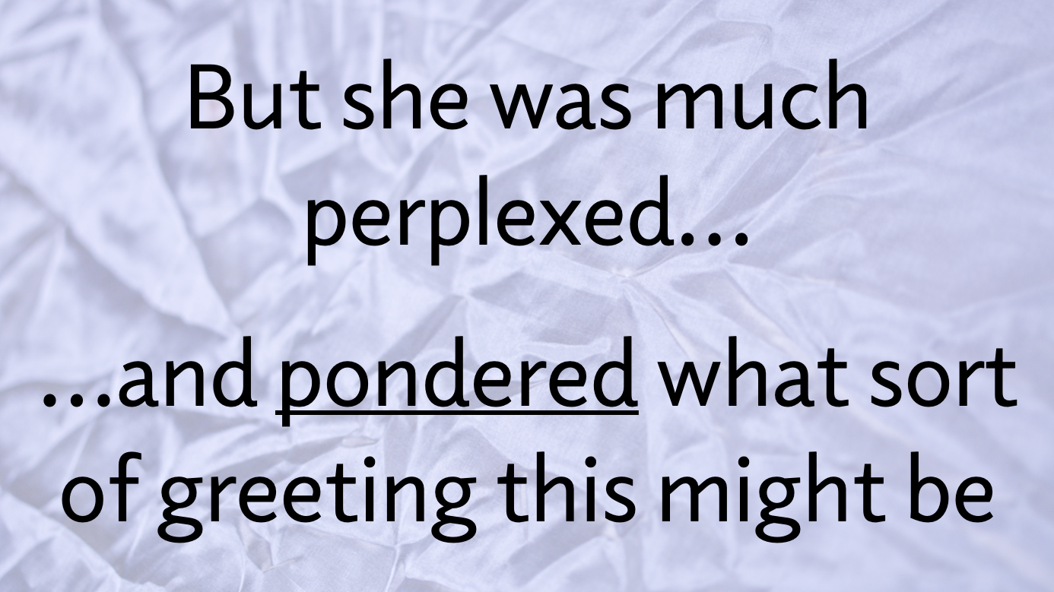
Mary was scared. She had much fear when God came uninvited into her life and essentially, in one moment, turned everything upside down. Now, you and I know the ending of the story: Mary eventually accepts what Gabriel tells her and says: “Here am I, the servant of the Lord; let it be with me according to your word.” But I want us to pay particular attention to a moment that existed in between Gabriels’ announcement and Mary’s acceptance.
Y’all know that I love me some verbs and the two verbs in this sentence, in verse 29, are telling. First, as we’ve already noted, is the verb perplexed/disturbed/agitated/deeply troubled.
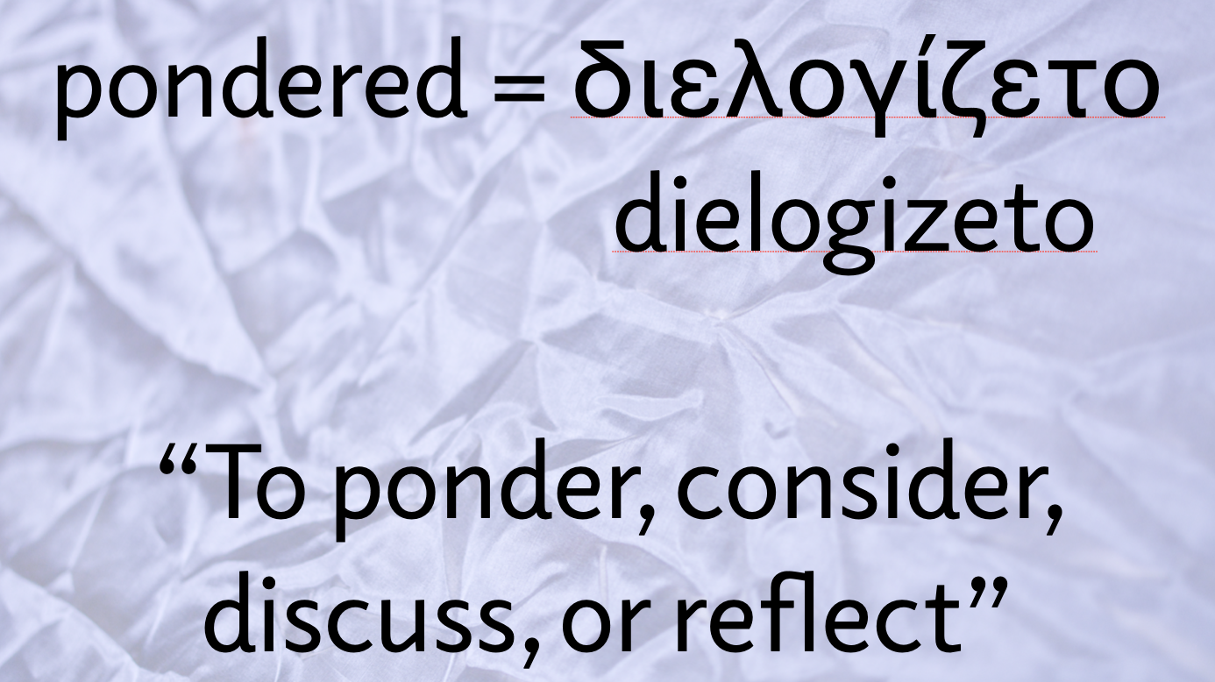
But the second verb is “ponder.” And it can also be translated as “to consider, to discuss, or to reflect.”
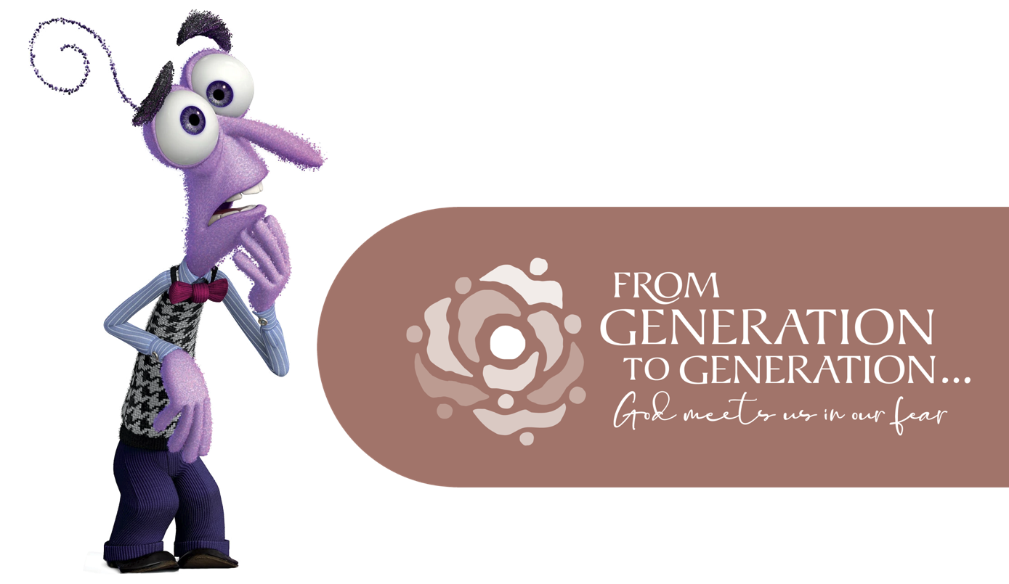
Friends, these two verbs tell us something quite profound about today’s story. First Mary was scared, and then she was curious. I propose to you this day that today’s passage reminds us that fear and curiosity are healthy dancing partners! When woven together, they can help us make faithful decisions in a fearful world.
Because, you see, fear in and of itself isn’t a bad thing. Fear, at its most basic understand, is intended to keep us safe. But we must also acknowledge that there are both rationale fears and irrational fears. For example, this is the first time that Tricia and I have lived in a house with a gas fireplace. So the other day I went and bought a carbon-monoxide monitor because a healthy fear made me decide that that was the best way to protect me and my family from harm. But there are also unhealthy fears. Unhealthy fears, for example, like the irrational ones that made it necessary for those four students from A&T University to sit at that lunch counter at Woolworth Story in downtown all those years ago. Fear, at its best, keeps us safe. Fear, at its worst, makes us hateful, violent, and unneighborly towards one another.
So this begs the question: how do you and I distinguish between unhealthy fears and healthy ones, between rational fears and irrational ones? Because there’s a lot of fears that we have. I gathered with more than a dozen of you last Monday for our first meeting of The Word This Week. And I polled the group about what fears we have and these were some that made the list:
Fears about violence and crime, both locally and abroad, especially violence in our schools and faith communities. Fears about inflation and the rising costs of pretty much just about everything and about how family budgets are being stretched thin in this holiday season. Fears about aging parents who are losing their independence or fears about themselves losing their physical independence. Fears about younger generations not attending church as frequently as their parents and grandparents, if attending even at all. Fears about geopolitical concerns like China, North Korea, or the Russian -Ukraine War. Fears of relationships being strained or perhaps permanently severed because of political/partisan divides.
That’s a lot to handle. Those are a lot of fears to sort out. Again, how do we answer that question? How do we sort out the rational fears from the rational fears. How do we process our fear in ways that assure that our responses to those fears are not destructive to ourselves and our neighbors?
I think the answer to that question is found in the wisdom of Mary. When we encounter fear, a faithful response to that fear is to practice curiosity. To ponder, if you will. What is this fear? Where is it coming from? What does this fear reveal about myself or the person I’m in conflict with or in relation to? Is this fear based on fact? Is the information I received that led to this fear obtained through a reputable, reliable news source? Is this fear something that is an actual threat to my wellbeing or the wellbeing of those I love or is this a fear that is being weaponized to divide me from my neighbor, a fear being used to separate “us” from “them?”
Now, to be sure, none of these questions are simple ones. They take time and patience, wisdom and restraint, in order to answer them faithfully in such complex times. But taking the time to process those questions is important discipleship-work for us to do because fear that isn’t coupled with holy curiosity turns violent, it turns hateful, it turns hurtful. And that’s not the way to “be the argument.” The way that you and I can “be the argument” is to have the wisdom of Mary to sit in our fear and understand that God doesn’t abandon us when fear comes knocking.
God meets us in our fear. God dwells with us in our fear. God sits next to us in our fear.
Mary leaned into that truth. Gabriel’s message to her must have brought a particular fear to her attention: the fear of communal isolation in that wake of such particularly scandalous circumstance. A young girl who was isolated by her community, for whatever reason, often was forced into a life of prostitution in order to survive.
But after fear, Mary allows holy curiosity to take the steering wheel. First she ponders, then she asks a clarifying question. When Gabriel tells her she will bear the very son of God, she asks, “How can this be?” Those four little words hold within them an openness. She is perhaps still fearful, troubled, but she doesn’t shut the door. Before she consents to this bizarre and holy journey, she has some questions.
And it’s ok, too, for us to have questions. It’s ok to be scared. It’s ok to be fearful. But we must never allow our fear to close off our holy curiosity for how God is working in the world, in our congregation, in our families, in our communities, and in our individual faith journeys.
Because fear without curiosity is a dangerous thing. But fear with curiosity opens doors, builds bridges, heals creation, and brings reconciliation to a world so very, very hungry for it.
And so, if you have days, like I do, when you feel like this, it’s ok. It’s called being human. But remember this, your fear isn’t the end of the story; and it doesn’t have to be a stopping place, but instead one stop (or several) on a lifelong pilgrimage where God meets us in our fear.
In the name of God the Creator, Redeemer, and Sustainer, may all of us, God’s beloved children, say: Amen.

