1st Sunday of Advent (Year A)

__________________________________________________________________________________________

Matthew 1:1-17

An account of the genealogy of Jesus the Messiah, the son of David, the son of Abraham.
Abraham was the father of Isaac, and Isaac the father of Judah, and Judah the father of Perez and Zerah by Tamar, and Perez the father of Hezron, and Hezron the father of Aram, and Aram the father of Aminadab, and Aminadab the father of Nahshon, and Nahshon the father of Salmon, and Salmon the father of Boaz by Rahab, and Boaz the father of Obed by Ruth, and Obed the father of Jesse, and Jesse the father of King David.
And David was the father of Solomon by the wife of Uriah, and Solomon the father of Rehoboam, and Rehoboam the father of Abijah, and Abijah the father of Asaph, and Asaph the father of Jehoshaphat, and Jehoshaphat the father of Joram, and Joram the father of Uzziah, and Uzziah the father of Jotham, and Jotham the father of Ahaz, and Ahaz the father of Hezekiah, and Hezekiah the father of Manasseh, and Manasseh the father of Amos, and Amos the father of Josiah, and Josiah the father of Jechoniah and his brothers, at the time of the deportation to Babylon.
And after the deportation to Babylon: Jechoniah was the father of Salathiel, and Salathiel the father of Zerubbabel, and Zerubbabel the father of Abiud, and Abiud the father of Eliakim, and Eliakim the father of Azor, and Azor the father of Zadok, and Zadok the father of Achim, and Achim the father of Eliud, and Eliud the father of Eleazar, and Eleazar the father of Matthan, and Matthan the father of Jacob, and Jacob the father of Joseph the husband of Mary, of whom Jesus was born, who is called the Messiah.
So all the generations from Abraham to David are fourteen generations; and from David to the deportation to Babylon, fourteen generations; and from the deportation to Babylon to the Messiah, fourteen generations.
__________________________________________________________________________________________

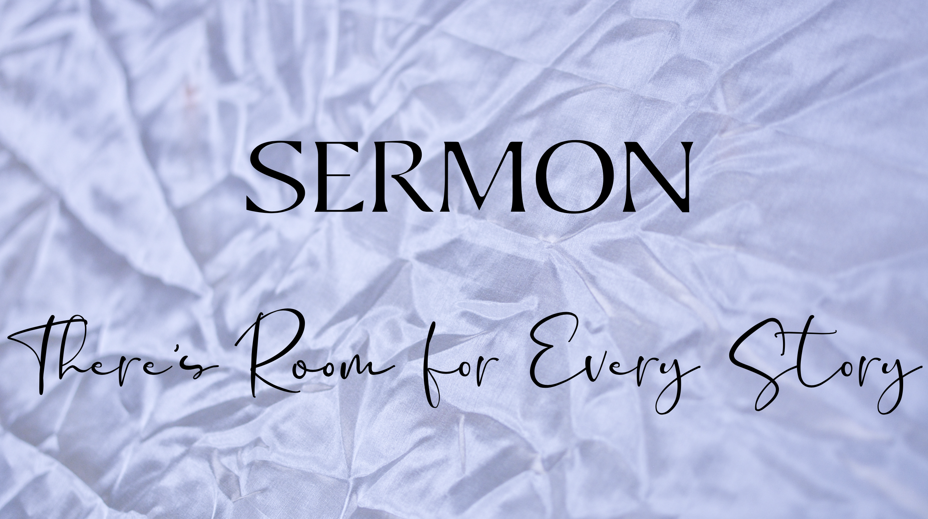
When I was in my high school and college years, my grandfather got very into genealogy. I remember him listening to him speak at length about our family’s history, pouring over documents spread out all over my grandparents’ kitchen table in Huntington, West Virginia. I would get lost in his descriptions of the intricate relationships between the different branches and vines of our family tree. But it didn’t matter if I got lost, because he was always there to guide me back along the path. Even if I didn’t understand every twist and turn, each nook and cranny, I stood in awe of his fascination of where he came from, as if it was the only way he could understand where he was and where I, as his grandson and future generation, could go.
Our Advent theme this year is “From Generation to Generation” and today’s sub theme is “There’s Room for Every Story.” My grandfathers’ passion for our family’s genealogy was a reminder that there were so many stories that made up the tapestry of our family and that it was important to pause in wonder of those stories in order to keep them alive and give us a sense of direction and purpose.
Advent is such a time. It’s a time when we gather again, as we have over the generations, to prepare for the coming of Jesus Christ as a human being with flesh as wondrous and fragile as our own. And so, we begin our time together at the beginning, in Matthew’s account of the genealogy of Christ.
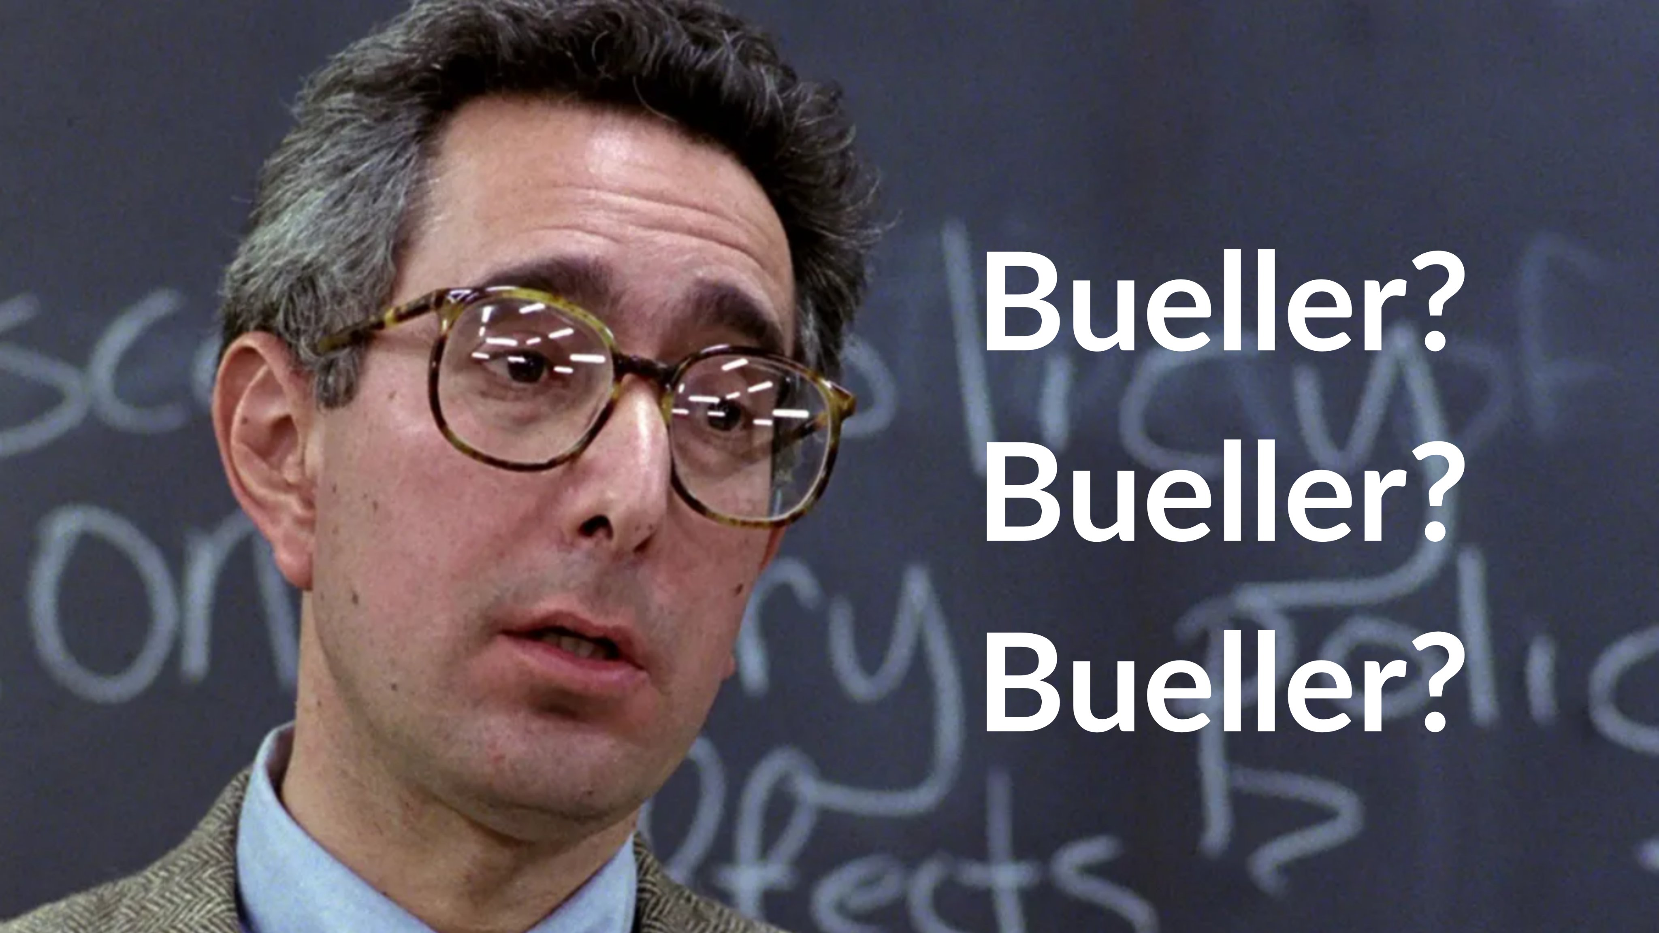
Now, I may be mistaken, but often when faced with genealogies in the Bible, we hear the lists of names with the enthusiasm of the students in this classroom.

This picture is, of course, from the iconic 1986 teen comedy, Ferris Bueller’s Day Off, when the teacher - played perfectly by Ben Stein - reads out loud the class roll in a painfully monotonous manner as the students endure the torment of name after name after name being recited.
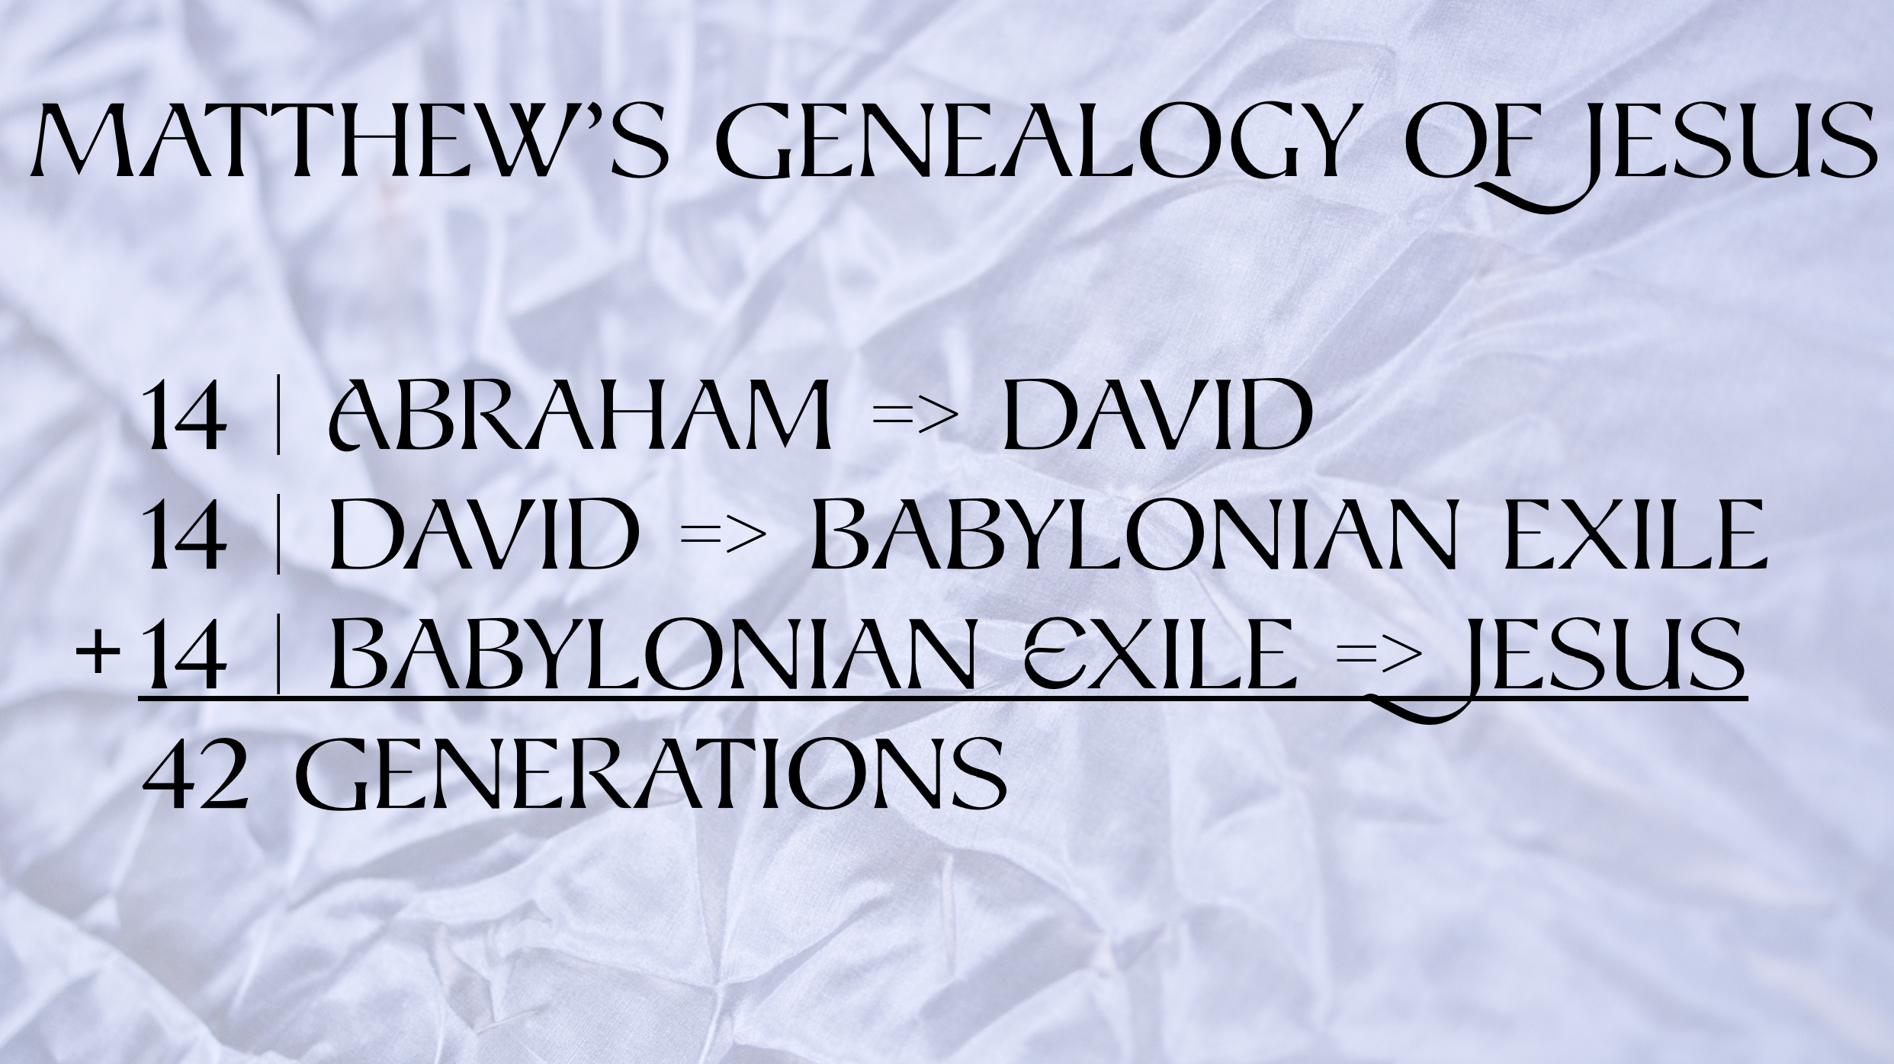
But, bear with me here, there are actually some pretty interesting things in today’s passage if, as I often say from the pulpit, we pay close attention to the text. First of all, since Matthew is writing to a primarily Jewish audience and Hebrew literature loves all things mathematical and tidy and symmetrical, we have some nice symmetry in today’s genealogy.

If we look closely, we’ll notice that there are three sections of 14 generations each, for a total of 42 generation. 14 generations from Abraham to David. 14 Generations from David to the Babylonian Exile. And 14 generations from the Babylonian Exile to Jesus.
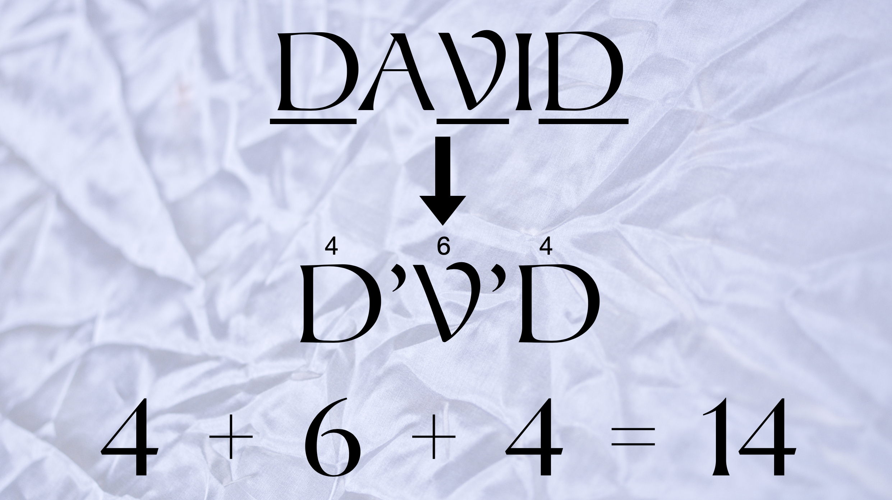
And these three sections of 14 generations are even more poignant when we stop to recognize that there’s some math play in the very name of David himself.
The genealogy begins by tying Jesus directly through the lineage of King David. Well, in Hebrew, each letter is assigned a number based on its location in the alphabet. Since there are no vowels in the Hebrew language, David is written as DVD. D (or dalet) is the fourth letter of the Hebrew alphabet and V (or vav) is the sixth letter. Therefore D + V + D is 4+6+4 which equals, you guessed it, 14!
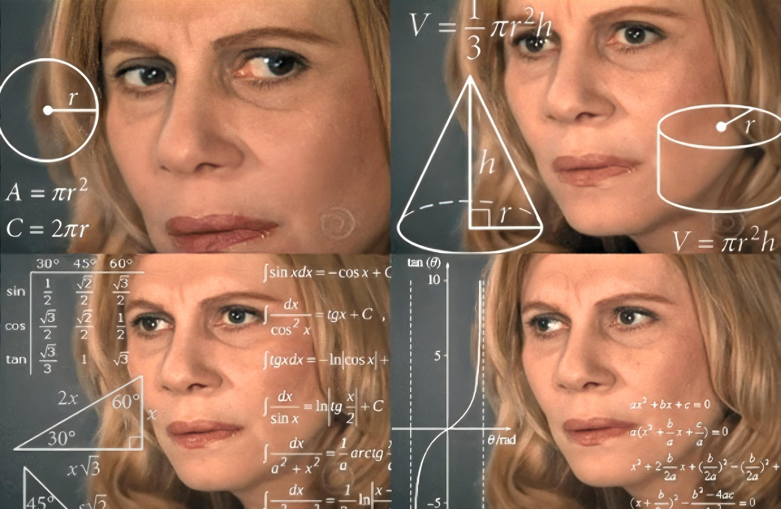
Now, if you’re feeling like this, no worries!
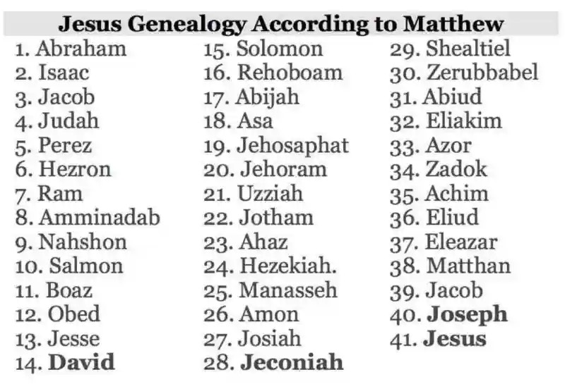
The point is this: the gospel writer has gone out of his way to make the genealogy of Matthew nice and tidy, perfect and symmetrical!

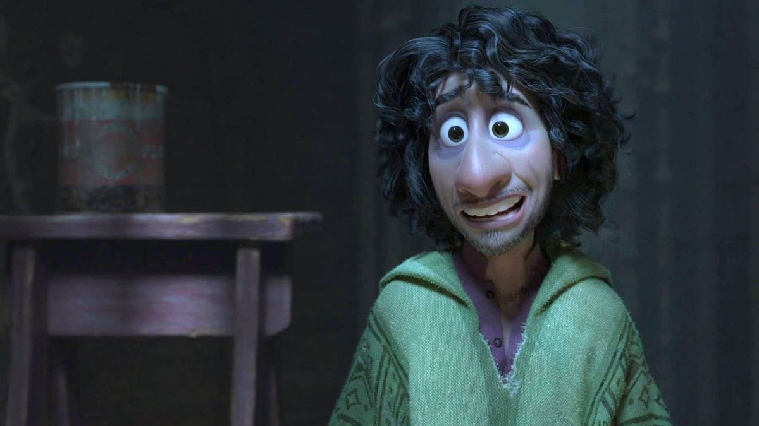
Which is what many of us prefer to do with our own family history right? We like to make them tidy, and attractive - devoid of drama or any of those messy details that are embarrassing, controversial or painful. We don’t like to mention the parent who was an alcoholic or the grandchild who is gay. We don’t like to talk about generational patterns of mental illness or the painful memory of families torn apart by political differences or generational divides. We do like to talk about those messy parts. Or, to borrow a phrase from a recent Disney film called Encanto,
“we don’t talk about Bruno.”
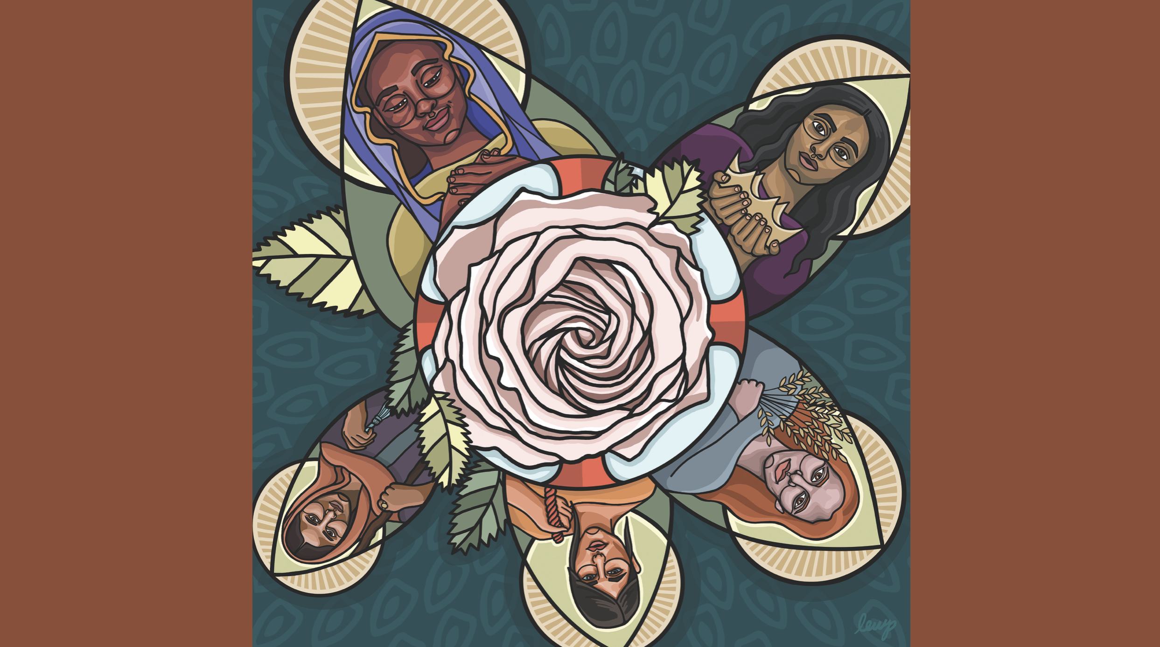
But if we look closely, we’ll notice that this genealogy of Christ isn’t as neat and tidy as it might first appear. Instead, it includes some messy stories that might actually share some insight on the meaning of Christ’s birth if we but have the courage to explore the less convenient parts of our family tree.
You see, there are five women that are included in Matthew’s genealogy and they’re depicted on this piece of art, which you’ll also find on the front of your bulletin. It’s a work called “The Genealogy of Christ” by Rev. Lauren Wright Pittman. And in it, she envisions Christ’s presence as the rose in the center of the composition and the five women depicted in Matthew’s genealogy as what Pittman describes as “foundational leaves building and upholding Christ.”

First, is Tamar on the bottom left (I rotated the image on the TV). Her placement on the list of names is curious because of the circumstances of her place in the family tree. Her husband died and, as was customary in those days, her husband’s brother was to wed her to provide for her and continue the family. But Tamar’s deceased husband’s brother, Onan, refused to do so. And so, Tamar maneuvered herself to bear children with her father-in-law in order to continue the line of Judah. Though this would be a story deemed a little scandalous by today’s standards, what actually happened is that Tamar did what she had to do to survive in a world dominated
by men. She did what she had to do to survive and thrive, and such places a story of courage and resilience in the timeline of Christ’s birth.

Next, working counterclockwise from Tamar, is Rahab. Rahab was the prostitute in the Book of Joshua that gave shelter to the two Israelite spies that were investigating the military strength of the city of Jericho. When the guards of the city came to her home to kill the Israelite spies, she feigned ignorance and hid them on the roof of her home by the wall of the city. Once she was informed of God’s intent to destroy the city, Rahab negotiated the safety of her family in return for her helping the Hebrew spies. In her depiction, you’ll see the crimson cord she draped from the window of her home to protect her family. Like Tamar, she did what she had to do to protect herself and those she loved, and such places a story of hospitality from an unlikely character in the timeless of Christ’s birth.
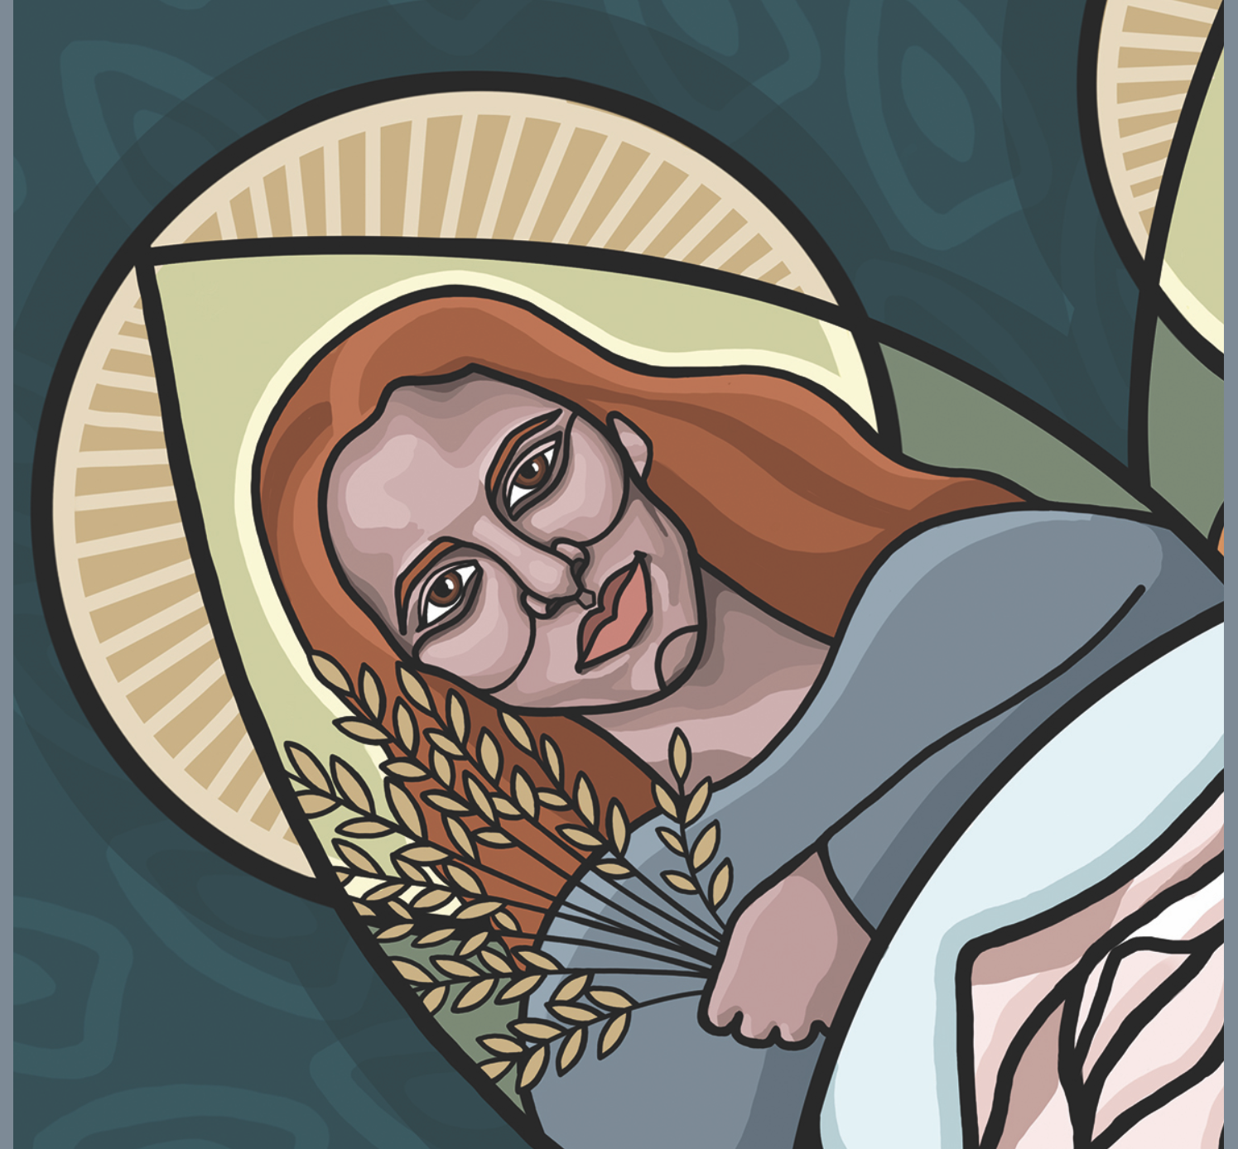
Next, in the upper right corner, we have Ruth. Ruth story is familiar to many of us. She was a Moabite woman who married an Israelite man. When every male in the family died tragically, Ruth’s mother-in-law, Naomi, told her and her fellow sisters-in-law to leave and fend for themselves. Ruth famously refused and told Naomi those famous words: “Where you go I will go, and where you lodge, I will lodge. Your people shall be my people, and your God my God. Where you die I will die, and there will I be buried.” In her depiction, you’ll see the wheat that she gleaned from the field during her struggles. Her inclusion in Christ’s genealogy includes a story of fierce loyalty and devotion, resiliency and steadfastness.
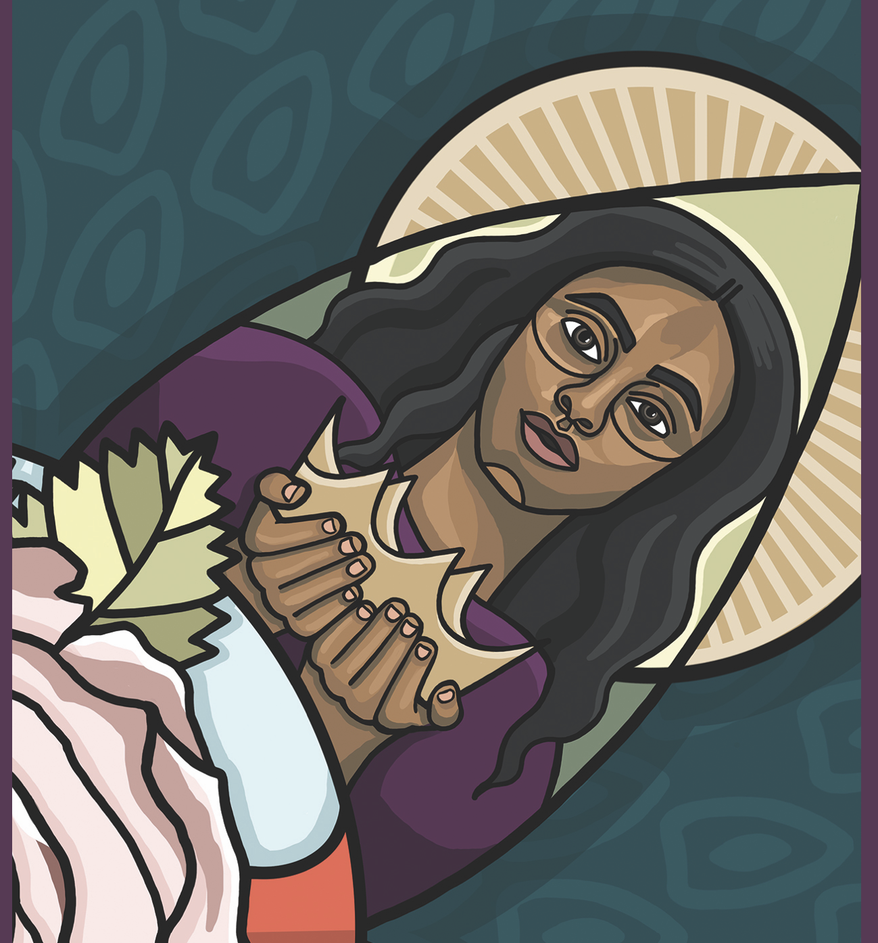
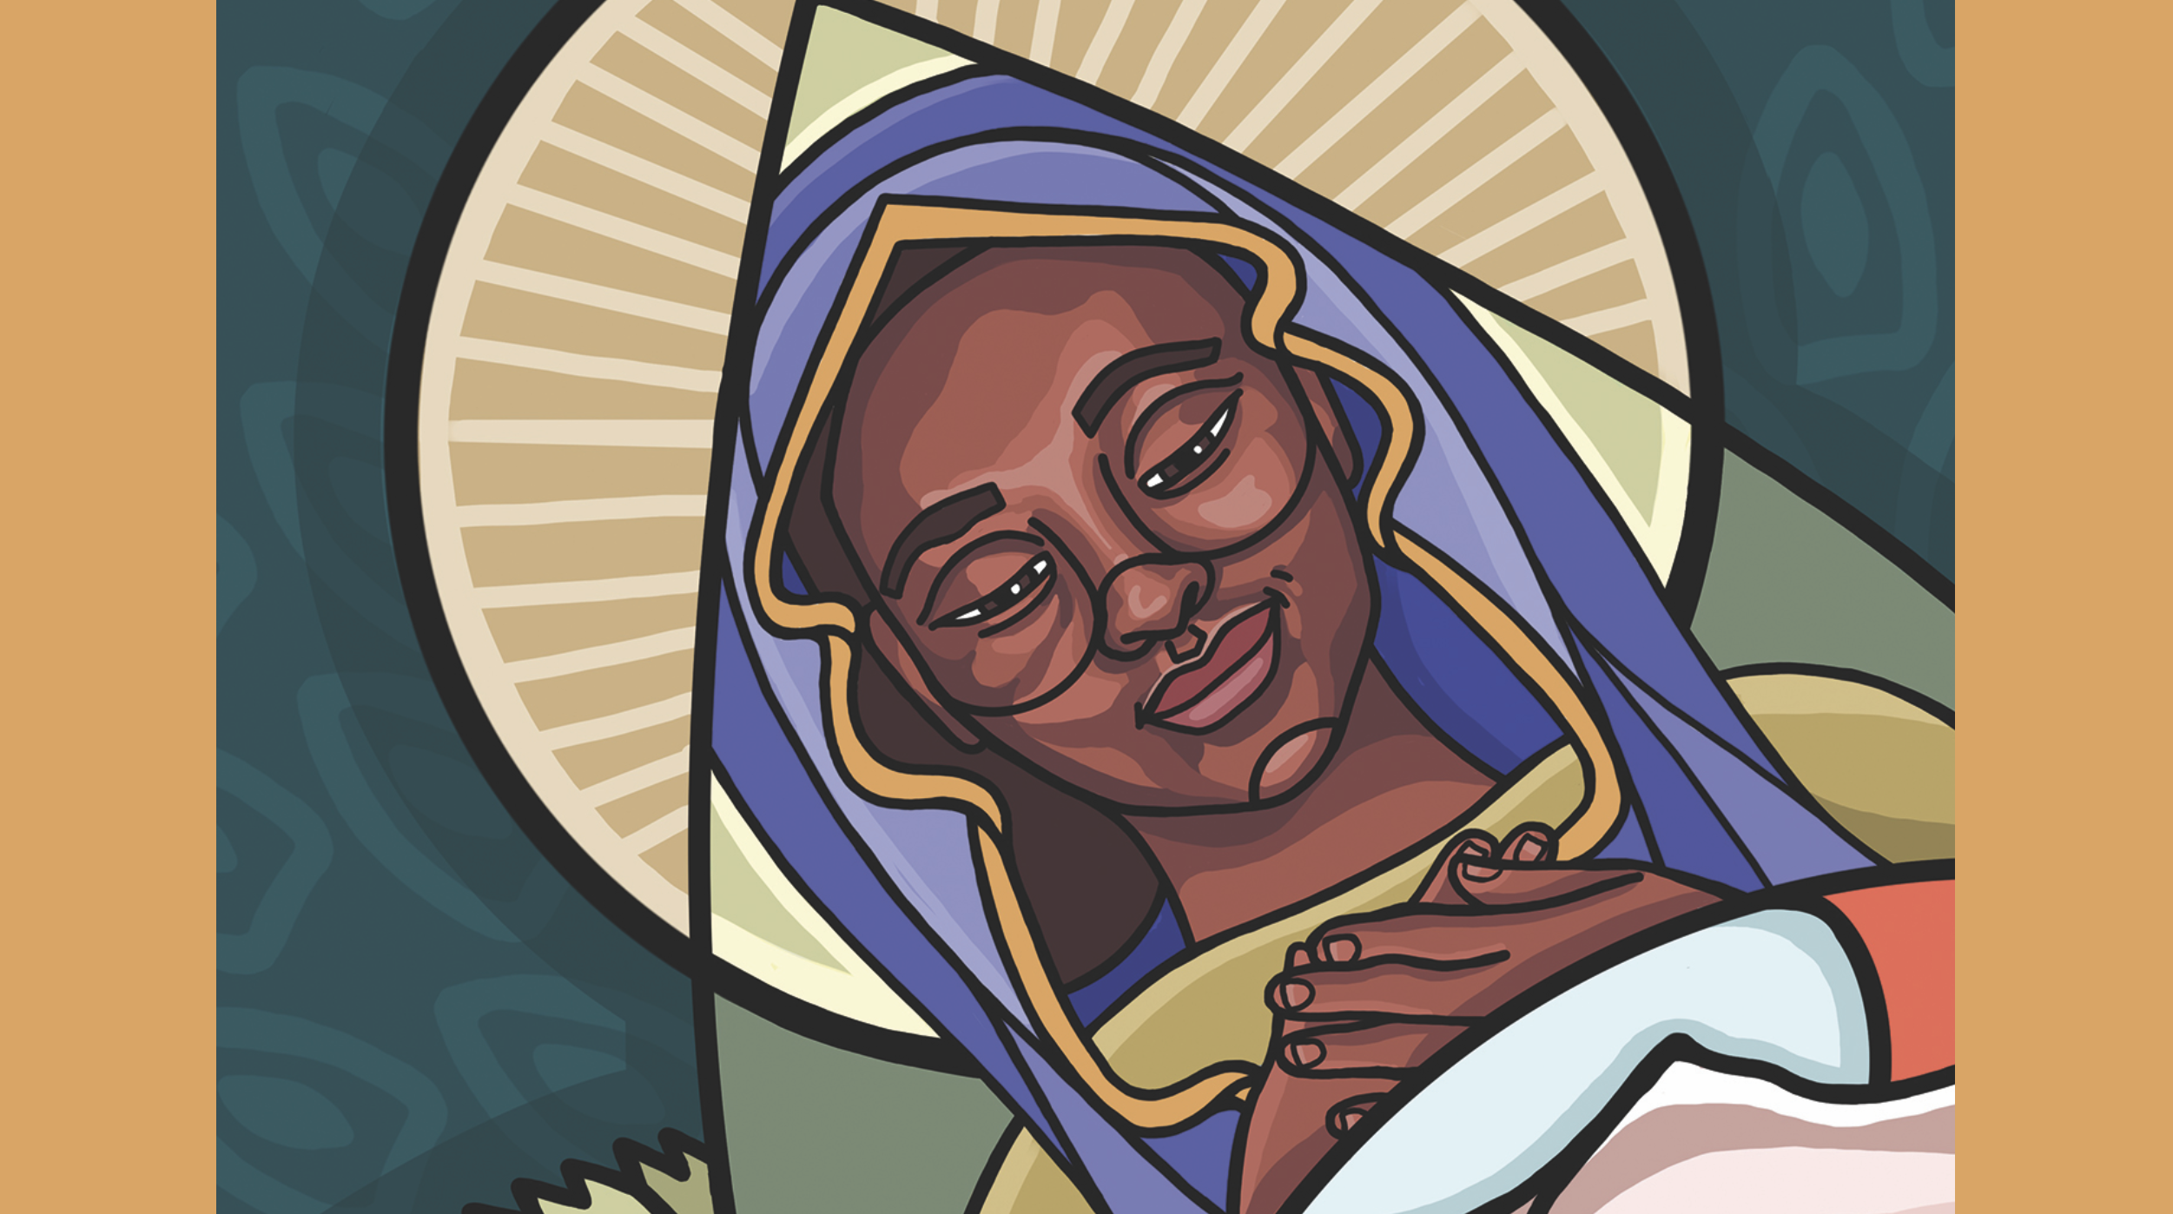
Next, and arguably the messiest story of them all, is the woman in the upper right corner. She weathered abuse from a king, endured the violent murder of her husband, and works tirelessly to make sure that her son went on to be a king of Israel known for his wisdom and intelligence. Her name isn’t given in today’s genealogy, where she is referred to simply as “the wife of Uriah.” But you and I know her real name. Anyone want to take a guess? That’s right. Bathsheba. Included in Jesus’ genealogy is a woman who suffered the collateral damage of King David’s many exploits and sexual misdeeds. Nevertheless, Bathsheba - we’ll use her real name and not simply her relationship to a man - Bathsheba endured, survived, and lived to provide for her children and stands today as a potent reminder of what happens when men in privilege abuse their power. Bathsheba’s inclusion in Jesus’ genealogy reminds us that there’s a place - an important place - for the stories of those who have painful truths to share.

And finally, in the upper left corner, is Mary the Mother of Jesus. She looks adoringly upon the rose e’er blooming, that of her beloved son, Jesus Christ, with her hands folded over her heart. Mary, the young woman, chosen by God to birth God’s son into the world, completes the circle surrounding Jesus, upholding him, loving him into being. Her story, too, is messy. What could be messier, after all, than an unwed teenage girl from an impoverished town in the Middle East being chosen to be the mother of God?
And so, these five women - Tamar, Rahab, Ruth, Bathsheba, and Mary - are inseparable parts of the story of Jesus. The story of Jesus is incomplete without their stories. There is room for every story. And I hope that you find that to be good news this day and every day!
Because maybe you know what it feels like to feel as if your story isn’t welcome. Maybe it’s too scandalous. Or messy. Or embarrassing. Or different. Maybe you know what it feels like to have your story uninvited, discontinued, or glossed over. Maybe, like Bathsheba, you - or someone you know - understand all too well what it’s like to have your name erased to provide cover for someone else’s mishaps.
This genealogy of Jesus reminds us that in order to fully welcome our neighbor, we must welcome their story as well, even and especially if that story reveals things about us that need to be named, claimed, and repaired. For reconciliation can only happen when we know, as Paul Harvey used to so famously say, “the rest of the story.”

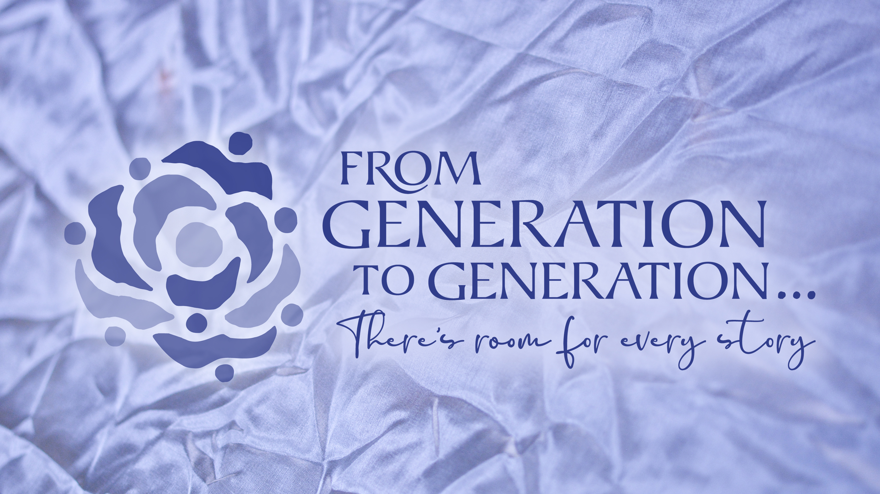
This genealogy of Jesus helps us know the rest of the story. And it reminds us that there’s room for every story. Every complicated story. Every embarrassing story. Every story of resilience and courage, of faithfulness and struggle. As the father of two young girls, I want my daughters, Hazel Grace and Winnie, to know these stories. When Tricia and I tell them the story of Christ’s birth, we’re not gonna skip over the first seventeen verses of Matthew’s Gospel. Because those stories are our stories; and they’re their stories. And I want them, and us, to be reminded that there’s room for every story. Thanks be to God!
In the name of God the Creator, Redeemer, and Sustainer, may all of us, God’s children, say: Amen.

