1st Sunday in Lent (Year A)

__________________________________________________________________________________________

Genesis 2:15-17; 3:1-7

The Lord God took the man and put him in the garden of Eden to till it and keep it. And the Lord God commanded the man, ‘You may freely eat of every tree of the garden; but of the tree of the knowledge of good and evil you shall not eat, for in the day that you eat of it you shall die.’
Now the serpent was more crafty than any other wild animal that the Lord God had made. He said to the woman, ‘Did God say, “You shall not eat from any tree in the garden”?’ The woman said to the serpent, ‘We may eat of the fruit of the trees in the garden; but God said, “You shall not eat of the fruit of the tree that is in the middle of the garden, nor shall you touch it, or you shall die.” ’ But the serpent said to the woman, ‘You will not die; for God knows that when you eat of it your eyes will be opened, and you will be like God, knowing good and evil.’ So when the woman saw that the tree was good for food, and that it was a delight to the eyes, and that the tree was to be desired to make one wise, she took of its fruit and ate; and she also gave some to her husband, who was with her, and he ate. Then the eyes of both were opened, and they knew that they were naked; and they sewed fig leaves together and made loincloths for themselves.
Matthew 4:1-11
Then Jesus was led up by the Spirit into the wilderness to be tempted by the devil. He fasted for forty days and forty nights, and afterwards he was famished. The tempter came and said to him, ‘If you are the Son of God, command these stones to become loaves of bread.’ But he answered, ‘It is written,“One does not live by bread alone, but by every word that comes from the mouth of God.”’ Then the devil took him to the holy city and placed him on the pinnacle of the temple, saying to him, ‘If you are the Son of God, throw yourself down; for it is written,“He will command his angels concerning you”, and “On their hands they will bear you up, so that you will not dash your foot against a stone.”’ Jesus said to him, ‘Again it is written, “Do not put the Lord your God to the test.”’ Again, the devil took him to a very high mountain and showed him all the kingdoms of the world and their splendor; and he said to him, ‘All these I will give you, if you will fall down and worship me.’ Jesus said to him, ‘Away with you, Satan! for it is written,“Worship the Lord your God, and serve only him.” ’ Then the devil left him, and suddenly angels came and waited on him.
__________________________________________________________________________________________
I’d like to begin today’s sermon by inviting us to hold 60 seconds of silence with one another. Take some time to settle your body, to place your feet flat on the floor, and, if you’d like, place your hands in your lap, palms up, in a posture of openness. Then, for the next 60 seconds, simply allow yourself to notice whatever thoughts and voices you hear. I invite us to do so free of judgment and open to whatever voices and feelings you have. Let us begin…
Pause in silence for 60 seconds…
I wonder what voices you heard.
Maybe you heard a voice of sadness, remembering a loved one who recently died…
Maybe you heard a voice of fear, wondering if you remembered to shut the garage door on your way out this morning…

Maybe you heard a voice of joy, celebrating gratitude for being able to gather with your friends and family this day…
Maybe your heard a voice of disgust, wondering if you look or feel the part to fit in with everyone else here today…
Or maybe you heard a voice of anger, asking God why it is that there is so much brokenness and division in the world.

Part of being human in these hurried days is navigating a life where we have more voices than ever competing for our attention. And though we might prefer it if we could easily categorize those voices into a dichotomy of “good” ones over here and “bad” ones over here, you and I know that the world isn’t as simple as that.
Take, for example the voice of the snake in the Garden. Often we are tempted to vilify the voice of the snake. And, while I’m certainly not saying that the serpent’s advice was “good,” in the mind of the people who inhabited that ancient world, snakes didn’t necessarily represent the sinister intentions that you and I have been taught to ascribe to them. I’ve never personally struggled with this because I actually had a pet snake growing up because my father was a middle school science teacher. We had a python whose name was, of course, Monty, and he was quite friendly! At any rate, snakes in ancient times didn’t represent the evil that we often associate with them. “In the ancient world," Rev. Danielle Shroyer writes, “snakes were a symbol of transformation. Their venom held the possibility of both poison and medicine.”
As it turns out, a staff with a snake coiled around it is a frequent symbol in the medical profession. Here, you’ll see the serpent in the logo for the World Health Organization.

And here you see the symbol of the Blue Cross Blue Shield with similar iconography with a snake.
And so, given the ancient understanding of a snake as a shrewd creature capable of both harm and healing, perhaps we might look upon this passage with new curiosity. You see, I don’t think the best question is whether or not the snake’s advice was “good” or “bad.” I think a deeper question that we might seek together is this: what the snake the best voice for Adam and Eve to listen to in that particular moment? You see, voices that might be helpful in one moment may not be so helpful in another moment.
I’ll use myself as an example. Like any pastor, I have a lot of voices in my head regarding my role as a pastor and preacher. What does this congregation need of me in this moment? What’s the best way to preach on this topic? Did I say too much or did I say too little? How do I remain faithful to my understanding of the Gospel without alienating folks who might see things differently? Am I spending enough time doing pastoral care? Am I doing a sufficient job of equipping the elders to help me with all that needs to be done to lead this congregation? All of these questions are questions us pastors ask ourselves. And there’s a time and a place for those voices to be listened to and explored! But when I’m on my days off, those voices are voices that need to be put on the shelf so I can devote myself to Tricia and the girls, and be fully present with them in my life as the girls’ father and Tricia’s spouse. You see what I’m saying? A voice that’s healthy in one moment may not be healthy in another.
Likewise, we might suggest that the serpent’s voice wasn’t the healthiest one for Adam and Eve to listen to in that moment because of what God had said to them before the serpent entreated the stage. God said “you may freely eat of every tree in the garden,” just not that one. Adam and Eve may have thought that rule arbitrary and meaningless, but any parent will tell you that rules that seem arbitrary to children are anything but for those of us tasked with their safety. We tell our children, “You can drink whatever you want, just not the things under the sink!” We tell them, “You can play wherever you want, just not in the middle of the street!”
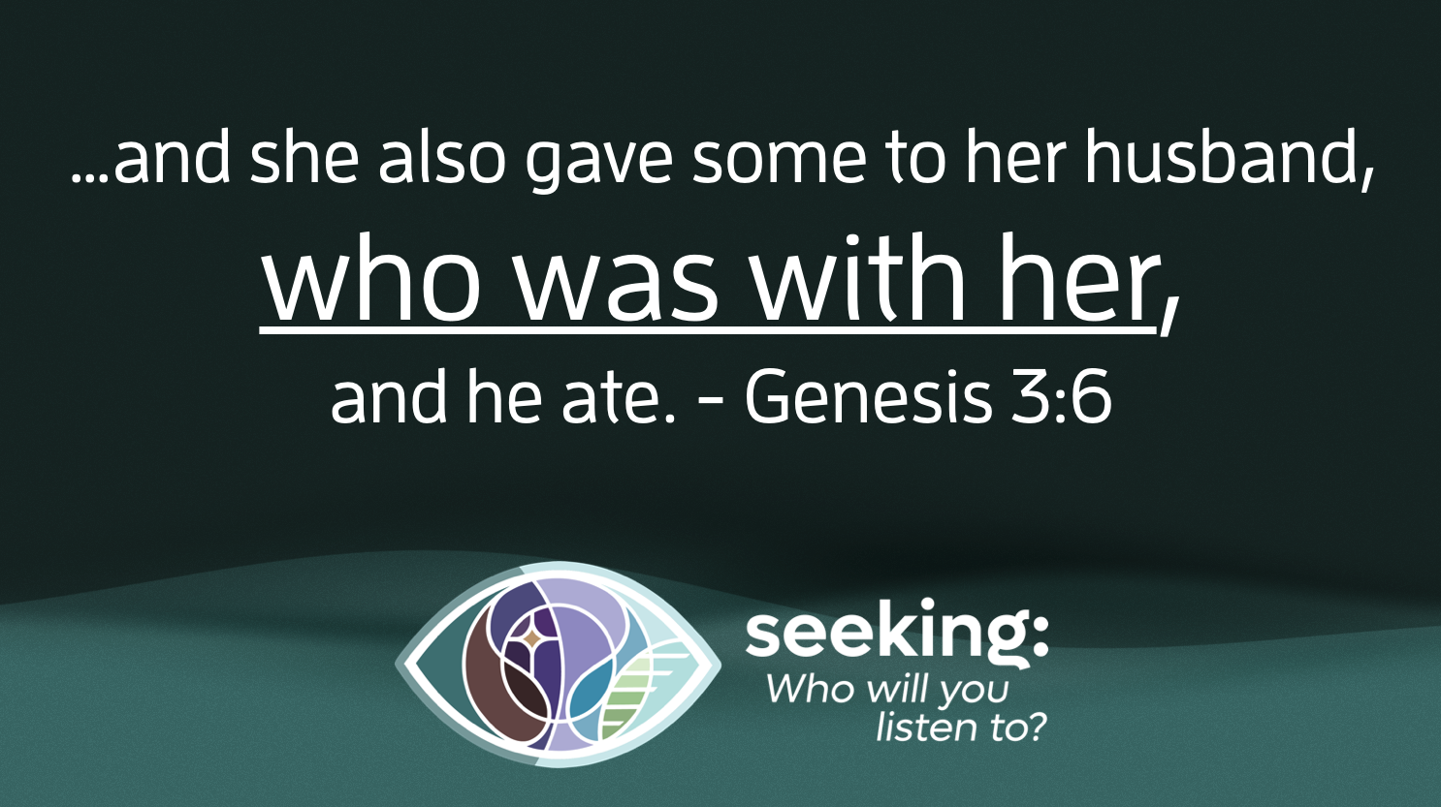
You see, under a different set of circumstances, the snake’s invitation to suspicion might have been a healthy voice to listen to. When I’m tempted to think that my self-worth is tied to my productivity, or my popularity, or my financial wellbeing, or my physical appearance, then the snake’s invitation to be suspicious of those voices might be quite welcome! But in the context of this mythological story, Adam and Eve chose not to listen to the voice of their creator, and they chose not to heed the wisdom of the Divine Being that loved them into being. Notice, by the way, that I say “they” and not “she.”
Though this text has been weaponized against women throughout the millennia to suggest that women are at fault for the first “sin” (which, by the way, is a word that doesn’t appear in today’s story), the text is very clear in verse six of chapter three that Adam was right next to Eve during this encounter with the serpent. As such, they share responsibility for listening to the voice of the serpent.
Let us turn our attention to the second passage, Matthew 4:1-11. We always begin the season of Lent with the story of Jesus’ temptation in the wilderness by the devil. I invite you to take a look at the artwork you’ll find on the front of your bulletin created by a friend and colleague of mine, Rev. Lisle Gwynn Garrity, founder of a Sanctified Art. In it, you’ll find a depiction of Jesus with the words of the devil behind him. Of this painting, Lisle says the following:
“In this image, the words of the Tempter hover in the background. The Tempter’s voice lingers like a ringing in Jesus’ ears, saying: “Take charge. Hoard your power. Dominate. Control.”
Somehow, Jesus has deciphered that these words are simply background noise. He closes his eyes and goes inward, wrapping himself in a posture of self-embrace. From this introspective perspective, Jesus essentially says, “Get behind me, Satan.”
The backdrop of this piece resembles the dust of the desert. Like sand washing along a beach, the sediment shifts into water in the top left, hinting at what bolsters Jesus in his ministry: his belonging to God. His belovedness washes over him, giving him the courage to defy the deception of the Tempter and tune into his inner wisdom. In this way, he is given a new song to carry with him, a lullaby from God that goes, “You, my child, in you, I am well-pleased.” This is a melody for singing, a song for dancing.
What are the voices that linger with you like a ringing in your ears? What are the messages that try to deceive or devour you? Let those voices buzz and fade into the background. Close your eyes, tune in, and embrace yourself. From your belovedness, what song will you sing?”
And so, I’d like to close this sermon by inviting y’all to help me answer two questions. The first is this: “What voices are taking up too much space in your head these days?”
Solicit responses from the Menti poll.
And the second question is this: “What voices do you listen to that remind you of your beloved-ness?
Solicit responses from the Menti poll.
My prayer for us this week is that we would seek together ways to sort out the many voices that compete for our attention. What voices are those that need to fade into the background? What voices are those that need to be affirmed and explored? Like the venom of a snake that can be used either for poison or for healing, how might the voices we let in lead us away from harm and towards healing for us and for our neighbors?
May our holy curiosity abound!
In the name of God the Creator, Redeemer, and Sustainer, may all of us, God’s seekers, say: Amen.

